2020 Review of the Disability Standards for Education 2005

Submission
September 2020

Executive summary
Children and Young People with Disability Australia (CYDA) appreciates the opportunity to provide a submission to the 2020 review of the Disability Standards for Education 2005. This submission builds on those we made to previous reviews of the Standards, as the recommendations for improvements we made in those submissions remain just as relevant today. We draw the Department’s attention to our recent reports highlighting the experiences of children and young people with disability during the COVID-19 pandemic, and our 2019 submission to the Disability Royal Commission. We have incorporated relevant themes and findings into this submission and have attached copies of these papers.
Our national education surveys show students with disability are routinely excluded in their education, with many segregated from ‘mainstream’ schools and classrooms, not attending school full-time, and/or being refused enrolment and excluded from school activities. Suspensions and expulsions are also common practices.
While most students in our surveys receive some support at school because of their disability, many families report paying out-of-pocket for relevant supports and equipment. Students with disability also face unacceptably high levels of abuse and violence at school, including bullying and restrictive practices such as restraint and/or seclusion.
Overall, families/caregivers of students with disability do not consider:
- students receive adequate support in their education
- they were communicated with regularly about the student’s learning progress
- teachers have high expectations of the student
- teachers have the required training to provide a supportive and enriching education environment.
This illustrates the Standards’ limited impact in enabling students with disability to access and participate in education on the same basis as students without disability. Other factors, including a pervasive culture of low expectations, lack of professional expertise and training for education providers, and funding patterns, also contribute to the present educational crisis for students with disability.
Young people, families/caregivers, advocacy organisations, and other stakeholders tell us of the Standards’ limited usefulness and efficacy in ensuring the educational rights of students with disability. Additionally, “the CRPD Committee has on various occasions, including in the above-mentioned Concluding Observations, raised concern about the effectiveness of the Standards, and the most recent formal review of the Standards in 2015 has not resulted in any updates despite the recommendation report.”
Education providers and departments’ lack of accountability remains concerning. With little oversight for implementation of the Standards, families have limited recourse to ensure education providers adhere to their obligations, and there is significant fear of retribution for people who do speak out. Experiences of schools and education authorities disregarding these obligations without consequence or accountability are common.

This submission is endorsed by the following organisations:
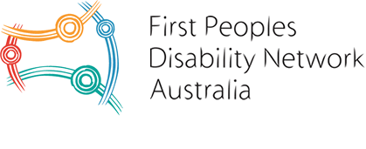 | 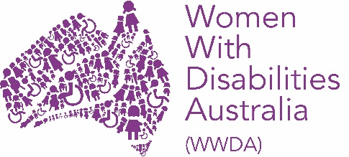
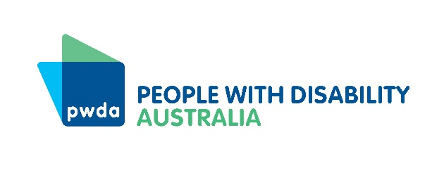
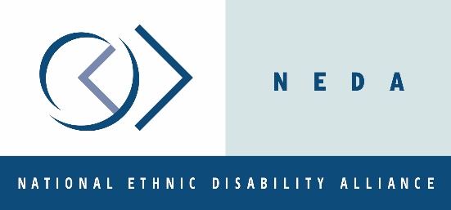

Authorised by:
Mary Sayers, Chief Executive Officer
Children and Young People with Disability Australia
E. marysayers@cyda.org.au
P. 03 9417 1025
W. www.cyda.org.au

Amend the Standards to reflect the human rights of students with disability
Recommendation:
- Amend the Standards to reflect human rights and resounding evidence for inclusive education, ensuring they:
  - Refer to, and are aligned with, the UN Conventions on the Rights of Persons with Disabilities and the Rights of the Child
  - Explicitly recognise and promote students’ right to an inclusive education, including when determining whether an adjustment is ‘reasonable’
  - Ensure the rights of full inclusion of all students with disability into mainstream education (not segregated in ‘special’ schools or separate settings)
  - Define the term ‘consult,’ and provide direction as to when it should occur
  - Require education providers to ensure all students with disability have an appropriate and up-to-date individual education plan
  - Reflect the additional barriers and specific support needs faced by students with disability from communities experiencing marginalisation and intersectional discrimination.

Students with disability have the right to an inclusive education
Australia is a signatory to the United Nations Convention on the Rights of Persons with Disabilities 2006 (CRPD) and the Convention on the Rights of the Child 1989 (CRC). These Conventions contain clear standards and obligations on the rights of children and people with disability to equal access to education. Australia’s ratification of these Conventions articulates the Australian Government’s commitment and responsibility to protect, respect and promote the rights of all children and young people with disability to receive a quality, free and inclusive education.
Inclusive education “requires recognising the right of every child (without exception) to be included and adapting the environment and teaching approaches in order to ensure the valued participation of all children.” It entails full participation and full membership of all students and families within a school community and ensures students with disability are valued as contributors and learners. Despite the Standards being in operation for more than a decade, it is rare for students with disability to be provided with a truly inclusive education experience, and families for whom this is the case often describe themselves as ‘lucky’.
CYDA frequently encounters situations where schools and education departments do not understand their obligations to deliver an inclusive education, or what this looks like in practice. Too often a student’s physical presence in an education setting is mistakenly perceived to indicate the student’s participation and inclusion; or the term is misused to imply that inclusion involves a student adapting to a school environment, rather than ensuring education meets the individual needs of each student.
Our 2019 report shows evidence of widespread exclusion in schools. In our sample, one in four students was in a special school or had dual enrolment between a ‘mainstream’ and special school. Meanwhile, one in ten was enrolled in a ‘mainstream’ school but segregated from their peers in a separate unit. Parents and caregivers also report significant gatekeeping, with one in ten students with disability refused enrolment. Significant numbers of students with disability are not participating in full-time schooling, with families reporting schools use suspensions and ‘support needs’ prevent students from attending school full-time. The standards must explicitly reference the need to phase out segregated education.
The Standards do not mention or refer to inclusion or inclusive education in any way, and as we have previously written, “the key concept of “reasonable adjustment” in the Standards does not seem to align with the defined term in the DDA or the equivalent concept under Articles 2, 5 and 24 of the CRPD, as explained in General Comment No. 4 and General Comment No.6.
It is also a limited enactment of Article 24 obligations that tends to encourage individualised, case-based and deficit “retrofit thinking” only and overlooks broader systemic architecture and design issues in the delivery of education services, including the implementation of Universal Design for Learning as expressly mentioned in paragraph 25 of General Comment No.4.
Similarly, the “unjustifiable hardship” exception permitted under the DDA does not seem to align with the equivalent concept under Article 24, as explained in General Comment No. 4 and General Comment No.6.”
The Standards therefore provide limited assistance for students with disability to access education and training opportunities on the same basis as students without disabilities, as per the review’s terms of reference.
In its response to the 2015 DSE review, the Australian Government clearly “affirm[ed] that all students should be provided with an inclusive education, where all students are supported to learn, contribute and participate in all aspects of their education and learning environment.”
In line with this, CYDA recommends the Standards are amended to articulate students’ right to an inclusive education explicitly. Given the considerable misunderstanding and misappropriation of the term inclusive education, it is important this includes a clear definition of inclusion, recognising every child has the “right to be a valued member of society and to be provided with equal opportunities to actively participate in and contribute to all areas of learning.”

Communication with students and families remains poor
Consultation is a core requirement per parts 4 to 8 of the Standards and must involve the individual student and/or an associate of the student, such as the student’s family. The experience and knowledge of students and families is critical to informing educational programs. This can include assessments of educational needs, individual education plans, learning styles and general information regarding a child’s needs.
Parents and caregivers tell us of the positive impacts of open and approachable communication between schools, families, and allied health professionals for students’ wellbeing. However, as noted in our previous contributions to DSE reviews, in practice this requirement is often ignored, or interpreted in considerably different ways.
In its initial response to the 2015 review, the Australian Government ‘agreed in principle’ to the review’s recommendation “to improve consultation practices with students or their associates, including development of policies or procedures on personalised planning for students with disability which outline the type of consultation required, the frequency of consultation and how consultations are to be documented.” We urge the Australian Government to re-consider its position that it “cannot enforce specific requirements around consultation” and to work with state and territory governments to include greater detail around consultation in the Standards.
Additionally, significant concerns remain around the development and implementation of students’ Individual Education Plans (IEPs), a key recommendation of the 2010 review. There is variability between states and territories regarding the requirements for IEPs, and parents often report it is up to them to push the school to develop and update their student’s IEP. Over 20 per cent of respondents to CYDA’s 2020 National Education Survey reported students did not have an IEP in place; and only 9 per cent of IEPs were updated or modified to account for the COVID-19 pandemic. The Standards should be amended to require education providers to ensure all students with disability have an appropriate and up-to-date individual education plan, which cannot be enacted without the signed consent of the student or their representative.

Intersectional discrimination is a barrier to education for many students
As well as facing disability-based discrimination, many children and young people also face other forms of discrimination and barriers in education. These forms of discrimination intersect and lead to compound disadvantage and inequities. Students facing intersectional discrimination include First Nations children and young people, those from culturally and linguistically diverse communities or non-English speaking backgrounds, children and young people in LGBTIQA+ communities, children and young people in out-of-home care or youth justice systems, and those living in regional, rural and remote areas.
In CYDA’s experience, the Standards do little to acknowledge and address the additional needs students with disability from diverse backgrounds may have, or the additional barriers or discrimination they may face. There is no specific reference to students with disability with diverse backgrounds within the Standards.
Additionally, the CRPD expressly states the need to incorporate a gender perspective in all efforts to promote the human rights of people with disability; meaning the rights of girls and women with disability must be addressed when interpreting and implementing the provisions in the Convention relating to education. The specific inequities many girls and non-binary young people face in accessing their education must be recognised in Australia’s moves towards inclusive education.
Children of migrant and refugee backgrounds are often segregated to English as a Second Language classes. Anecdotal accounts from teachers indicate there is a cohort of children in these classes who have either invisible disabilities and/or psychosocial disabilities who are not reaching milestones and this is seen as their failure to grasp English, not because of their disabilities that require additional support in addition to social integration with student peers.
When the Standards are amended to reflect students’ human rights, this should include recognition of the specific and varied barriers experienced by students facing additional marginalisation. Decisions around whether an adjustment is reasonable – particularly where education providers offer suggestions for alternative adjustments – should also consider any specific communication, cultural, or other equity needs of the student, to enable access to education appropriately. It is also essential that consideration of these issues is translated into policy and practice.

Greater accountability and enforcement of the Standards is urgently required
Recommendation:
- Strengthen mechanisms for accountability and enforcement of the Standards, including through:
  - Introducing compulsory, comprehensive, and ongoing training for educators on inclusion
  - Obligations for education providers to supply a copy of the Standards and explain it in accessible language to every student or their family/caregiver upon enrolment
  - Outcomes reporting and measurement
  - Alignment with the new National Disability Strategy and the development of a new National Action Plan for Inclusive Education.

CYDA consistently receives feedback from young people with disability, families, advocates, and other stakeholders, that accountability for implementing the Standards is seriously lacking – and this is clear from the data and firsthand accounts we have shared above. In its response to the 2015 review, the Australian Government recognised “that there are difficulties in enforcing the Standards... and this issue still remains.” Unfortunately little has changed since 2015 in this respect. Much more work is required to ensure all stakeholders are aware of, understand, and uphold the Standards and the rights of students with disability.
The educational impacts felt by students with disability during the COVID-19 pandemic is a clear example of failure of the Standards. More than half of the students in our recent survey sample did not have regular contact with the education provider to ensure the learning was accessible, or curriculum and learning materials in accessible formats.
Discussion of the Standards and a focus on human rights and inclusive education should be built into teacher education programs, including through ongoing professional development for educators. Further, there should be an obligation for the Standards to be provided and discussed with families/caregivers at the time of enrolment/consideration of enrolment. Many parents we have spoken to, who have years of strong advocacy history for their children, say they found out about the Standards by accident or because of specific promotion of this review.
To measure progress, appropriate data collection and system oversight by an independent body is needed, along with information on how to report breaches of the Standards. The current option of complaints to the AHRC should remain as an avenue but more expedient and accessible options should also be provided. Reforms should also be implemented to permit representative disabled persons and family organisations to make complaints and take legal action to address systemic discrimination.
Finally, broader work is vital to deliver genuinely inclusive education for students in Australia. This will involve:
- Building a comprehensive policy framework, including alignment of the Standards with the new National Disability Strategy, and development of a National Action Plan for Inclusive Education
- Addressing the funding and resource constraints to support inclusive education
- Improving the interface between education systems and the NDIS
- Countering the systemic culture of low expectations for children and young people with disability.

CYDA and All Means All (2019). Joint submission to Free and equal: An Australian conversation on human rights.
See Articles 28 and 29 of the CRC and Article 24 of the CRPD, and CRPD General Comment No.4 Right to Inclusive Education.
Cologon, K. (2013) Inclusion in Education: Towards Equality for Students with Disability, Children with Disability Australia, Melbourne, p.3.
Cologon op. cit., p.13.
Children and Young People with Disability. (2019) Time for change: The state of play for inclusion of students with disability.
See the following paragraphs in CRPD General Comment No.4.: paragraph 12 calls for ‘ending segregation within educational settings by ensuring inclusive classroom teaching in accessible learning environments with appropriate supports’ and for inclusive education to be ‘monitored and evaluated on a regular basis to ensure that segregation or integration is not happening either formally or informally;’ paragraph 13 states that ‘the right to non-discrimination includes the right not to be segregated and to be provided with reasonable accommodation;’ paragraph 39 provides that the full realisation of Article 24 ‘is not compatible with sustaining two systems of education: mainstream and special/segregated education systems’ and paragraph 68 calls for ‘a transfer of resources from segregated to inclusive environments.’
For more information see All Means All (2019) Empowering children with disabilities for the enjoyment of their human rights, including through inclusive education, Submission to UN Human Rights Council.
CYDA and All Means All op. cit.
Australian Department of Education and Training. (2015) Australian Government Initial Response to the 2015 Review of the Disability Standards for Education 2005, p.5.
Cologon op. cit., p.20.
Australian Department of Education and Training op. cit.
Cologon K. et al. (2014) ‘The A-Z of IFSPs, IEPs and SSPs!: Positive planning for inclusion’ K Cologon (ed), Inclusive education in the early years: Right from the start, Oxford University Press, South Melbourne, p.211.
Dickinson, H., Smith, C., Yates, S. & Bertoul, M. (2020) Not even remotely fair: Experiences of students with disability during COVID-19, Report on CYDA’s Education Survey 2020: Learning in a time of crisis COVID-19 (Coronavirus), Public Service Research Group, University of New South Wales, Canberra, and Melbourne Graduate School of Education, University of Melbourne, Melbourne, July 2020.
See Article 6 of the CRPD.
This should include recognition of the low participation of female and non-binary children with disability in support programs such as the NDIS and of their unique experiences of violence and discrimination such as exposure to physical and emotional abuse and restrictive practices, such as forced contraception and menstruation management.
Australian Department of Education and Training op. cit.
This includes children and young people with disability and their families, other students and families, schools, early childhood education providers, and other education providers, education departments, and allied health professionals and other professionals in children’s lives.
Dickinson op. cit.
CYDA and All Means All op. cit.
Australian Education for Inclusive Education (ACIE). (2020) Driving change: A roadmap for achieving inclusive education in Australia.

