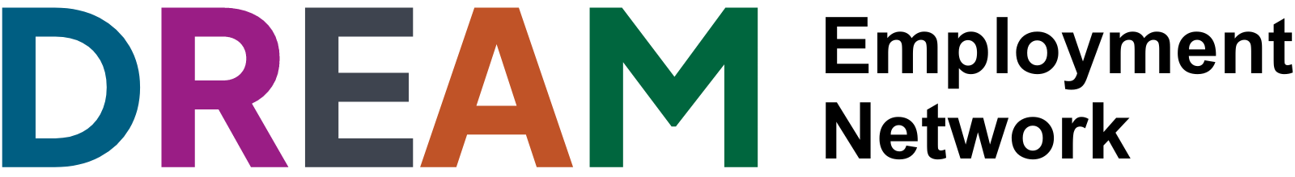

Disability Representation Employment and Accessibility Mission (DREAM) Network

Participant Code of Conduct – Young People and Employers

To make the DREAM Network an amazing and engaging experience for everyone including young people with disability and employers, we ask everyone to follow this Code of Conduct.

Do lots of this!
- Respect what others think and believe. We encourage diversity of thought!
- Value the opinions and experiences of other people. Feel free to respectfully disagree or present a different point of view but remember that DREAM participants come from a wide range of experiences and backgrounds and we want to celebrate diversity.
- Be friendly to everyone!
- Be inclusive and patient – the DREAM Network is about everyone feeling welcome and celebrated for who they are and communicating in ways that work for them.
- Think carefully about what you say. If you would not want someone to say that thing to you – don’t say it to others.
- Use appropriate language and be conscious of how you're communicating.
- It’s OK to ask questions and get things wrong, as long as you have genuine intentions and come with an open mind to learn.
- Get people involved in the DREAM Network that you think would benefit!

Don’t do any of this:
- Saying inappropriate, obscene, offensive or provocative things
- Personally attacking or trolling others
- Saying abusive, harassing, insulting or threatening things
- Criticising others
- Saying things that are discriminatory or might incite hatred, on the basis of race, religion, gender, nationality, sexuality, disability, ability or other personal characteristics e.g. (ableist language)

If you think someone is violating this Code of Conduct, please contact:

Daniel Munter, CYDA Youth Programs Manager
danielmunter@cyda.org.au or (03) 9417 1025 or 0423 833 523.

Lastly, please do not share the details of events with individuals not registered with the DREAM Network. Due to CYDA’s commitment towards child and youth safety, inclusion and accessibility, there are a bunch of reasons why we need people to register with the Network to get involved. This includes ensuring children and young people with disability are safe, access needs can be met, and so much more!

Thank you for helping make the DREAM Network a safe and supportive environment for everyone!

