Children and Young People with Disability Australia (CYDA)
Look! It's me!
Top 14 children's picture books about diversity and inclusion as reviewed by young people with disability.
www.cyda.org.au
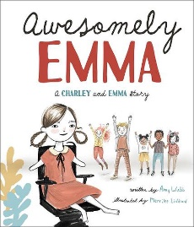
- Awesomely Emma - A Charley and Emma story
By Amy Webb From Beaming Books
5 stars “Awesomely Emma is a charming book about self-advocacy and the power of collective action to drive social change.” - Chloe R
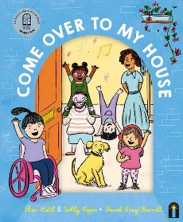
- Come over to my house
By Eliza Hull and Sally Rippin From Hardie Grant Children's Publishing
5 stars “[A] great look into how different people and different families function, normalising disability and access needs." - Aegon
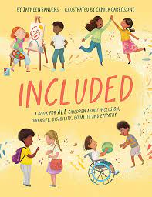
- Included - A book for ALL children about inclusion, diversity, disability, equality and empathy
By Jayneen Sanders from Educate2empower Publishing
5 stars “Included gives a glimpse into the lives of different children living with disability. Excellent for facilitating conversations around disability.” - Tessa
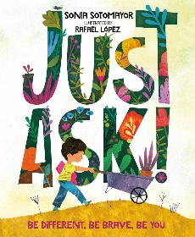
- Just Ask! - Be different, be brave, be you
By Sonia Sotomayor From Penguin Random House
5 stars “This is a metaphor for all people with or without disabilities coming together making the world a beautiful place.” - Alyssia
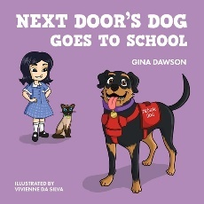
- Next Door's Dog Goes to School
By Gina Dawson From New Holland Publishers
5 stars “My favourite part: Learning and understanding how everyone is different and needs help in various ways.” - Jessica
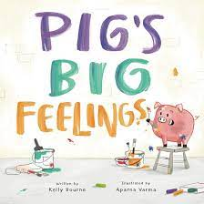
- Pig's big feelings
By Kelly Bourne From Flying Pig Press
5 stars “It explains all about how all emotions are natural to feel, and to accept them, but also be able to communicate them to others around us.” - Atticus
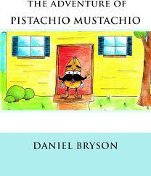
- The Adventure of Pistachio Mustachio
By Daniel Bryson From CreateSpace Independent Publishing Platform
5 stars “I liked the inclusivity and the friendship … which helped them feel confident in themselves and to empower them to embrace who they are.” - Alyssia
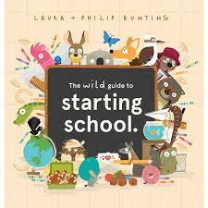
- The wild guide to starting school
By Laura Bunting From Scholastic Australia
5 stars “I liked the book because it had funny parts in it, and I think that even kids who are not very keen about going to school would still enjoy the book.” - Lily
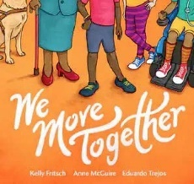
- We move together
By Kelly Fritsch and Anne McGuire From AK Press
5 stars “The colourful illustrations showed a good understanding of equality, people with and without disability, different genders and various skin colours.” - Jessica
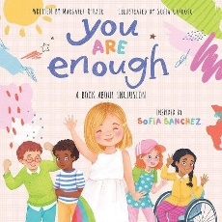
- You are enough - A book about inclusion
By Margaret O'Hair and Sofia Sanchez From Scholastic Inc
5 stars “I feel like it should be read to everyone. Children with and without a disability, even adults, could all benefit from the positive messaging in this book.” Chloe S
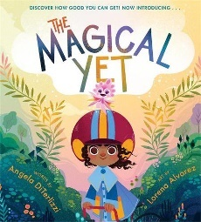
- The magical yet - Discover how good you can get now introducing…
By Angela DiTerlizzi From Little, Brown Books for Young Readers
4.5 stars “This book gives a wonderful message that determination, hard work and continuing to give things a go leads to success.” - Kai
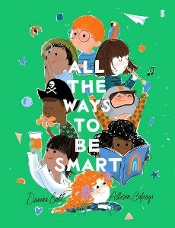
- All the ways to be smart
By Davina Bell From Scribble US
4 stars “The book serves as a reminder that intelligence comes in various forms, from creativity and empathy to problem-solving and curiosity.” - Rahim
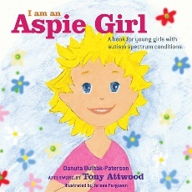
- I am an Aspie Girl - A book for young girls with autism spectrum conditions
By Danuta Bulhak-Paterson, Teresa Ferguson and Tony Attwood From Jessica Kingsley Publishers
4 stars “It will reassure [newly diagnosed girls] they are not alone, which is an important component of autistic pride and acceptance.” - Georgia
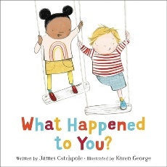
- What happened to you?
By James Catchpole From Little, Brown Books for Young Readers
4 stars “It teaches to not pester people with disabilities about it.” - Elijah

