Submission to the Royal Commission into Violence, Abuse, Neglect and Exploitation of People with Disability (DRC)
Submission by Children and Young People with Disability Australia, February 2021

Concern about the DRC not making recommendations following the neglect of students with disability during the COVID pandemic
The Royal Commission into Violence, Abuse, Neglect and Exploitation of People with Disability (DRC) handed down its report on the hearing into Experiences of people with disability during the ongoing COVID-19 pandemic in November 2020. This report pulls few punches and finds the Australian Government culpable for failures in a number of areas. However, while noting significant impacts on the education of children and young people with disability, there were no recommendations made to this effect. Education jurisdictions seem to have been let off the hook where others sectors such as health, which is jointly overseen by the Australian and state and territory governments, have been directed into action.
What does the report say?
The Royal Commission report makes 22 recommendations on the Australian Government’s response to the pandemic for people with disability covering health care, disability workforce, lack of safeguarding during the pandemic, First Nations People and the need for disability advocacy funding. However, no recommendations were made about the systemic neglect of students with disability despite evidence being provided that their needs were routinely ignored by education jurisdictions during the pandemic. The discrimination and neglect they faced was acknowledged by the DRC, but no recommendations ensued.
Importantly in its report the DRC said
“The Australian Government’s acknowledgements of its international obligations are both appropriate and significant . . . but the federal structure does not mean that the Australian Government can disclaim responsibility for ensuring compliance with its international obligations. More specifically, the Australian Government cannot disclaim responsibility for ensuring compliance with Australia’s obligations under the CRPD [Convention on the Rights of Persons with Disabilities] on the ground that the states provide certain essential services such as testing for COVID-19 or providing all state school children with online education during government imposed ‘lockdowns’. The Australian Government has both the legislative power under domestic law and the responsibility under international law to ensure that the human rights of people with disability outlined in the CRPD are respected and enforced within Australia.”

Education during the pandemic
The research conducted by CYDA, and eminent researchers from the University of New South Wales Canberra and the University of Melbourne, was presented to the DRC COVID-19 hearing, based on our report Not even remotely fair: Experiences of students with disability during COVID-19. We found schools across Australia were unable to provide, or dramatically reduced support for students in their education during the first COVID-19 lockdown. Despite the well-known inequities students with disability face in their education there was a lack of assertive and proactive support for this group. There were few formal mechanisms across the Australian, state and territory governments to plan for this to prevent further disadvantage in education for students with disability during the pandemic. This had very real impacts on students and their families.
As noted by Witness ABB at the DRC COVID hearing reflecting on her daughter’s experiences during the first lockdown:
“…I think one of the biggest issues was the obvious lack of preparation in terms of supporting my daughter’s learning, especially during the COVID shutdown. I think at the core of this there is some deeply rooted ableism where there is a view that students with disability are an add-on, a burden, that they belong somewhere else.”
The Australian Government holds many of the levers for ensuring students with disability are fully included in school. Most importantly, they hold the funding and legislative levers under the Disability Discrimination Act and the Disability Standards for Education that have been widely criticised as being ineffective, including by the Committee overseeing the Convention on the Rights for Persons with Disabilities for not providing the impetus for schools to provide inclusive education.
In evidence provided to the DRC, Mary Sayers, CEO of Children and Young People with Disability Australia (CYDA), said the Department of Education, Skills and Employment’s Education and Employment Sector Pandemic Preparedness Committee, which bought together states and territories to plan for the pandemic for all students (not disability specific), was wound up on 24 June 2020. This was the only national forum that brought state and territory jurisdictions together to consider education impacts in the pandemic − but concluded in the midst of the pandemic. There was no specific national planning for students with disability in their education despite their well-known experiences of disadvantage in education, which was likely to be exacerbated during the global pandemic.
Education jurisdictions let off the hook
Given these observations and the evidence regarding the impact of the pandemic on the education of children and young people with disability, it is disappointing there were no recommendations regarding this issue and education jurisdictions seem to have been let off the hook. This has let the opportunity slip away to grapple with the iinequitable funding and policy that pervades contemporary Australian education. Instead of embracing the evidence and opportunity to provide guidance and support for more inclusive practices advocated by the young people and families that testified to their experiences of isolation and neglect, the recommendations are oddly silent. For children and young people with disability this is yet another signal that they are not a priority and the tyranny of lower expectations pervades. Furthermore, it also means that we might not learn from this experience and is a missed opportunity to further encourage the sorely needed reform of education for children and young people with disability. The failings during pandemic are indicative of the lack of accountability in Australia generally for inclusive education. Should the COVID pandemic in Australia again result in lockdowns we fear the same underlying issues will again cause major harm to students with disability without systemic reform.
We urgently request that the Disability Royal Commission makes strong recommendations about the systemic neglect and discrimination of students with disability in its future work. After almost two years of work, and three hearings where educational abuse and neglect has been examined by the Commission, we are yet to see strong critique or recommendations from the DRC about the pervasive institutional structures, practices and systems that perpetuate abuse and neglect and their failure to comply with the United Nations Convention on the Rights of Persons with Disabilities and the right to inclusive education.

This submission has been endorsed by:
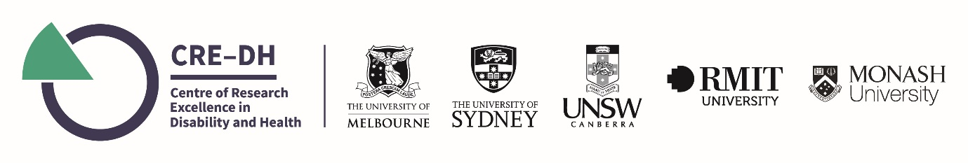
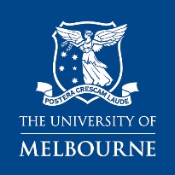
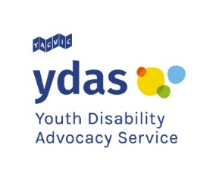
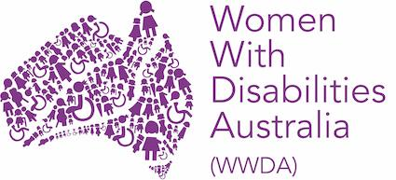
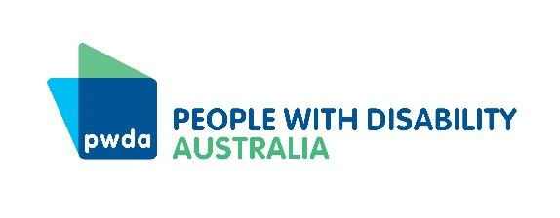
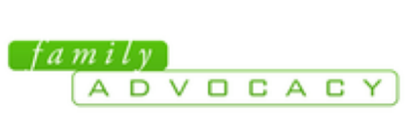
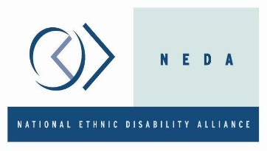
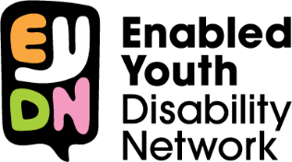
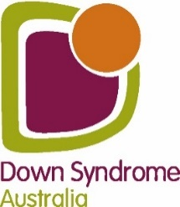
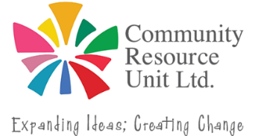
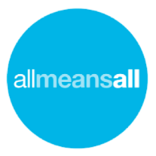
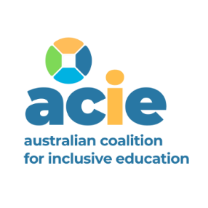

Royal Commission into Violence, Abuse, Neglect and Exploitation (2020) Public Hearing Report Public hearing 5 Experiences of people with disability during the ongoing COVID-19 pandemic, pp 35-36
Dickinson, H., Smith, C., Yates, S., Bertuol, M. (2020) Not even remotely fair: Experiences of students with disability during COVID-19. Report prepared for Children and Young People with Disability Australia (CYDA), Melbourne.
Royal Commission into Violence, Abuse, Neglect and Exploitation (2020) Public Hearing Report Public hearing 5 Experiences of people with disability during the ongoing COVID-19 pandemic. p. 37

