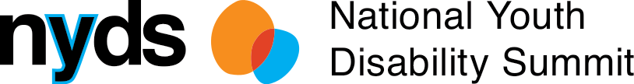

What young people with

disability said:

Awareness, Access + Inclusion

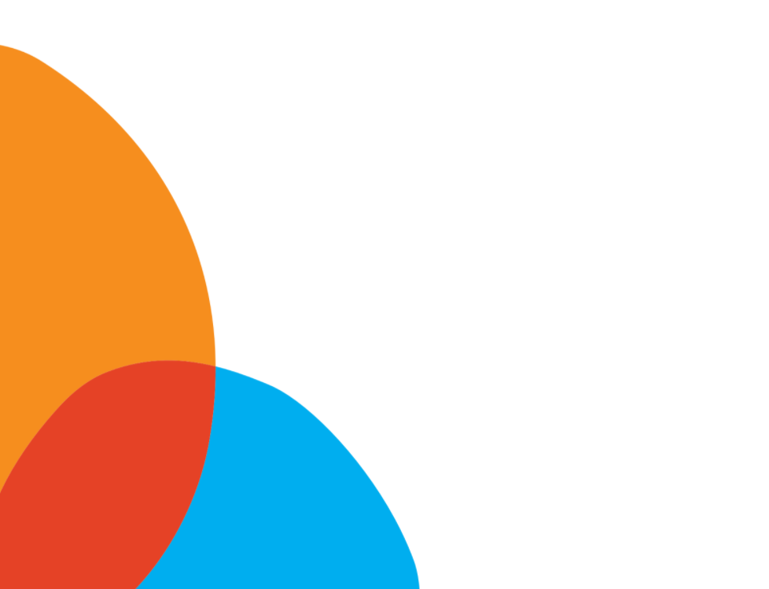
Insights, ideas, and solutions from young people with disability
The outcomes of the inaugural National Youth Disability Summit
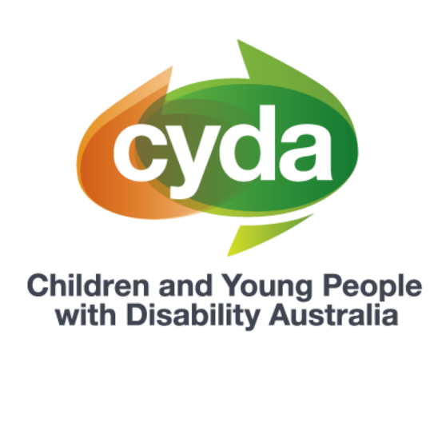
Presented by Children and Young People with Disability Australia (CYDA)
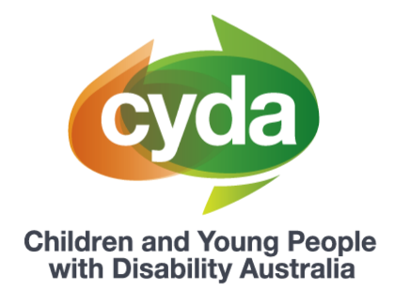

About Children and Young People with Disability Australia

Children and Young People with Disability Australia (CYDA) is the national representative organisation for children and young people with disability aged 0 to 25 years. CYDA has an extensive national membership of more than 5,000 young people with disability, families and caregivers of children with disability, and advocacy and community organisations.
Our vision is that children and young people with disability are valued and living empowered lives with equality of opportunity; and our purpose is to ensure governments, communities, and families, are empowering children and young people with disability to fully exercise their rights and aspirations.

Background to the National Youth Disability Summit

At the end of September 2020, the inaugural National Youth Disability Summit (‘the Summit’) took place. The Summit was established with the vision to create an inclusive environment where young people with disability from across Australia could come together as a community and use their voices to shape the future.
The Summit was designed by and for young people with lived experience of disability. Over nine months, the Co-Design Committee, consisting of 20 young people with disability from across Australia, designed the vision, content and delivery of the Summit.
Hosted over five days, the Summit was an entirely online conference that offered young people a range of sessions and workshops, the opportunity to meet other young people, share their ideas, insights and expertise, and develop new skills and knowledge. Over 250 young people attended, with four of the five days being ‘youth only’.
Each day of the Summit had a focussed topic, as chosen by the Co-Design Committee. The topics were:
- Education
- Employment
- Mental Health and Wellbeing
- The NDIS and Housing
- Awareness, Access and Inclusion.
This paper will focus on the findings that came out of the Awareness, Access and Inclusion day. Four different papers have been released to reflect the respective learnings from the other days.
The National Youth Disability Summit was presented by CYDA and funded by the National Disability Insurance Agency, with support from the Department of Social Services and Equity Trustees.
Background on awareness, access and inclusion, and young people with disability

The extent to which young people can grow their skillset, personally develop, and continue to learn and be challenged is contingent on the opportunities they are provided. For example: a person needs to have opportunities to meet new people, grow their social circles, and build relationships; a person needs to be given a chance in a new job for them to build their capacity and go on to flourish in their career.
The opportunities we are provided in life can ultimately be determined by those around us. As a society, we decide who gets to be included and excluded. Those who are seen as holding ‘valuable’ roles in society are generally granted the opportunities to enjoy the good things in life, such as getting an education, having a paid job that meets their skillsets and interests, and participating in social and community activities. Whereas those who are viewed as holding less ‘valuable’ roles face increased, socially constructed barriers to accessing these important aspects of life.
People with disability have faced a long history of low expectations and this pervasive attitude remains today. As recently as 2018, a survey of community attitudes and beliefs about people with disability showed that nearly one quarter (23.5 per cent) of survey respondents agreed or strongly agreed that people with disability have less to look forward to than others. The survey also demonstrated that 11.8 per cent of respondents agreed or strongly agreed that people with disability are a burden on society, and 21.9 per cent agreed of strongly agreed that people should not expect too much from those with disability.
These misinformed and discriminatory beliefs about disability have widespread impacts on the lives of young people. A 2019 survey² of young people across Australia found that over half (55 per cent) of young people with disability stated that their disability made it hard for them to feel like they fit in (at school, work or socially). Further, more than double the proportion of the young respondents with disability felt negative or very negative about the future compared to their non-disabled peers.
People’s prejudiced attitudes can impact how young people see themselves, the opportunities they have to enjoy the good things in life, and ultimately, their potential to grow and thrive. By shifting these attitudes and setting new, more inclusive norms, society can support young people with disability to succeed.

Young people with disability’s perspective on awareness, access and inclusion
CYDA has reviewed, analysed, and collated the young participants’ ideas into five key themes that emerged throughout the Summit week. These five themes are: Identity, Enablers, Barriers, Solutions and Social Movement.
Key theme | Theme description
Identity | How do young people with disability define themselves
Enablers | The factors that enable or support young people with disability to live the lives they would like to live
Barriers | The factors that inhibit or prevent young people with disability to live the lives they would like to live
Solutions | Practical solutions for organisations, government, and the community to promote the autonomy, independence, and power of young people with disability
Social Movement | How organisations, government, and the community can contribute to the greater social movement young people with disability want to see in the world
Here’s what young people said:

Identity

Across sessions on the Awareness, Access, and Inclusion day – and the Summit more widely – young participants expressed disability pride and a sense of community with other people with disability. Some young people also shared that being actively involved in the disability community can lead to feelings of disability pride.
“Getting involved in wheelchair sports has given me opportunities to form relationships, learn a new sport, and learn from others”
“I did find my way to disability pride, but it wasn’t until my mid to late twenties. And it was because I connected with another disabled person in my small country town.”
“Disability pride is about being proud of ourselves. It's about learning our history. It's about knowing that strength and creativity and courage that exists in disabled communities. It's about knowing that there are disabled communities. That disability is not just an individual experience or just an interaction between the individual and a broader society. There are disabled communities, there is disability culture, there are disabled arts groups, disabled activist groups, disabled people living and creating spaces together as disabled people, not in spite of disability, but actively, openly and proudly as disabled people.”

Young participants who attended the Summit discussed the importance of identity and how education settings need to recognise and be respectful of a diverse range of identities. This includes embracing and celebrating disability and the different ways young people identify. For instance, some young people prefer to use person first language to talk about themselves (e.g. ‘person with a disability’), whereas others feel more comfortable when using self-descriptors (e.g. ‘disabled person’). One young participant commented that the “one-size-fits-all approach” does not represent people’s differences, comparing it to a “blanket thrown over people with disabilities that contains stereotypes”.

Young people also shared the significance of intersectionality and how the recognition and promotion of different identities, such as ethnicity or sexual and gender diversity, in education settings is fundamental in ensuring that all students feel safe and included.
“I felt left out. Felt different. Felt like I don’t belong. Like the default is white, abled and heterosexual. I have experienced discrimination from teachers and lecturers, such as being told that I was ‘too sick’ to be at university, and constantly being in detention at school because the system just wasn’t designed for someone like me.’’

There is a shared belief among young people that people in power should be proactive in asking students how they identify, and to “just ask if you are unsure”.
Enablers
Young participants at the Summit discussed the different factors that help them feel included and supported in education settings. One factor that was consistently highlighted across sessions was the importance of educators and education systems proactively asking young people what they need and then following through and implementing these preferences. The participants valued having “solutions on their own terms” and flexibility in their learning options.

“[Inclusive education] lets us decide what we want from our education. It will do anything in its power to achieve that. It would ask me, us, disabled young people, ‘what is it doing wrong?’, and it would listen to our answers. It would act on what we have told it. It would consider me the key stakeholder, not only in my life, but the education system overall. It would like me being viewed as somebody people can learn from.”

Young people at the Summit also shared a commitment to elevating the voices of more marginalised members within the disability community, who ‘’don’t have a voice’’. This includes young people with disability who face increased structural and systemic barriers, such as young First Nations peoples and young people in the LGBTQIA+ community.
‘’There is no one way to be disabled ... it’s really important that we show the diversity of the disability community through that.’’
“Our story doesn’t have to look like anyone else’s. There is no one way to be disabled. I think it’s really important that we show the diversity of the disability community through that. So, don’t feel like you have to look, or act or talk a particular way, post in your underwear, etc. In my opinion, the more diverse backgrounds and different stories that we can share, the better.”
Enablers

A prominent theme that emerged across the Summit that enables young people to feel more included in the community is the presence of role models with disability. Young people value how role models present new options and help pave the way for different life pathways. One participant shared how having examples of athletes with disability influenced their own journey with sport, adding how by initially seeing clips of the wheelchair sport sparked a passion that has ‘’evolved over the years to get me to where I am now.’’ One young person also added that they wished they had role models earlier in life to show them ‘’that this life [that they are now living] is possible.’’

Another enabler that was raised by young people was organisations proactively offering or detailing available supports and accessibility considerations. This includes events sharing details about the access procedures and the space the event will take place in. As shared by young people, this proactively removes pressure and feelings of uncertainty, and allows them to only make necessary disclosures about access.
‘’Expecting disabled people, especially those with multiple disabilities, to shed the immense levels of detail about every possible access need and hope we have thought of everything that might come up in your event, is a lot of work. So, talk about what you are already doing and then let us make additional requests if our needs are not covered.’’

Barriers

Ableism³ was identified by participants as a major barrier to young people with disability experiencing inclusion in their daily lives. Media outlets were highlighted as a source of these attitudes. As expressed by one young person, people with disability in the media are often depicted from “a place of pity” or on a “pedestal”. The young person continued that people with disability are “very rarely just seen [in media] as a person”. Participants also commented on the specific lack of representation of young people with disability.

“So often when we talk about disability, you know, in my head I often picture an old, 94 year old on a walker and I’m like, ‘But that’s not me and my mates’. … When do we get represented?”

Harmful, ableist attitudes held by others have negative impacts on young people and their ability to participate in the community. Participants at the Summit shared that they did not feel heard when they expressed their feelings about inclusion or instances where they felt excluded.

“I think a lot of us find that we get discriminated against, or get turned down for jobs for reasons that don’t seem quite right, or maybe we have difficulty finding houses – and that just increases your anxiety and makes it harder. … So people kind of question ‘Well, why are you anxious doing those things?’, and well because every time I’ve tried this before or whatever, it hasn’t gone well for numerous reasons and it just builds upon itself.”

Lack of access to support was also identified by young participants as a barrier to community inclusion. This includes access to broad supports in regional and remote areas, as well as lack of targeted supports, such as for young First Nations peoples with disability.

“Lot of people think people should just move to the city where they can get the help they need, No − regional communities need better infrastructure and accessibility.’’

‘’Many of our First Nations young people with disability shouldn’t be in juvenile detention. They’re there because the system has failed them.’’

Solutions

Creating space for young people with disability was highlighted as a pathway toward a more inclusive society. Participants at the Summit emphasise that no one knows what young people need better than they do, so they must be supported to be at the centre of solutions for change to be effective.

“We need meaningful opportunities. We need career paths that put us in positions of power and authority to enact change, to create a more accessible society.”

“I believe that young people's voices need to be heard. … [W]e have the future ahead of us and we see the changes that need to happen. It will be silly not to give young people a voice and input in the matters that affect them.”

“Listen to young people. Because there is not a decision that is not with us at the end of the day. The mistakes made today will haunt us in the future.’’

Honest conversations about accessibility and access needs – and their sometimes competing priorities – was also viewed by young participants as essential in creating a more inclusive society.

‘’Sometimes they [access decisions] require compromise, sometimes they require acknowledging that not every space will necessarily be accessible for every person. And having those frank discussions can be tricky. It's about how we respond when someone says, ‘Actually, that doesn’t work for me’ and it's something we didn't plan for. It’s about understanding that accessibility changes depending on which groups you are working with.’’

Social Movement

Addressing power imbalances that currently exist between young people with disability and non-disabled people (particularly those who are in position of power), was understood by participants to be fundamental in moving toward a more inclusive society.

“Governments have never decided to implement change because it’s the right thing to do or it’s the just thing to do. They did it because we advocated for it. We fought for it. In all the loud and shouty, soft and gentle, systemic and individual ways that we do. We need to keep fighting. We need to keep connecting with each other and working to towards a more just and equitable world.”

“Young people in particular … are not part of the conversation about what should be in those supports or plans or policies [that affect young people]. … People very much think, ‘I know all about young people so I can put this policy together without talking to them’, but when you do that, there are so many stories, narratives, bits of information that you miss because you are not talking to the affected person.”
Storytelling was identified as a tool in the movement towards inclusion, as ‘’there is a lot of power to be found in being vulnerable.’’

“I think that authentically sharing your story and your experience is one of the most effective ways to raise awareness of the issues and the barriers that you face.”

Peer work was also viewed as an important strategy to break down power dynamics between young people and people in power, such as clinicians and health professionals.

“It [peer work] has really shifted the typical power imbalance between young people and those involved in our care. … To be able talk to someone without the fear of judgement and to see that they have created a life worth living and instilled hope, that was something that no clinician, no professional, no academic [could have] given me.

“Having people with lived experience administering and/or providing your services makes a huge difference”

Where to from here?

Young people with disability deserve and are entitled to participate in social and community life on an equal basis. As CYDA heard from young people who attended the Summit, this is currently not happening – and it is largely because of the attitudes and barriers constructed by others.

In line with the insights of participants, CYDA values the importance of creating opportunities for young people to come together to share ideas, learn and grow. These networking opportunities are not only valuable to create safe spaces where young people can socialise and connect with others who share similar experiences, but are also an investment in creating a platform for emerging leaders to grow their skillsets and confidence.

Governments, organisations, and the community members alike also need to reflect on how we think, talk about, and portray young people with disability. When we depict young people with as a homogenous group or through a lens of low expectations, as a society we limit their potential. However, when we promote the diversity and strengths of young people, and create meaningful opportunities in our community for them to contribute their skills and talents, we all benefit − culturally and economically.

Organisations should also review if the content they share and the events they host are accessible –and then amend if necessary. This also includes proactively sharing information about events or venues outlining the accessibility features, such as the use of Access Keys, that improve the experience of young people with disability and remove the burden of them needing to constantly follow up when information is ambiguous or non-existent.

Lastly, young people are hungry to hold positions of real power where they can enact change for the betterment of their community – now and into the future. It is one thing for young people to have a voice, but to improve systems so they are truly inclusive, young people need to be provided with meaningful platforms so they can be heard.

Calls to action

Governments:
- Create and resource opportunities and platforms where young people with disability can come together to build their skills, develop, and make networks and friends.
- Invest in community interventions, including media portrayal, that target misinformed and discriminatory attitudes and beliefs held about people with disability.
- Invest in young people’s skills development and provide platforms across government levels where they can be heard and enact change.

Organisations:
- Review and amend organisational content and events to ensure they are accessible for a wide range of needs and strengths. If unsure, reach out to youth and disability representative and advocacy organisations for guidance.
- Proactively provide information about accessibility considerations for events.

Calls to action

All community members:
- Critically reflect on our own beliefs or biases about young people with disability and how these attitudes can impact the lives and opportunities of others.

To learn more about what young people said at the Summit and this work, please feel free to contact CYDA’s Youth Action Team at YouthActionTeam@cyda.org.au or on (03) 9417 1025.

Footnotes

Bollier A, M., Krnjacki, L., Kavanagh, A., Kasidis, V., Katsikis, G., & Ozge, J. (2018). Survey of Community Attitudes toward People with Disability: A report for the Victorian Department of Health and Human Services. Melbourne, VIC: Disability & Health Unit, Centre for Health Equity, University of Melbourne.

² Mission Australia. (2019). Young, willing and able: Youth Survey Disability Report 2019. Available at https://www.missionaustralia.com.au/publications/youth-survey/1610-young-willing-and-able-youth-survey-disability-report-2019/file

³ Ableism refers to the discriminatory perspective that able-bodied persons are viewed as ‘normal’ or superior. As a product of ableism, people with disability experience prejudicial treatment and/or their needs are not factored in.

