What young people with

disability said:

Mental Health + Wellbeing

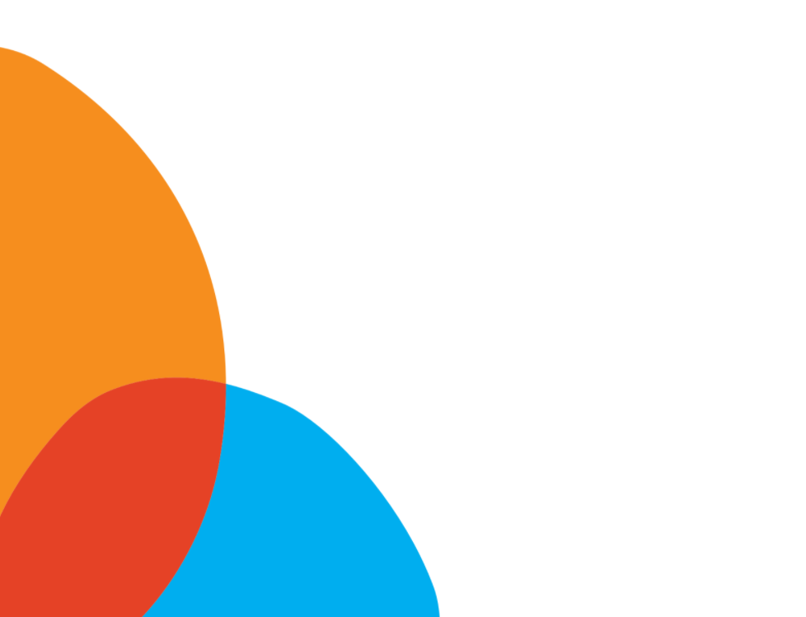
Insights, ideas, and solutions from young people with disability
The outcomes of the inaugural National Youth Disability Summit
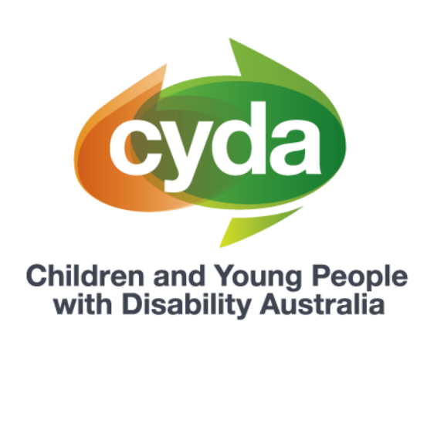
Presented by Children and Young People with Disability Australia (CYDA)
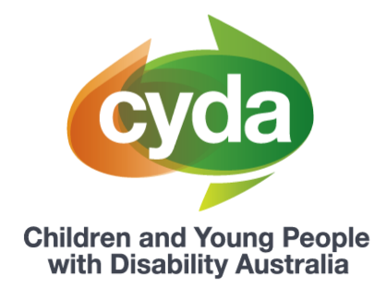

About Children and Young People with Disability Australia

Children and Young People with Disability Australia (CYDA) is the national representative organisation for children and young people with disability aged 0 to 25 years. CYDA has an extensive national membership of more than 5,000 young people with disability, families and caregivers of children with disability, and advocacy and community organisations.
Our vision is that children and young people with disability are valued and living empowered lives with equality of opportunity; and our purpose is to ensure governments, communities, and families, are empowering children and young people with disability to fully exercise their rights and aspirations.

Background to the National Youth Disability Summit

At the end of September 2020, the inaugural National Youth Disability Summit (‘the Summit’) took place. The Summit was established with the vision to create an inclusive environment where young people with disability from across Australia could come together as a community and use their voices to shape the future.
The Summit was designed by and for young people with lived experience of disability. Over nine months, the Co-Design Committee, consisting of 20 young people with disability from across Australia, designed the vision, content and delivery of the Summit.
Hosted over five days, the Summit was an entirely online conference that offered young people a range of sessions and workshops, the opportunity to meet other young people, share their ideas, insights and expertise, and develop new skills and knowledge. Over 250 young people attended, with four of the five days being ‘youth only’.
Each day of the Summit had a focussed topic, as chosen by the Co-Design Committee. The topics were:
- Education
- Employment
- Mental Health and Wellbeing
- The NDIS and Housing
- Awareness, Access and Inclusion.
This paper will focus on the findings that came out of the Mental Health and Wellbeing day. Four different papers have been released to reflect the respective learnings from the other days.
The National Youth Disability Summit was presented by CYDA and funded by the National Disability Insurance Agency, with support from the Department of Social Services and Equity Trustees.
Background on mental health and wellbeing, and young people with disability

Our wellbeing is inextricably linked to the opportunities we have to connect with our communities, friends and families, opportunities to access supports when we need them and to lead fulfilling lives. Mental health and wellbeing looks different for each person, and so do mental health care needs.
Physical, structural and social barriers to education, employment and community life also, often concurrently, impact mental health and wellbeing. Choice, and the opportunity to make choices about our lives, significantly impacts our wellbeing as does the absence of decision-making power. Wellbeing is linked to all domains of our lives, and our inclusion in society.
Mental health and wellbeing is a major concern for young people with disability. Because of the increased barriers faced in education and employment settings and systems, young people with disability experience lower engagement rates and higher unemployment rates.¹ A 2019 national youth survey found that nearly half of young respondents with disability had experienced mental health problems, and one in four were concerned with suicide.2 Young people with disability were also twice as likely as their non-disabled peers to be bullied in the past 12 months, with two in five young people with disability reporting being bullied (43 per cent compared with 19 per cent).³
People’s prejudiced attitudes can impact how young people see themselves, the opportunities they have to make choices and enjoy the good things in life, and ultimately, their potential to seek wellbeing and thrive. By shifting these attitudes and setting new, more inclusive norms, society can support young people with disability to succeed.
Young people with disability’s perspective on mental health and wellbeing
CYDA has reviewed, analysed, and collated the young participants’ ideas into five key themes that emerged throughout the Summit week. These five themes are: Identity, Enablers, Barriers, Solutions and Social Movement.
Key theme | Theme description
Identity | How do young people with disability define themselves
Enablers | The factors that enable or support young people with disability to live the lives they would like to live
Barriers | The factors that inhibit or prevent young people with disability to live the lives they would like to live
Solutions | Practical solutions for organisations, government, and the community to promote the autonomy, independence, and power of young people with disability
Social Movement | How organisations, government, and the community can contribute to the greater social movement young people with disability want to see in the world
Here’s what young people said:

Identity

Across sessions on the Mental Health and Wellbeing day participants discussed the ways in which disability identity impacts mental health and wellbeing. Some young people shared that the way society responds to their identity has a negative impact on their mental health, and described structural and systemic barriers faced in accessing support. Young people also shared the significance of intersectionality and how “different marginalisations can obviously impact a person’s experiences differently and therefore that may impact their mental health differently as well”.
“Mental health is a very important part of disability…But the kind of support that you are able to access is influenced by your age, your gender, your sexuality, your race, where you’re coming from, the kind of socio-economic background you’re from.”
“I also think it is important to understand that I am multiply marginalised in terms of being a queer person with disability. But I also acknowledge that I am – I experience a lot of privilege as well in terms of financial privilege, white privilege and also identifying as cis-gender. And I think all of those things are really important when talking about mental health.”

Young people highlighted how engaging in work, hobbies and activities they enjoy has a positive effect on their mental health and identity. Many young people described being involved with sport and creative arts as having a positive influence on their mental health.

“I think it’s important, like I said before, to understand what’s feeding into your mental health in a negative way but then also what’s feeding into it in a positive way. And if you identify those factors then you can make conscious choices around spending more time on the positive things when the negative things are building up. So that’s probably my biggest tip: to understand what is influencing your mental health and spend more time on the positive.”

“Through engaging with sport, I wasn’t just a person with special needs. I was needed. I had a role to play on the team”

A prominent theme that emerged during the Summit was the amount of choice young people have in their lives, and how this impacts young people’s wellbeing. Young people described having choice, such as “having autonomy over how I dress, how I cut my hair, how I present myself to the world”, as being part of a good life. Young people also highlighted the importance of choice when maintaining and treating their mental health.

“It feels satisfying because you know the choices that are happening are the ones you made, so there is a lot of contentment that comes with that”

Choice looks like…“the types of therapies I do, as well as how much I was to participate in them and what I want to focus on”

“Getting treated like an adult. People coming to talk to me about my own life rather than speaking directly to my parents, rather than to me”

Enablers

Young people who attended the Summit shared their insights on what helps them make choices that are important to them and supports their wellbeing. The responses were widespread and highlighted the importance of practical and tangible support and opportunities, as well as emotional and social support. Young people shared that the people in their lives helped provide both types of support.

For many, it was their families and friends who supported their wellbeing and ability to make choices. Others also mentioned the positive impact that paid support, clinicians, and organisations had had on their lives.
“Having people around you that respect your right to make you choices, even if they don’t like your choice, they’ll respect you because it’s your own choice and your own life. So I think people have a really big impact, especially if they have any power.”
“Having access [to people] outside of my family. Previously, I’ve relied heavily on my mum to help me make decisions … but I think it’s been really good having people that I can chat about stuff with outside of my family.”
More specifically, young people value when the people in their lives, including services and practitioners, actively listen to their wants and needs. As explained by one young person, “when [people] listen to you, it opens up a whole new world where you get to … become a better version of yourself. The dialogue can start a conversation that can change your life.”
Another common theme that emerged was how choice, and the opportunity to make choices, impacts young people’s wellbeing.
“Choice is giving people dignity. Being able to have choices about your own life, like where you’re living − that’s dignified. Having that taken away from you, it doesn’t feel great − it sort of feeds into self-worth and how you see yourself. So, for me, choice is dignity in my life.”
“Being able to make choices is a huge part of taking control of our lives and just being who we want to be and not what society has pushed us into the corner as.”
“For me, [having choices] kind of just feels like independence … reclaiming choices that abled people don’t think we can make. It’s setting our own benchmark.”
As a determinant to having choice, young people also highlighted the importance of information. Reflecting on their own experiences, one young person added “If I had that information when I was 15, for example, how different it would have been for me in a lot of different situations. So yeah, information is huge.”

Barriers

Young people at the Summit also discussed what negatively impacted their ability to make choices, and ultimately, their wellbeing.
While the people in their lives can be an important support, young people wholly agreed that other people’s attitudes and actions can also be one of the biggest barriers in getting what they want in life.

“Ableism and societal constructs and the fact that everyone with disability is thrown into a box and [people] going, ‘No, you can’t do that, so don’t bother trying.’”
“One of the barriers I faced growing up was having therapists, or teachers, or whoever they were, thinking they knew what was best for me and making decisions for me thinking it’s the best route, where it’s like, ‘Hang on, don’t I get a say in this? Don’t I get to know what’s best for my life?’”
“[I]f we’re seen as meeting a milestone that abled people meet, we’re seen as an inspiration and I’m like, “No, no. I just have to work a bit harder and I’m doing what I want to.’ I’m not finding the cure for cancer or anything, I’m doing nothing that is special.”

Young people also added that the perceptions of others also can impact how they their mental health and how they view themselves.
“[It’s] infantilising people with disability. If we have choices in our lives and have the opportunities to make choices for ourselves, it helps not only other people see us as fully functioning adults, but it helps us see ourselves in that way too. That’s so important.”
“So for me, the main that relate to my experience of disability that impact me negatively really are to do with ableism. … So obviously there are other things that can impact me negatively but I think really most of the things that have a long term effect on my mental health could be brought back to ableism as the key driver.”
One young person also added that while it is important for their wellbeing to have choices and make decisions, it does not mean that they want to make every decision alone.
“Because I think I can be quite capable to make decisions in some instances, friends, therapists and professionals can assume I’m always good at making decisions independently and don’t always need support, particularly around easy decisions. … and because I’m not very good at communicating, or say, ‘Sorry, I’m actually having difficulties answering this’, I just leave it. That’s a big barrier for me in making decisions.”

Solutions
Young participants who attended the Summit emphasised the need for a mental health system that is accessible and empowers them to makes choices, in their mental health treatments and in their lives overall. This includes options for therapies and wellbeing activities that that are accessible and person-centred.
“There needs to be a specific inpatient beds in these units. That can be accessed by people like myself with the appropriate help”
‘’To access therapy for mental health, therapy needs to be accessible to our disability. We need to be understood.’’
Some young people described the benefit of accessing therapists with lived experience of disability who understand the impacts of disability on mental health.
“Imagine a psychologist who gets it because they are disabled too. I never thought it was possible before but why not? I mean, disabled people can do anything. And that would really have benefitted me knowing that someone else knows how tough it can be navigating an ableist world. Not because they just read it in a book but because they have lived it.”
‘’I think choices on what I get to do each day and not being forced to do certain things that someone else has made me do. … Choices to go to health practitioners that I feel comfortable with, not just necessarily ‘oh, they’re the best, so you have to go to them’.”
Meaningful and positive representation of young people with disability was highlighted as a pathway towards increased wellbeing. The importance of seeing people with disability represented in all walks of life, across society was viewed by Summit participants as essential to combating internalised ableism.⁴ Young people highlighted the positive impact roles models have on their mental health, and their desire to be role models themselves.
“So I think if we can continue to create more meaningful and positive representation for people with disability, the perceptions of us will begin to change for the better as well...So It’s sort of like, I guess, like a snowball effect. I feel that representation can be that really important, first kind of leap in terms of making positive change.’’

“I really had a lot of ableism in myself and thought about myself very negatively. It wasn’t until I found other disabled people on Instagram and TikTok who were living their best life…being themselves proudly, that I thought “I guess that’s an option for me”. I didn’t know any other disabled people who were… doing well and successful I guess.”

Social Movement

Young people who attended the Summit emphasised access to mental health supports is a human right. They viewed accessible and inclusive mental health care as essential to social movements towards disability rights.
Young people championed the need for greater collaboration within the disability and mental health sectors. They expressed that there is a need for organisations, governments and services to create more spaces for young people with disability to advocate and lead the way towards a more inclusive mental health care system.
“We all have the rights to access therapeutic support for our mental health and that to be accessible to us, our Autism or our other disability. It’s not our difference that is the disability but our environment and the approach not being accessible to us. That’s disabling.‘’
“So mental health is a crisis that we are all dealing with at the moment. And because we can’t see it and because we are dealing with physical health crises it’s something that no one is talking about. And I know a lot of you are listening in from isolated backgrounds. You’re feeling alone or you’ve not seen your friends in a while. And so mental health is a conversation that is very important to be having. And I’m very glad to be here.’’
Addressing power imbalances that currently exist between young people with disability and non-disabled people (particularly those who are in position of power), was understood by participants to be fundamental in moving toward more accessible and inclusive mental health care. Young people highlighted that many inaccessible mental health supports need to be redesigned with young people with disability.

“And also the fact that generally it’s non-disabled people who have the power to create these things [accessible events and spaces]. People with disability, I guess, still because of systemic ableism aren’t being employed in those roles to create enough change to have that big impact. Yet!”

Where to from here?

Young people with disability are entitled to accessible mental health supports, and to make choices about their care and their lives. As CYDA heard from young people who attended the Summit, this is not the current reality – and it is largely because of the attitudes and barriers constructed by others.

In line with the ideas, solutions and insights of participants, CYDA values the importance of creating opportunities for meaningful, positive representation of young people with disability across society. When role models with disability from all walks of life and in positions of power are elevated, the perception of young people with disability will change; both societally and internally.

Mental health care and wellbeing services should also review if their services and therapies are accessible –and then amend if necessary. This also includes proactively speaking about accessibility with young people who engage with their services to remove the burden of them needing to constantly follow up when information is ambiguous or non-existent. In-patient and acute care facilities must ensure they are equipped to support young people with disability.

CYDA also supports the calls of young people who attended the Summit for services and practitioners to meaningfully include young people with disability in the design, implementation and evaluation of policies, programs, and delivery methods. In 2014, CYDA released Strengthening Participation of Children and Young People with Disability in Advocacy, a paper that outlines prerequisites and methods to ensure this type of work is done in a way that is safe and genuine.

Young people want to drive change in the systems they interact with, to ensure they are genuinely accessible and inclusive. Young people need to be provided with authentic opportunities to influence service design and delivery to ensure services meet their needs.

Calls to action

Governments:
- Invest in community interventions, including media portrayal, that target misinformed and discriminatory attitudes and beliefs held about people with disability.

Calls to action

Governments:
- Invest in young people’s skills development and provide platforms across government levels where they can be heard and enact change.
- Invest in in-patient and acute care settings which can adequately support young people with disability.

Services and Organisations:
- Review and amend service design and delivery to ensure service accessibility. If unsure, reach out to youth and disability representative and advocacy organisations for guidance.
- Increase diverse, meaningful representation of people with disability across sectors.
- Provide authentic opportunities for young people with disability to enact systems change through co-design of service design and delivery.

To learn more about what young people said at the Summit and this work, please feel free to contact CYDA’s Youth Action Team at YouthActionTeam@cyda.org.au or on (03) 9417 1025.

Footnotes

10.9 per cent of young people aged 15 to 24 have left school before the age of 16 compared to 3.6 per cent of young people without disability; AIHW. (2020). People with disability in Australia. Available at https://www.aihw.gov.au/reports/disability/people-with-disability-in-australia/contents/education-and-skills/educational-attainment

² Mission Australia. (2019). Young, willing and able: Youth Survey Disability Report 2019. Available at https://www.missionaustralia.com.au/publications/youth-survey/1610-young-willing-and-able-youth-survey-disability-report-2019/file

³ Ibid.

⁴ Ableism refers to the discriminatory perspective that able-bodied persons are viewed as ‘normal’ or superior. Internalized ableism refers to a person’s self-image or understanding of disability as a concept characterised by internalisation of the ideas and prejudices of society that see disability as 'other', as something undesirable.

