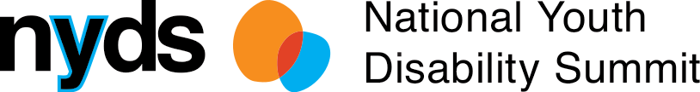

What young people with

disability said:

Education

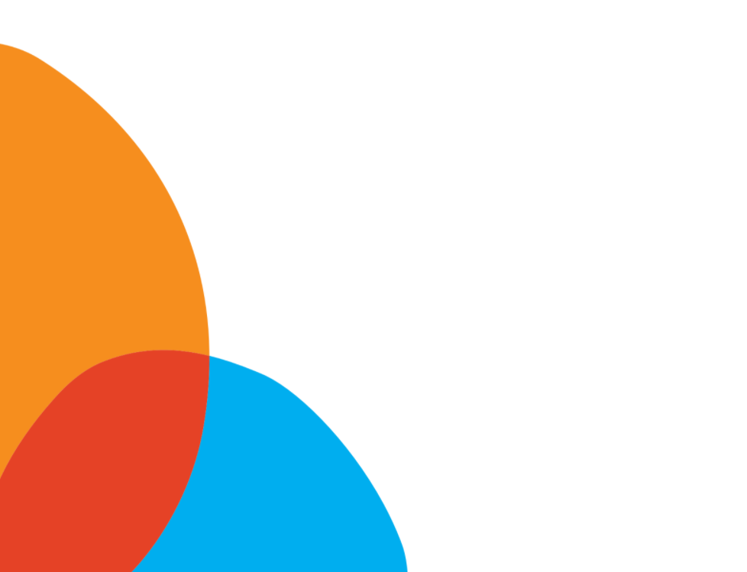
Insights, ideas, and solutions from young people with disability
The outcomes of the inaugural National Youth Disability Summit
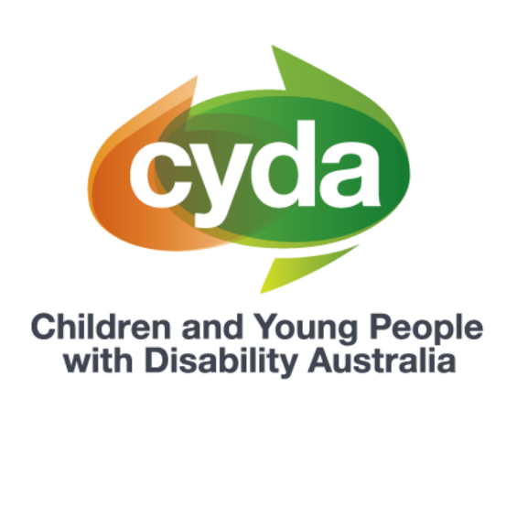
Presented by Children and Young People with Disability Australia (CYDA)
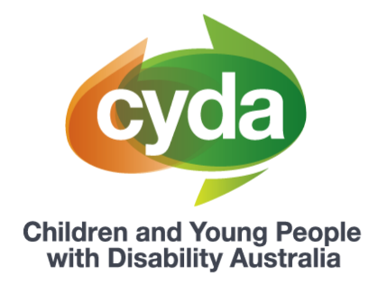

About Children and Young People with Disability Australia

Children and Young People with Disability Australia (CYDA) is the national representative organisation for children and young people with disability aged 0 to 25 years. CYDA has an extensive national membership of more than 5,000 young people with disability, families and caregivers of children with disability, and advocacy and community organisations.
Our vision is that children and young people with disability are valued and living empowered lives with equality of opportunity; and our purpose is to ensure governments, communities, and families, are empowering children and young people with disability to fully exercise their rights and aspirations.

Background to the National Youth Disability Summit

At the end of September 2020, the inaugural National Youth Disability Summit (‘the Summit’) took place. The Summit was established with the vision to create an inclusive environment where young people with disability from across Australia could come together as a community and use their voices to shape the future.
The Summit was designed by and for young people with lived experience of disability. Over nine months, the Co-Design Committee, consisting of 20 young people with disability from across Australia, designed the vision, content and delivery of the Summit.
Hosted over five days, the Summit was an entirely online conference that offered young people a range of sessions and workshops, the opportunity to meet other young people, share their ideas, insights and expertise, and develop new skills and knowledge. Over 250 young people attended, with four of the five days being ‘youth only’.
Each day had a focussed topic, as chosen by the Co-Design Committee. The topics were:
- Education
- Employment
- Mental Health and Wellbeing
- The NDIS and Housing
- Awareness, Access and Inclusion.
This paper will focus on the findings that came out of the Education day. Four different papers have been released to reflect the respective learnings from the other days.
The National Youth Disability Summit was presented by CYDA and funded by the National Disability Insurance Agency, with support from the Department of Social Services and Equity Trustees.

Background on education and young people with disability

Gaining an education is an important building block that helps set us up for life. Having a good education is linked with better employment and health outcomes in adulthood. The skills, attributes and knowledge we gain through getting a good education also supports us to be active citizens in our community.
Young people with disability do not have equal opportunity to gain an education on the same basis as their peers without disability. A 2019 national youth2 survey found that compared with those without disability, twice the proportion of respondents with disability reported that they were either dissatisfied or very dissatisfied with their studies.3 CYDA’s own national survey4 also found that approximately half of respondents disagreed or strongly disagreed that students with disability received adequate support in their education.
Because of the increased barriers faced in education settings and systems, young people with disability experience lower engagement rates. Young people with disability leave school before the age of 16 at a rate nearly three times higher than that of their counterparts.5 Students with disability are also less likely to complete year 12 or attain a tertiary education, such as a gaining a bachelor’s degree or higher.6

Young people with disability’s perspective on education
CYDA has reviewed, analysed and collated the young participants’ ideas into five key themes that emerged throughout the Summit week. These five themes are: Identity, Enablers, Barriers, Solutions and Social Movement.
Key theme | Theme description
Identity | How do young people with disability define themselves
Enablers | The factors that enable or support young people with disability to live the lives they would like to live
Barriers | The factors that inhibit or prevent young people with disability to live the lives they would like to live
Solutions | Practical solutions for organisations, government, and the community to promote the autonomy, independence and power of young people with disability
Social Movement | How organisations, government, and the community can contribute to the greater social movement young people with disability want to see in the world
Here’s what young people said:

Identity

Young participants who attended the Summit discussed the importance of identity and how education settings need to recognise and be respectful of a diverse range of identities. This includes embracing and celebrating disability and the different ways young people identify. For instance, some young people prefer to use person first language to talk about themselves (e.g. ‘person with a disability’), whereas others feel more comfortable when using self-descriptors (e.g. ‘disabled person’). One young participant commented that the “one-size-fits-all approach” does not represent people’s differences, comparing it to a “blanket thrown over people with disabilities that contains stereotypes”.

Young people also shared the significance of intersectionality and how the recognition and promotion of different identities, such as ethnicity or sexual and gender diversity, in education settings is fundamental in ensuring that all students feel safe and included.
“I felt left out. Felt different. Felt like I don’t belong. Like the default is white, abled and heterosexual. I have experienced discrimination from teachers and lecturers, such as being told that I was ‘too sick’ to be at university, and constantly being in detention at school because the system just wasn’t designed for someone like me.’’

There is a shared belief among young people that people in power should be proactive in asking students how they identify, and to “just ask if you are unsure”.
Enablers
Young participants at the Summit discussed the different factors that help them feel included and supported in education settings. One factor that was consistently highlighted across sessions was the importance of educators and education systems proactively asking young people what they need and then following through and implementing these preferences. The participants valued having “solutions on their own terms” and flexibility in their learning options.

“[Inclusive education] lets us decide what we want from our education. It will do anything in its power to achieve that. It would ask me, us, disabled young people, ‘what is it doing wrong?’, and it would listen to our answers. It would act on what we have told it. It would consider me the key stakeholder, not only in my life, but the education system overall. It would like me being viewed as somebody people can learn from.”

Some young people also added that they appreciate when educators provide different information and options that enable them to determine how they can best learn. As explained by one group member, “you can't ask for things you don't know about”.
The group also expressed the importance of the allies in their lives, such as friends or favourite teachers, who help take the “pressure off” young people in navigating an imperfect system alone. However, it was also highlighted that ideally students would not need an ‘ally’, as the whole education system would be supportive of different strengths and needs.
Barriers
One of main barriers to experiencing inclusive education that was consistently shared across sessions at the Summit was the ableist attitudes of other people. In the words of one young participant, “In the eyes of society, we are not seen as normal”. As such, young people shared that their education needs are often disregarded, ignored and/or misunderstood:
‘’It shouldn’t have to be the case that the greatest learnings in my life have come from discrimination, ableism and accessibility. But unfortunately, that is the reality of the world we live in today. With an education system that provides so inadequately for young people to get equal access to the supports we deserve and at the same time refusing to educate all, and in particular abled students and educators, on disability. It means we are forced to learn from adversity.”
A common occurrence discussed by the group was being punished for engaging in self-stimulating (or ‘stimming’) activities, such as listening to music, that allows young people to self-regulate or focus. One participant expressed their experience of getting a detention for stimming in the classroom as “very painful and hurtful”.
Young people also discussed how those in power in education settings often make assumptions about what is best for them and their education, resulting in students receiving supports that are inadequate and/or do not properly meet their needs and preferences.
I don’t think anyone, regardless of what disability they have, should be seen the same. Teachers viewed us [students with disability] all the same and it was always negative. We weren’t given the opportunity to be individuals and for people to get to know us.”

Solutions

Young participants who attended the Summit see the ‘education of educators’ as a key step toward making educations settings more inclusive and accessible for students with disability. This includes providing education to teaching, school and education staff about the experiences of young people with disability, different disability types and diverse learning needs and strengths. The group believed this education should be co-designed by those with lived experience of being a young person with disability at school, university or TAFE. There is also the belief that young people should be fairly compensated for their time and skills in co-design projects.
While some young people believe the ‘education of educators’ strategy would have positive ‘trickle-down’ effects on the attitudes and awareness of students, others think that education should also be specifically designed for and targeted at their peers without disability.
“One thing that schools can do to help, to like be educated, is understanding what different learning environments can look like, so then they know how to best be accommodate[ing]. So, for some people paying attention and concentration might look like fidgeting, drawing or listening to some music. Some students learn in ways that are not typically taught and therefore teachers assume the kids are disengaged”
“I would love disability to be more normalised and that people without disabilities got an education on how people with disability are valuable and someone they can be friends with.”
“However, if people do need to understand the lived experience of disabled people, then hire us! Pay us for our emotional labour. Don’t expect us to always educate you for free.”

Social Movement
Young people who attended the Summit championed the need for greater collaboration within the disability and education sector. They expressed that there is a need for organisations, government and schools to create more spaces for young people with disability to advocate and lead the way towards a more inclusive education system.
“Politicians don’t have lived experience of the systems they are designing. So, they don’t necessarily know the ways of enacting systems change that are going to best benefit the people that exist within the system.’’
“As a young person myself, I've been told 'no, you can't speak' or 'you're not old enough', so it's so lovely to see older people especially respect that the future is ours to take. And that our decisions and our voice is important.”

Where to from here?

In line with the ideas, insights and visions of the young people who attended the Summit, CYDA sees the need for major reform in the education system to ensure all children and young people have equal opportunity to thrive in their education. This includes providing safe and inclusive environments where students’ individual identities and learning strengths are embraced, and different learning needs are appropriately supported.

The Australian Coalition for Inclusive Education (ACIE), an initiative which brings together organisations (including CYDA) that share a commitment to advance inclusive education in Australia, has developed a 10-year plan, known as the Driving change: A roadmap for achieving inclusive education in Australia (Roadmap). The Roadmap seeks to fulfill that every child and young person is welcomed and valued as a member of their school and receives a quality inclusive education on an equal basis with others in learning environments free of discrimination

The Roadmap steps out the key levers and outcomes required to achieve inclusive education, as defined by the United Nations Convention on the Rights of Persons with Disabilities (which Australia has endorsed, but not fulfilled). To achieve this reform, the commitment and shared responsibility of the Australian and all state and territory governments is required.

CYDA also supports the calls of young people who attended the Summit for education systems and institutions to meaningfully include young people with disability in the design, implementation and evaluation of policies, programs, and curriculum content and delivery methods. In 2014, CYDA released Strengthening Participation of Children and Young People with Disability in Advocacy, a paper that outlines prerequisites and methods to ensure this type of work is done in a way that is safe and genuine.

Calls to action

Governments:
- Commit to and resource major reform of the education system to realise inclusive education
- Meaningfully engage with young people with disability and their representative organisations in the design, implementation and evaluation of education-based policies, programs, and curriculum content and delivery methods.

Educators and education institutions
- Meaningfully engage with young people with disability and their representative organisation in the design, implementation and evaluation of education-based policies, programs, and curriculum content and delivery methods.

Organisations
- Pledge your support for inclusive education on ACIE’s website.

To learn more about what young people said at the Summit and this work, please feel free to contact CYDA’s Youth Action Team at YouthActionTeam@cyda.org.au or on (03) 9417 1025.

Footnotes
¹ Cassells, R., Dockery, M., Duncan, A., Gao, G., & Seymour, R. (2017). Educate Australia fair?: education inequality in Australia, Focus on the States series, no. 5, June 2017, Bankwest Curtin Economics Centre, Curtin University, Bentley. Available at http://bcec.edu.au/publications/educate-australia-fair-education-inequality-australia/.
2 Aged between 15 and 19 years old
3 16.1 per cent compared with 6.9 per cent of participants without disability; Mission Australia. (2019). Young, willing and able: Youth Survey Disability Report 2019. Available at https://www.missionaustralia.com.au/publications/youth-survey/1610-young-willing-and-able-youth-survey-disability-report-2019/file
4 Children and Young People with Disability. (2019). Time for change: The state of play for inclusion of students with disability: Results from the 2019 CYDA National Education Survey. Available at https://www.cyda.org.au/images/pdf/time_for_change_2019_education_survey_results.pdf
5 10.9 per cent of young people aged 15 to 24 have left school before the age of 16 compared to 3.6 per cent of young people without disability; AIHW. (2020). People with disability in Australia. Available at https://www.aihw.gov.au/reports/disability/people-with-disability-in-australia/contents/education-and-skills/educational-attainment
6 ibid.

