Submission to the Disability Royal Commission: CYDA’s Summary of Recommendations 2019-2022

“My university counsellor has insisted on me taking part in a scientific research expedition off the coast despite me repeatedly telling her that my dyspraxia means that would be really dangerous for me as I cannot swim.
The insistence that ‘you can do anything if you put my mind to it’ places the ‘blame’ of inaccessibility on disabled bodies, not disabling barriers.” (Young person with disability)

Children and Young People with Disability Australia
December 2022

Authorised by:
Skye Kakoschke-Moore
Chief Executive Officer
Contact details:
Children and Young People with Disability Australia
E. skye@cyda.org.au
P. 03 9417 1025
W. www.cyda.org.au
Acknowledgements:
Children and Young People with Disability Australia would like to acknowledge the traditional custodians of the lands on which this report has been written, reviewed and produced, whose cultures and customs have nurtured and continue to nurture this land since the Dreamtime. We pay our respects to their Elders past, present and future. This is, was and always will be Aboriginal land.

Contents
Executive Summary and key recommendations 4
Introduction 5
Responsibility for enacting recommendations from the DRC 5
Recommendations linked to the Australian Disability Strategy 7
ADS outcome area 1: Employment and Financial Security 7
ADS outcome area 2: Inclusive Homes and Communities 8
ADS outcome area 3: Safety, Rights and Justice 10
ADS outcome area 4: Personal and Community Support 12
ADS outcome area 5: Education and Learning 13
ADS outcome area 6: Health and Wellbeing 16
ADS outcome area 7: Community Attitudes 18
Appendix A 20
Index of CYDA submissions to the Disability Royal Commission: 20
Appendix B 23
Roles and Responsibilities of governments 23
Endnotes 24

Executive Summary and key recommendations

As a representative organisation for children and young people with disability across Australia and a contributing member of the Disability Strategic Engagement Group for the Disability Royal Commission (DRC), Children and Young People with Disability (CYDA) is committed to facilitating the meaningful engagement of children and young people with the DRC. CYDA views the work of the DRC as critical to the vision of the Australian Disability Strategy along with fulfilling our own purpose to ensure governments, communities and families, are empowering children and young people with disability to fully exercise their rights, to highlight systemic injustices and drive reform.
As children and young people do not get the opportunity to engage in their communities, education and employment at the same level as their non-disabled peers they are at greater risk of experiencing violence, abuse, neglect and exploitation across any place or system and throughout their life course.
We, therefore, urge the DRC to focus their attention on the rights of children and young people by making bold, unambiguous and targeted recommendations to improve laws, policies, structures and practices to ensure a more inclusive and just society. CYDA’s key recommendations are noted below.
Key recommendations
- Ensure equity in education by making early childhood education and care (ECEC) the first step of an inclusive life.

To achieve this, we call on Australian governments across all jurisdictions to;
- Revise existing models and subsidies to support children with disability to enrol and attend ECEC, regardless of;
  - the setting,
  - whether they have an Early Childhood Approach/NDIS plan in place or not and;
  - the income or work status of the families.
- Lead the development of and commitment to a plan to phase out segregated education for all students and ensure each and every student with disability has access to inclusive education.
- Create equity in employment and economic participation by implementing a national comprehensive, consistent, and evidence-based approach to support young people find employment and overcome high unemployment and gain post-school qualifications
- Guarantee ongoing and sufficient funding of the NDIS to ensure equitable life opportunities and co-design a child and young person engagement framework to capture and use their voices and ensure their rights and developmental and social needs are included
- Address the developmental, social and economic scarring effects of the COVID-19 pandemic by developing and implementing a roadmap to recovery that specifically addresses the inequities faced by children and young people with disability.

Introduction

CYDA is the national representative organisation for children and young people with disability aged 0 to 25 years. CYDA has an extensive national membership of more than 5,000 young people with disability, families and caregivers of children with disability, and advocacy and community organisations.
Our vision is that children and young people with disability are valued and living empowered lives with equality of opportunity; and our purpose is to ensure governments, communities, and families, are empowering children and young people with disability to fully exercise their rights and aspirations. We do this by:
- Driving inclusion
- Creating equitable life pathways and opportunities
- Leading change in community attitudes and aspirations
- Supporting young people to take control
- Calling out discrimination, abuse, and neglect.
CYDA welcomes the opportunity to make this, our final submission to the Disability Royal Commission (DRC), which summarises CYDA’s DRC-related work during the period September 2019 to December 2022. Specifically, we provide an overview of the key recommendations derived from the 22 submissions CYDA has presented to the DRC.
Through CYDA’s work in facilitating the engagement of children and young people with the DRC, we have made an extensive list of important recommendations across 22 submissions. In the context of the evidence demonstrating the additional ways that children and young people with disability are oppressed and marginalised due to their age and legal status, and drawing on data gathered from children and young people with disability, CYDA distilled this evidence to the key recommendations noted in the executive summary.
The recommendations are drawn from data collected from several sources:
- the CYDA community of children and young people with disability (the majority focus),
- our collaboration with other Disability Representative Organisations, and
- evidence reviews of the contemporary literature academic and grey literature (such as government and technical reports, resources).
CYDA calls for the DRC to thoroughly consider the recommendations outlined in this document, in the development of the DRC’s final report. The majority of these recommendations represent the views, experiences and aspirations of children and young people with disability. As the DRC looks to the future, CYDA insists that the voices of young people with disability remain front and centre.

Responsibility for enacting recommendations from the DRC

Over the different stages of their lives, children and young people with disability are beholden to the adults in their lives to advocate for their best interests. Systemic change is necessary to ensure children and young people are granted the same opportunities as their non-disabled peers, as they transition through critical developmental and life stages.
As CYDA provides recommendations in submissions such as this, we ground our work in evidence and a human rights approach. This includes the impact of siloed and disparate policy and system settings on children and young people with disability. There are a range of international instruments that establish normative standards and principles for the treatment of children and young people with disability, including:
- The United Nations Charter on the Rights of People with Disability (CRPD)
- Convention on the Rights of the Child (CRC)
- Convention on the Elimination of all Forms of Discrimination Against Women
- International Convention on the Elimination of All Forms of Racial Discrimination
- International Covenant on Civil and Political Rights
- International Covenant on Economic, Social and Cultural Rights
- Declaration on the Rights of Indigenous Peoples
The systemic issues affecting the rights of children and young people with disability are extremely broad, spanning a large range of government portfolios and topic areas including child protection, health, education, employment, the NDIS, quality and safeguarding, to name a few. This means that children and young people’s voices need to be heard through participatory processes across a wide range of policy areas, and reform is needed to ensure all our service systems are accessible and inclusive for all our children.
As noted in the ADS, more than one level of government has some level of responsibility for a support, service or system. Appendix B lists government roles and responsibilities. The table on government roles and responsibilities that is included in this Appendix shows where:
- one level of government holds primary responsibility for the delivery of a system
- responsibilities are shared to an extent that primary responsibility for delivery cannot be assigned to one level of government
There is little opportunity and few formal structures for young people with disability and families and caregivers of young children to be involved. The machinery of government approaches to policy-making and program delivery for children and young people with disability create structural barriers meaning that governments generally have difficulty in holistically considering the needs of young people with disability and involving them in consultation and/or policy development.
CYDA calls for the DRC to ensure that any recommendations made in its final report acknowledge those complexities and also attribute actions and responsibility accordingly.

Recommendations linked to the Australian Disability Strategy

As the findings of the DRC are intended to further advance the Australian Disability Strategy as a blueprint for a more inclusive and just society, the following 27 recommendations are organised into themes, corresponding to the seven outcomes areas from Australia’s Disability Strategy (ADS) 2021–2031. Each of CYDA’s 22 submissions made to the DRC during the period September 2019 to December 2022 are categorised according to the relevant ADS outcome area as summarised in Appendix A and detailed below.

ADS outcome area 1: Employment and Financial Security

Young people with disability continue to face systemic disadvantage in the employment market. CYDA recognises that young people with disability are one of the most disadvantaged cohorts in the labour market. They experience the intersectionality of systemic disadvantage and oppression of both being a person with disability and a young person – with this disadvantage being even further amplified by other demographic factors, such as socio-economic status, ethnicity, gender or sexual diversity, or living in a regional or rural area.

In a 2020 paper released by CYDA, the organisation observed that:
“Young people with disability in the labor force are more than twice as likely to be unemployed than older adults with disability (24.7 per cent compared to 7.9 per cent). Young people with disability are also more than twice as likely to be underemployed”
This disparity is reaffirmed in a 2022 report released by the Australian Institute of Health and Welfare, which states that people aged 15–24 with disability are more than twice as likely to be unemployed (25%) as those aged 25-64 (7.9%) and are twice as likely to be unemployed as their peers without disability.
CYDA recognises that systemic underemployment is major contributor to the vulnerability young people with disability face in regard to violence, abuse, neglect and exploitation and therefore makes the following recommendations to address this.
Employment and Financial Security Recommendations
- Incentivise and support accessibility and positive hiring practices (inclusive of training) in all sectors in preparation for hiring people with disability, including promoting increased representation of disability in management and leadership.

- Incentivise employers and require public service systems to offer diverse mainstream employment pathways that allow greater support, adjustments and flexibility (such as part-time work during graduate positions).

- Develop ongoing post-school transition activities that include a focus on diversity and disability, ensuring educators, employers and policy makers adopt a human-rights and strengths-based approach.

- Address complex barriers to employment that are compounded by a fragmented disability employment service system, including ongoing reform to a service model where young people can be supported to thrive.

- Reform the Disability Support Pension to ensure fair access to a financial safety net in conjunction with improved post school education and employment.

ADS outcome area 2: Inclusive Homes and Communities

Australia’s Disability Strategy 2021-2031 states that, “People with disability are experts in their own lives and have the same rights as people without disability. Community acceptance of these rights and experiences will maximise individual power and autonomy, and support economic participation, social inclusion, safety and equality”.
Young people with disability from the CYDA community, described the barriers they face to inclusion which included overt ableism and discrimination, inherent bias and gaslighting, and outdated professional and institutional cultures, all which prevented them from accessing a range of educational, recreational, and community activities.
Furthermore, inclusive transport is a crucial enabling factor for people with disability to live full and independent lives and experience social inclusion. Systemic and institutional ableism includes both hostile and indirect discrimination and results from the failure to comply with the various laws and guidelines governing disability rights. It is also born out of internalised attitudes. Young people with disability who have participated in CYDA-hosted consultations provided multiple examples that fit this category and the quote below is one such illustration of how ableism occurs in the community.
“I go to [get] on the train and there’s nowhere I can actually strap my chair to so I’m just moving around, and that’s the supposed accessible spot for wheelchair users. And these are brand new trains.”

In order for children and young people to live in inclusive, accessible communities, CYDA makes the following recommendations.
Inclusive Homes and Communities Recommendations
- Invest in increased housing options for young people to support choice including using an intersectional approach to make decisions for themselves, suitable for their age and needs

- Fund the Nationally Inclusive Transport Advocacy Network (NITAN) to provide systemic advice regarding disability access to public transport, the Modernisation of the Transport Standards Process, and the Disability Discrimination Act as it relates to the Disability Transport Standards

ADS outcome area 3: Safety, Rights and Justice

Children and young people with disability have the same rights as people without disability and community acceptance of these rights is essential to maximising social inclusion, safety and equality. Australia’s Disability Discrimination Act 1992 (DDA) makes discrimination on the basis of disability unlawful. Despite this, people with disability continue to experience discrimination in their daily lives.
CYDA’s work highlights a range of areas where the rights and safety of children and young people are at risk, our submissions to the DRC include two areas in particular which are of concern; a) the continuation of restrictive practices and b) the poor treatment of young people in the criminal justice system as detailed below.
- Restrictive practices
As detailed in the Australian Disability Reform Council (2014) report, the eradication of restrictive practices is supported by governments across Australia:
“Reducing and eliminating the use of restrictive practices is consistent with the United Nations Convention on the Rights of Persons with Disabilities (CRPD) and its intent to protect the rights, freedoms and inherent dignity of people with disability. Australia has ratified and agreed to be bound by the terms of the CRPD under international law.”
Notwithstanding this agreement, children and young people with disability continue to face unnecessary restrictive practices in settings such as schools and other education environments.
CYDA has conducted national education surveys consistently since 2016, with specific data on restraint and seclusion also collected. Our 2020 survey respondents reported:
• 31 per cent of students with disability experienced restraint or seclusion in the last year and 11 per cent experienced both
• 21 per cent of students with disability experienced restraint in the last year, with the most common form being physical restraint, followed by psycho-social, mechanical, and chemical restraint
• 21 per cent of students with disability experienced seclusion in the last year. The settings for seclusion included solitary confinement with and without supervision in a room, classroom or staff office.
- Criminal justice system.
According to the Royal Commission into the Protection and Detention of Children in the Northern Territory;
“The youth justice system should address a young person’s reasons for offending (i.e. criminogenic needs), it should link with disability, health, education, vocational and other supports that young people need, and it should address the community’s concerns about youth offending.
Interventions will need to be delivered appropriately, reflecting the cognitive abilities and communication skills of young people, and … be gender-appropriate and respect how young people interact and communicate.”
Despite significant work having been undertaken to examine conditions and improve outcomes for children and young people in contact with criminal justice systems across Australia–including a Royal Commission, numerous reviews and inquiries, as well as strong civil society campaigns–conditions remain poor and First Nations children and young people, and children and young people with disability, continue to be over-represented in these systems.
Below is a summary of the recommendations we have made in past submissions to the DRC on the ADS outcome related theme of safety rights and justice.
Safety Rights and Justice recommendations
Restrictive practices
- Limit authorisation of restrictive practices as an absolute last resort, utilising the least restrictive practice and for the shortest period possible

- Create mechanisms for transparent monitoring and reporting on the use of restrictive practices against children and young people with disability, in all settings and across states and territories

- Invest in clear complaints pathways, including greater investigation and compliance mechanisms with access and supports for young people with disability, families/caregivers, advocates, and whistle-blowers
Criminal justice system
- Examine and dismantle the structural issues that contribute to the over-representation of children and young people with disability in these systems

- Review and amend for the impact of the current ‘age of criminal responsibility’ legislation on children and young people with disability

- Ensure all children and young people entering criminal justice systems have a full health and disability assessment, and can access NDIS supports on leaving systems, where eligible

ADS outcome area 4: Personal and Community Support

According to the Australian Disability Strategy, people with disability should be supported to live more accessible and connected lives within their communities so that they are able to fully participate in a way that is safe for them. This includes having access to a comprehensive and effective health and service system tailored to individual needs. Importantly, this requires accessibility to be an integral part of the design of services and systems to overcome barriers and help support the inclusion of people with disability in their communities.
The National Disability Insurance Scheme and other support services featured prominently in CYDA’s submissions to the DRC. The experiences of young people with disability detailed in these submissions clearly illustrates the connection between inadequate support (or difficulty meeting basic needs) and vulnerability to incidents of violence, abuse, neglect and exploitation.
“I can't access NDIS so all I have is my parents around me but I don't want to always do that. (Young person with disability)
“For me the barriers are systems such as the NDIS stop us [from embracing our identity]”. (Young person with disability)
“Something that I wanted to bring up is the "cliff" between NDIS and not having NDIS support. There's quite a threshold to get on the NDIS …. the way the NDIS is set out, not every disabled person needs the NDIS, but there are still many disabled people who might not need the NDIS but still need some support.” (Young person with disability)
While our communities remain inaccessible young people with disability will face isolation, fewer opportunities, and a poorer quality of life. Communities and service systems that embrace lived experience of disability will allow young people to thrive. To address this imbalance, we make the following recommendations.
Personal and Community Support Recommendations
- Broaden the eligibility for the NDIS to support early childhood early intervention principles as well as ensuring access to appropriate services for those who are not eligible for the NDIS

- Ensure comprehensive disability-specific training across systems ensuring a robust understanding of disability, including embedding trauma-informed practice in all mainstream and disability-specific services

- Improve enforcement of accessibility standards, the dissemination of accessibility-related information and the principles of universal design across all domains of children and young people’s lives. Central to this is the implementation of effective complaints and feedback mechanisms

ADS outcome area 5: Education and Learning
The United Nations (UN) Convention on the Rights of Persons with Disabilities (CRPD), Article 24 defines access to education (on an equal basis with peers without disability) to be fundamental in the development of all young people with disability. The Disability Standards for Education (DSE) have been in place for 17 years and the Disability Discrimination Act (DDA) since 1992. Neither the DDA, the DSE or any state or territory based polices ensure an equitable and quality education for students with disability.
Through our annual national education survey (2019 and 2020 results submitted to the DRC), CYDA observes and records that poorer outcomes remain prevalent for our young people with disability. These poor outcomes are seen to be a direct contributor to experiences of violence, abuse neglect and exploitation under investigation by the DRC.
Figure 1 CYDA’s 2022 draft education survey results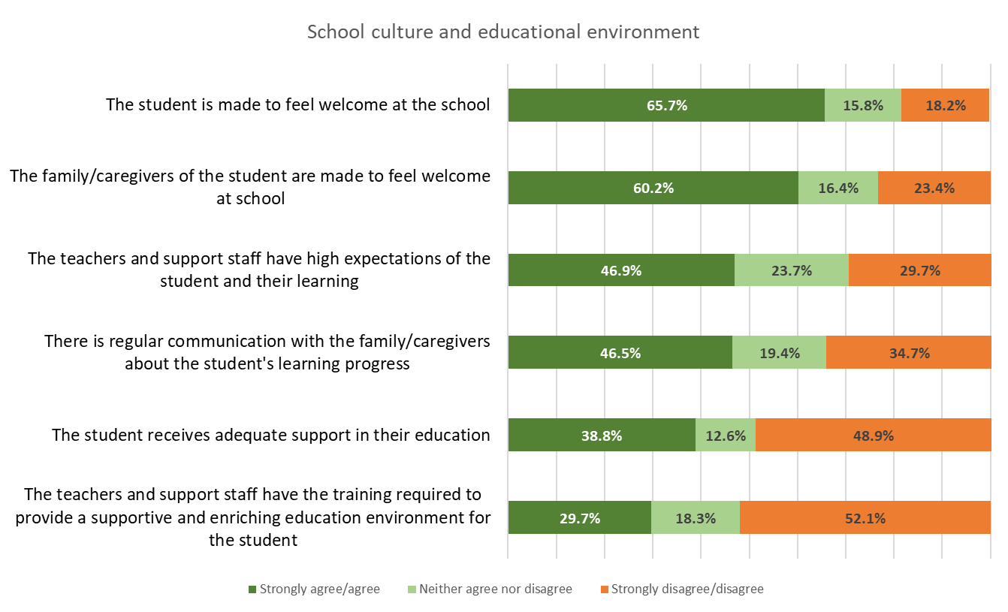
In Figure 1, CYDA’s 2022 draft education survey results (due to be released early 2023) show:
- The student is/was made to feel welcome at the school: Strongly agree/agree 65.7% Neither agree nor disagree 15.8% Strongly disagree/disagree 18.2%
- The family/caregivers of the student are/was made to feel welcome at school:
Strongly agree/agree 60.2% Neither agree nor disagree 16.4% Strongly disagree/disagree 23.4%
- The teachers and support staff have/had high expectations of the student and their learning: Strongly agree/agree 46.9% Neither agree nor disagree 23.7% Strongly disagree/disagree 29.7%
- There is/was regular communication with the family/caregivers about the student's learning progress: Strongly agree/agree 46.5% Neither agree nor disagree 19.4% Strongly disagree/disagree 34.7%
- The student receives/received adequate support in their education: Strongly agree/agree 38.8% Neither agree nor disagree 12.6% Strongly disagree/disagree 48.9%
- The teachers and support staff have the training required to provide a supportive and enriching education environment for the student: Strongly agree/agree 29.7% Neither agree nor disagree 18.3% Strongly disagree/disagree 52.1%
CYDA remains committed to improving educational outcomes for children and young people with disability, leading work in inclusive education as the chair of the Australian Coalition for Inclusive Education (ACIE).
CYDA’s previous CEO Mary Sayers provided valuable evidence during Hearing 9 and Hearing 18. Additionally, CYDA worked collaboratively with the DRC to ensure that a number of young people with disability could share their experiences of education, this sentiment is echoed in our written submissions addressing education. As education is made more inclusive and outcomes for young people with disability improve, we will see marked reduction in the incidents of violence, abuse, neglect and exploitation experienced by young people with disability, within educational settings and beyond, as outlined in the recommendations below.
Education and Learning Recommendations
- Make early childhood education and care (ECEC) the first step of an inclusive life, with revised models and subsidies to support children with disability to enrol and attend regardless of the setting, the Early Childhood Approach/NDIS plan in place and income or work status of the families

- Develop and commit to a plan to phase out segregated education and ensure each and every student with disability an inclusive education, including changes to state and territory legislation that currently supports ministerial (or equivalent) enrolment override)

- Develop a National Inclusive Education Act, proactive rather than discrimination-based legislation complemented by a national accreditation framework for inclusive education (along the lines of the National Quality Framework for Early Childhood Education)

- Develop annual public reporting on the continued investment by governments in the dual-track education system that segregates students with disability, and current specialised settings including capital and operational expenditure, student numbers, educational outcomes and post school pathways taken

- Invest in further funding for independent disability advocacy for families and young people with disability, to ensure students can have their rights to inclusive education upheld

- Introduce mandatory professional development for school staff (particularly careers teachers) in post school transition for students with disability

ADS outcome area 6: Health and Wellbeing

CYDA’s submissions to the DRC that focus on this outcome area, centre predominantly on the impact of the Covid-19 pandemic. This is unsurprising given the trajectory of the pandemic which, for the most part, parallels the timing and work of the DRC. It has been a challenging period for people with disability, and in particular for children and young people as they have experienced a higher degree of risk during the global pandemic, not because of their impairment, but because of discriminatory, limited, or inappropriate policies that have been implemented to manage infection in the community. CYDA’s policy work highlights the impact of a lack of a coherent national strategy and response to the pandemic, which has been further exacerbated by exclusion, uncertainty and distress experienced by children and young people with disability.
When asked by CYDA to describe what they were feeling and experiencing during the Omicron wave of COVID-19, young people’s responses were overwhelmingly negative, with many reporting feelings of fear, anxiety and worry. See Figure 2 for range responses, with the most frequently used descriptors represented by larger words.
Figure 2 A word cloud of young people’s responses to questions asking them to describe what they are feeling and experiencing during the Omicron wave
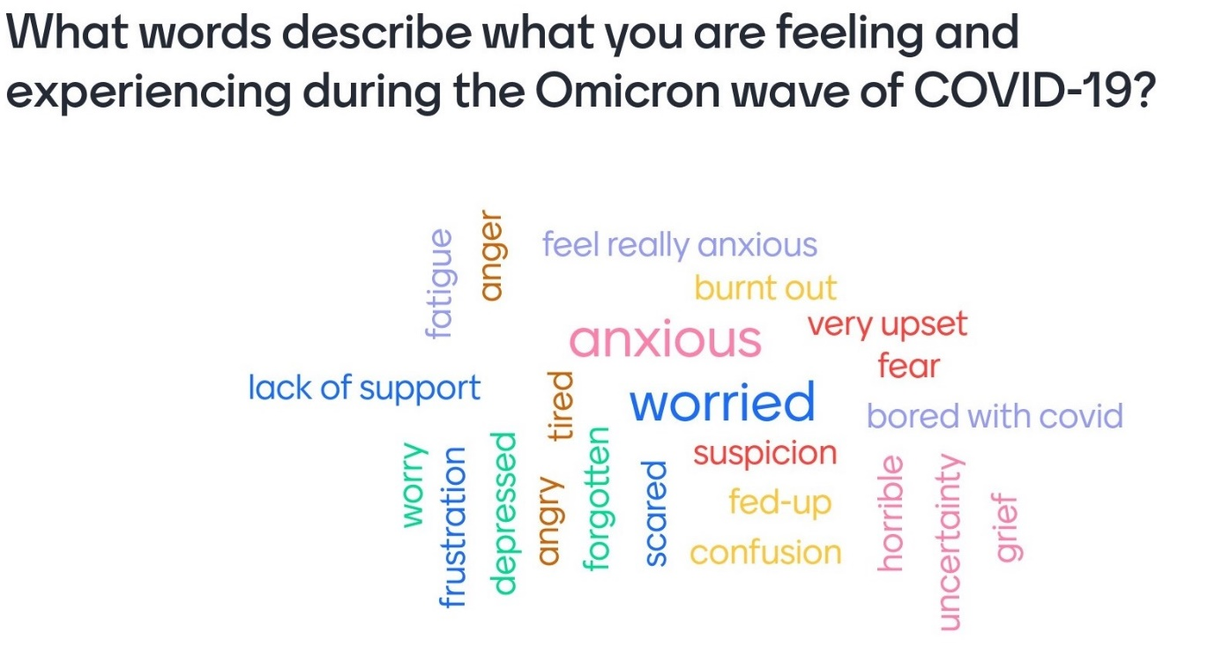
Image description: Question asks ‘What words describe what you are feeling and experienced during the Omicron wave of COVID-19?
Words shown include lack of support, fatigue, anger, feel really anxious, burnout, anxious, very upset, fear, tired, worried, bored with covid, suspicion, fed-up, confusion, worry, frustration, depressed, angry, forgotten, scared, horrible, uncertainty, grief.
Health and Wellbeing recommendations
- Centre the voices and needs of children and young people in all policy planning and COVID recovery measures. Children and young people have been more at-risk during the global pandemic, not because of their impairment, but because of discriminatory, limited, or inappropriate policy strategies

- Develop an effective COVID recovery plan driven and invested in by government in consultation with children and young people to mitigate ongoing impacts

- Ensure emergency/disaster/pandemic planning, response and recovery by government and service providers adequately includes children and young people with disability as a distinct cohort, rather than a generalised disability approach that does not consider this cohort’s distinct challenges and needs

ADS outcome area 7: Community Attitudes

CYDA works towards a community (wider Australia) that accepts, includes and celebrates disability at all levels. CYDA believes that an ideal future for young people with disability includes a community that sees them safe, fully included, respected and valued. Our community should facilitate strong connections and celebrate their talents.
Community Attitudes play a major role in defining the opportunities available to and experiences of young people with disability. Education, visibility, and prominent representation are key mechanisms by which attitudes can be improved. CYDA maintains that young people should be at the centre of policy discussions and seeks to amplify their voices when understanding what needs to change.
When asked about what community attitudes mean to them, young people cogently described it as follows.
“We need to be able to access society.” (Young person with disability)
“Just keep supporting people [and] listen.” (Young person with disability)

CYDA understands that young people with connections to their community experience far greater safety, opportunity, and quality of life than those without. In this regard, our community plays a crucial role in mitigating violence, abuse, neglect and exploitation experienced by young people with disability.
In relation to ADS Outcome #7 CYDA engaged in a body of lived-experience focused work that highlights youth lead solutions. These include CYDA’s recent submissions on the Vision for an Inclusive Society and on Disability Pride (See Appendix A). Below is an exemplar of young people’s reflections on the role of their community:
“You're asking disabled people to break down a large complexity about community attitudes, I think ultimately it's so hard for us to do because it's a continual process of validating and invalidating our existence because so much of our lives are decided by external voices to the point that it is not just our access needs or our quality of life, it comes down to even our identity as disabled people, which is completely destructive to community attitudes within the disabled community because it means we're not even able to have our own community growth if external voices are always monitoring it.” (Young person with disability)
Community Attitudes Recommendations
- Fund, promote and support more awareness campaigns and disability led research. This includes taking steps to encourage people with lived experience to take part in and lead/conduct research.

- Implement policies and programs that normalise positive, strength-based language around disability. This should include funding more inclusive events (talks, festivals, interactive activities) with universal design as the bedrock.

- Support the ongoing development and funding of programs that address broader community attitudes with the goal of supporting people with disability to become community and political leaders and role-models. This should increase the visibility of disabled experiences more generally as well as in leadership and decision making roles.

- Promote increased awareness of the social model of disability. This should occur alongside more consistent implementation of the Convention on the Rights of People with Disability.

Appendix A

Index of CYDA submissions to the Disability Royal Commission:
September 2019-December 2022
Each submission is themed according to relevant outcomes areas from Australia’s Disability Strategy (ADS) 2021–2031

# | Date | Title | ADS outcome area
 | September 2019 | Draft Accessibility Strategy of the Royal Commission into Violence Abuse Neglect and Exploitation | N/A
 | October 2019 | Disability Royal Commission – Education of children and young people with disability | ADS 5 – Education and learning
 | May 2020 | Emergency Planning and Response during COVID-19 | ADS 6 – Health and well-being
 | May 2020 | Response to Criminal Justice Systems issues paper | ADS 3- Safety, rights and justice
 | October 2020 | Disability Royal Commission response to Restrictive Practices Issues Paper | ADS 3- Safety, rights and justice  ADS 5 – Education and learning
 | October 2020 | Disability Royal Commission response to Rights and Attitudes Issues Paper | ADS 7 – Community attitudes
 | October 2020 | Disability Royal Commission response to Employment Issues Paper | ADS 1- Employment and financial security
 | February 2021 | DRC response to the Covid-19 hearing report | ADS 6 – Health and well-being  ADS 3- Safety, rights and justice
 | March 2021 | #End Segregation Campaign and Position Paper on Segregation | ADS 1- Employment and financial security  ADS 5 – Education and learning
 | June 2021 | Response to the Disability Royal Commission's Promoting Inclusion issues paper | ADS 1- employment and financial security  ADS 5 – Education and learning  ADS 7 – community attitudes
 | January 2022 | A joint submission: Institutional Neglect and the Disability Transport Standards | ADS2 – Inclusive homes and communities
 | February 2022 | Submission to the consultation of the New Disability Employment Support Model | ADS 1- employment and financial security
 | April 2022 | Clearing the Roadblocks: Promoting equitable pathways and opportunities  CYDA’s 2022 election platform | All
 | May 2022 | DRC Workbook for preparing a submission in support of your child | ADS 5 – Education and learning
 | May 2022 | CYDA’s response to the Disability Royal Commission’s issues paper: The impact of and responses to the Omicron wave of the COVID-19 pandemic for people with disability | ADS 6 – health and well-being  ADS 3- safety, rights and justice
 | August 2022 | CYDA’ response to the Disability Royal Commission’s Supported decision-making and guardianship: proposals for reform roundtable paper | ADS 3- safety, rights and justice  ADS 7 – community attitudes
 | September 2022 | Submission to the Select Committee on Work and Care’s inquiry (the Inquiry). | ADS 1- employment and financial security
 | November 2022 | Submission to the Disability Royal Commission: Targeted Engagement with young people with disability | All
 | November 2022 | Joint submission from Disability Representative Organisations Identified gaps in the scope of work undertaken by the Disability Royal Commission | All
 | December 2022 | CYDA submission to the DRC: Disability Pride | ADS 7 – community attitudes
 | December 2022 | Human Rights Charter – Joint submission | ADS 3- safety, rights and justice
 | December 2022 | Vision for Inclusive Australia:  Quest for Inclusion submission  LivedX policy paper series: What Young People Said: Inclusion and Decision Making | All  ADS 7 – community attitudes  ADS 4 – personal and community supports  ADS2 – Inclusive homes and communities

Appendix B

Roles and Responsibilities of governments
Primary responsibility for delivery lies with the Australian Government | Primary responsibility for delivery lies with state and territory governments
- NDIS (administration)  - Information, Linkages and Capacity Building (ILC)  - NDIS Quality and Safeguards Commission  - Employment services  - Income support payments  - Federal justice system  - Australian Federal Police  - Child Care Subsidy  - ECEC Inclusion Support Program  - Medicare Benefits Schedule  - General practitioners  - Pharmaceutical Benefits Scheme  - Aboriginal Community Controlled Health Organisations  - Aged Care system  - Veterans’ Care system  - Universities  - Hearing Services Program  - Commonwealth Ombudsman  - Australian Human Rights Commission | - Public, social and community housing  - Public hospitals  - Community health services  - Home and Community Care programs for under 65s  - Public transport services  - Public primary and secondary schools  - TAFE/Vocational Education and Training (VET)  - Kindergartens and pre-schools  - Jurisdictional court systems and correctional centres  - State and territory Police  - Guardianship, Public trustees and Ombudsman  - Child protection  - Community visitors programs  - Domestic and family violence services  - Major sporting facilities  - State and territory human rights/anti-discrimination bodies
Primary responsibility for delivery lies with local governments | Responsibility for delivery is substantially shared across levels of government
- Urban planning/design of the built environment  - Accessible buildings  - Local development planning  - Local roads, bikeways and footpaths  - Local parks and recreational facilities  - Local sports grounds  - Public toilets  - Playgrounds  - Council-run childcare and aged care centres  - Municipal services  - Parking regulation  - Public libraries and community halls | - NDIS (funding and shared governance)  - Mental health supports and services  - Disability advocacy services – individual and systemic  - Concessions for government services  - Community infrastructure  - Arts and cultural funding and support  - Public museums, galleries and performance facilities
Note: This listing of roles and responsibilities is not comprehensive, and some responsibilities may change over time.

Endnotes

Australia’s Disability Strategy 2021-2031
CYDA (2020), National Youth Disability Summit - What young people with disability said - Employment Position Paper, https://www.cyda.org.au/resources/details/242/national-youth-disability-summit-what-young-people-with-disability-said-employment-position-paper
Australian Institute of Health and Welfare (2022) https://www.aihw.gov.au/reports/disability/people-with-disability-in-australia/contents/employment/unemployment
Commonwealth of Australia. (2021). Available at: Australia’s Disability Strategy 2021–2031 (disabilitygateway.gov.au)
Australian Disability Strategy 2021-2031, Safety, Rights and Justice Outcome
Australian Disability Reform Council. (2014) National Framework for Reducing and Eliminating the Use of Restrictive Practices in the Disability Service Sector.
Armytage, P. & Ogloff, J. (2017) Youth Justice Review and Strategy: Meeting needs and reducing offending, Executive summary, p.11.
Royal Commission into the Protection and Detention of Children in the Northern Territory; final report provided in 2017
Australia’s Disability Strategy 2021-2031, Available at: https://www.disabilitygateway.gov.au/document/3106

