Advocacy and the NDIS

Children and Young People with Disability Australia

About this book
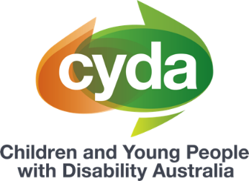 | This book is from Children and Young People with Disability Australia or CYDA.
This book has some hard words.
Hard words are in bold.
 | We tell you what hard words mean.

 | This book is about how an advocate can help you with the NDIS.
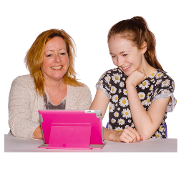 | An advocate is someone who can help you speak up.
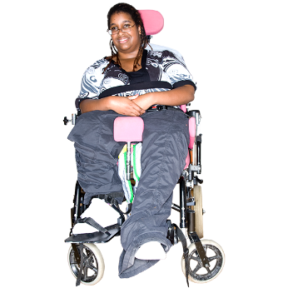 | An advocate can help you speak up if your rights are not met.

Rights are things that everyone should
- get
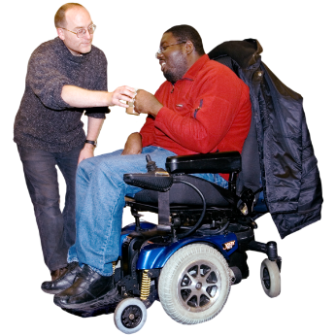 | - have
 | - do.
 | For example, all young people should be able to go to school.
An advocate can be
- a friend
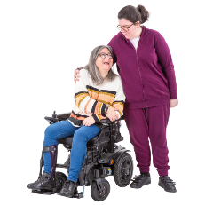 | - a family member
 | - a professional.
 | An advocate should show you respect.
Respect means an advocate should
- listen to you
 | - be kind to you
 | - not hurt you.
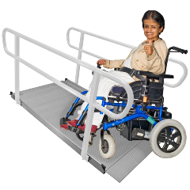 | An advocate will understand the NDIS.
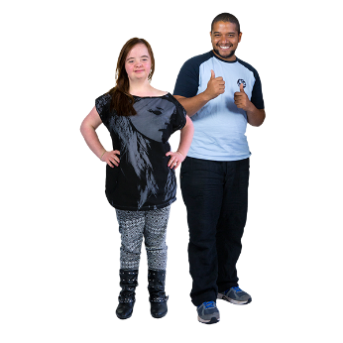 | An advocate can  - help you speak up about what you need
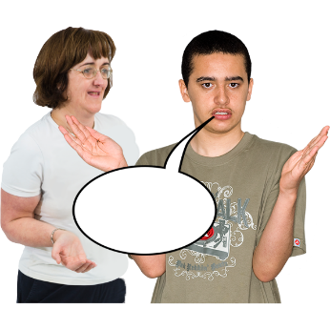 | - speak to the NDIA for you.
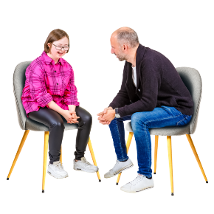 | You do not have to tell your advocate information you do not want to.

Advocacy types
Individual advocacy is when an advocate works with you.
The advocate can help you solve problems.
 | Self advocacy is when you speak up for what you want and need.
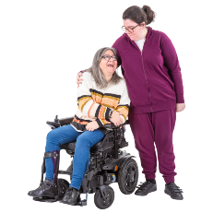 | Family advocacy is when a family member helps you speak up for what you want and need.
 | Legal advocacy is when a lawyer helps you speak up for what you want and need.

How an advocate can help
 | An advocate can help you appeal what the NDIA decides.
 | Appeal means you
 | - give the NDIA more information
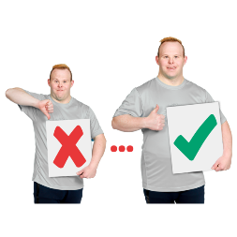 | - ask the NDIA to change your plan.
 | An advocate can also help you get ready for a plan review.
 | A plan review is when the NDIA looks at your disability supports.

The NDIA might say you can have
- more support

- the same support
- less support

How to get an advocate
You can contact some organisations to get
an advocate.
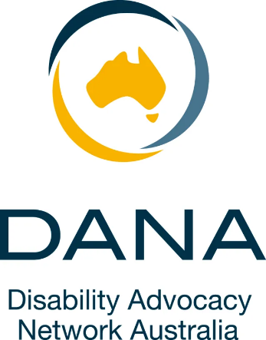 | For example, you can contact  - Disability Advocacy Network Australia
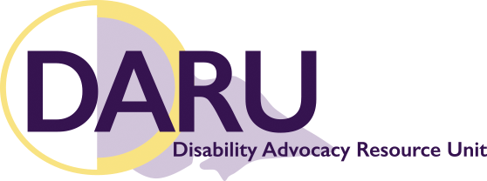 | - Disability Advocacy Resource Unit  or DARU
 | You will need to tell the organisation about the problem you need help with.

More information
For more information you can
contact CYDA.
Call 03 9417 1025
Website cyda.org.au
Email info@cyda.org.au
You can contact Lifeline if you are feeling upset and need someone to talk to.
Call 13 11 14

Text 0477 13 11 14

You can read the full document ‘Navigating Advocacy’ on our website. CYDA’s In Control My Way resources have been created to support families of children and young people with disability to help manage their NDIS plans. Information provided is intended as a general guide and may not contain the most recent information and updates. CYDA is not responsible for decisions made by the NDIA or its partners in the community. For the most current information on the NDIS, refer to the NDIS website. These fact sheets are current as of June 2023.
Pictures by Photosymbols.

