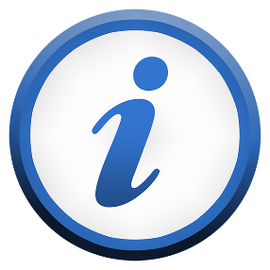
How to find the right NDIS information

Children and Young People with Disability Australia

About this book
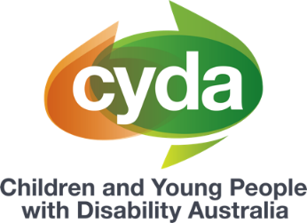 | This book is from Children and Young People with Disability Australia or CYDA.
This book has some hard words.
Hard words are in bold.
 | We tell you what hard words mean.
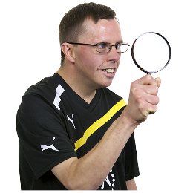 | This book is about how to find the right information about the NDIS.
 | You can get information about the NDIS from many places.
 | For example, you might
 | - go to the NDIS website
 | - ask family or friends for help.
You might also get information about the
NDIS from
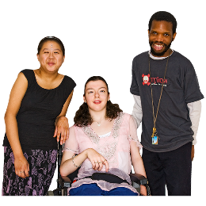 | - other people with disability
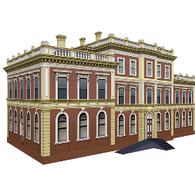 | - disability organisations.
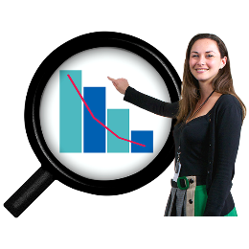 | You should try to find organisations that know about your disability.

What information can I find out?
 | You can find out
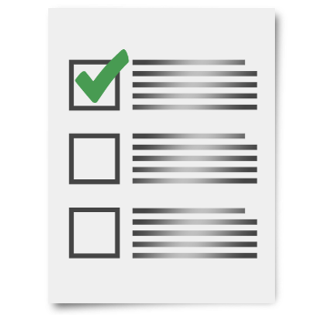 | - about the NDIS
 | - if you can get NDIS support
 | - who can help you understand the NDIS.

 | You can also find out
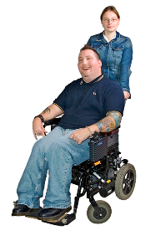 | - how the NDIS can help you
- what to do if you have a problem
with NDIS.

More information
For more information you can
contact CYDA.
Call 03 9417 1025
Website cyda.org.au
Email info@cyda.org.au

You can read the full document ‘The right information for NDIS’ on our website. CYDA’s In Control My Way resources have been created to support families of children and young people with disability to help manage their NDIS plans. Information provided is intended as a general guide and may not contain the most recent information and updates. CYDA is not responsible for decisions made by the NDIA or its partners in the community. For the most current information on the NDIS, refer to the NDIS website. These fact sheets are current as of June 2023.
Pictures by Photosymbols.

