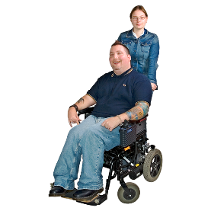
How to work with service providers

Children and Young People with Disability Australia

About this book
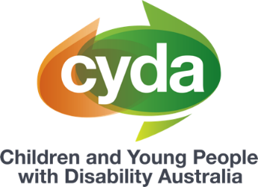 | This book is from Children and Young People with Disability Australia or CYDA.
This book has some hard words.
Hard words are in bold.
 | We tell you what hard words mean.
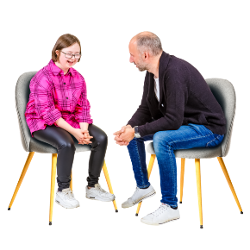 | This book is about how you can work with NDIS service providers.
 | Service providers can be
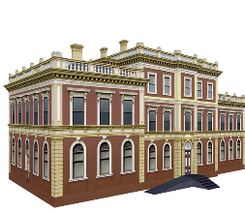 | - a business or organisation
 | - a person.
Service providers can give you
different support.
 | For example, a service provider might help clean your house.

How to choose a service provider
You can find information about service providers in each state at the NDIS provider finder.
Website
Provider finder | NDIS

Before you choose a service provider,
think about
- how much the service will cost
- if you need the service
- if the service will help you reach
your goals.
You can communicate with your service provider in a way that works for you.
For example, you might
- email
- meet in person
- text.
You might also
- call
- video chat.

What to do if something goes wrong
 | You can speak up if you are not happy with your service provider.
 | For example, if your service provider
 | - says you have to pay too much
 | - does not show you respect.
 | Respect means your service provider should
 | - listen to you
 | - be kind to you
 | - not hurt you.
 | You can talk to your service provider.
 | You can talk to
 | - your friends
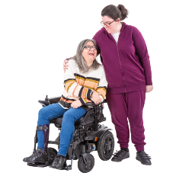 | - your family.
You can talk to your Local Area Coordinator
or LAC.
You can contact the NDIS Quality and Safeguards Commission or the Commission.
The Commission helps NDIS participants when there is a problem with NDIS supports.
 | Call 1800 035 544
 | Email contactcentre@ndiscommission.gov.au

More information
For more information you can
contact CYDA.
Call 03 9417 1025
Website cyda.org.au
Email info@cyda.org.au
If you feel upset and need to talk to someone you can contact Lifeline.
Call 13 11 14
Text 0477 13 11 14

You can read the full document ‘Navigating Advocacy’ on our website. CYDA’s In Control My Way resources have been created to support families of children and young people with disability to help manage their NDIS plans. Information provided is intended as a general guide and may not contain the most recent information and updates. CYDA is not responsible for decisions made by the NDIA or its partners in the community. For the most current information on the NDIS, refer to the NDIS website. These fact sheets are current as of June 2023.
Pictures by Photosymbols.

