Information about you for the NDIS

Children and Young People with Disability Australia

About this book
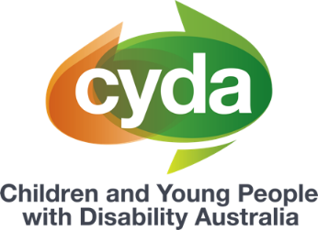 | This book is from Children and Young People with Disability Australia or CYDA.
This book has some hard words.
Hard words are in bold.
 | We tell you what they mean.
This book is for you to tell
the NDIS about you.
 | You can write or type your answers to the questions in this book.
You can ask someone to help you fill in
this book.
You can bring this book to your NDIS
planning meeting.

Questions about you
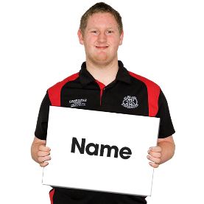 | What is your name?
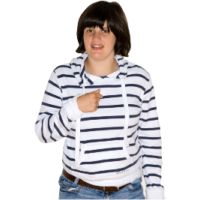 | What do you like people to call you?  You might like people to call you by your name or something else.
What are your pronouns?
Pronouns are words people use to talk
about you.
Pronouns can be
- she or her
- he or him
- they or them

How do you like to communicate?
 | You can choose more than 1.
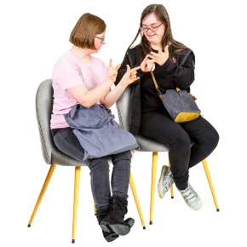 | - Auslan
 | - in person
 | - phone
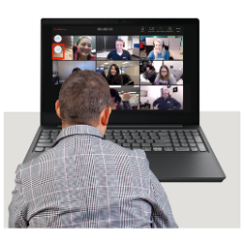 | - Zoom
 | - text or email
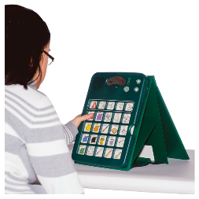 | - communication boards.

Questions about your life
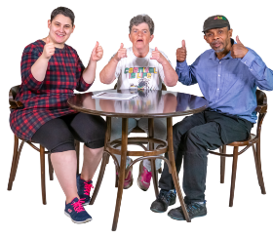 | What are you good at?
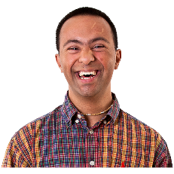 | What do you like to do?
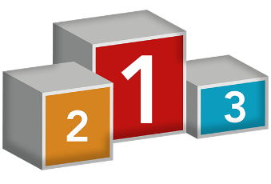 | What is important to you?
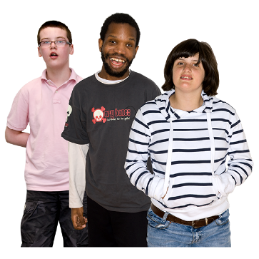 | Who are the people who support you?
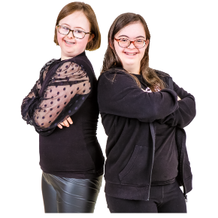 | What do you want to do more?  For example, you might want to see friends every day.
What are your goals for 1 year?
Goals are things you want to happen.
For example, you might want to get a job.
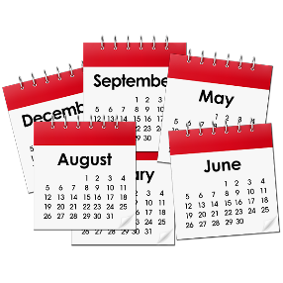 | What are your goals for 5 years?
What support do you need to achieve
your goals?

More information
For more information you can
contact CYDA.
Call 03 9417 1025
Website cyda.org.au
Email info@cyda.org.au

You can read the full document ‘Navigating Advocacy’ on our website. CYDA’s In Control My Way resources have been created to support families of children and young people with disability to help manage their NDIS plans. Information provided is intended as a general guide and may not contain the most recent information and updates. CYDA is not responsible for decisions made by the NDIA or its partners in the community. For the most current information on the NDIS, refer to the NDIS website. These fact sheets are current as of June 2023.
Pictures by Photosymbols.

