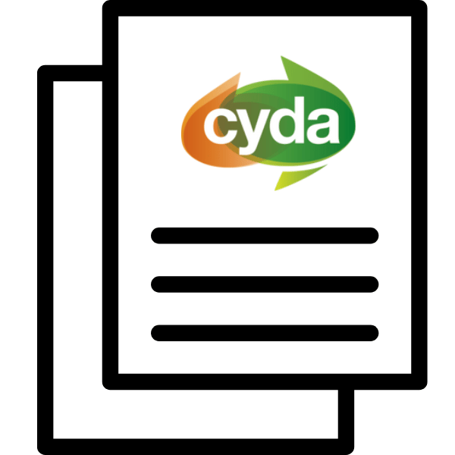

Annual report

2023 to 2024

Children and Young People with
Disability Australia

About this book
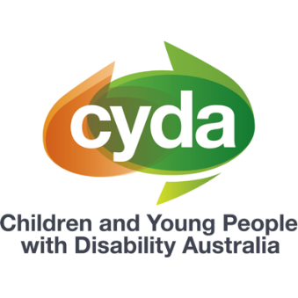 | This book is from CYDA.
 | CYDA stands for Children and Young People with Disability.
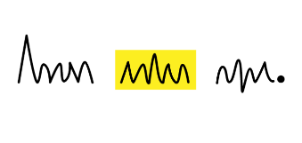 | This book has some hard words.
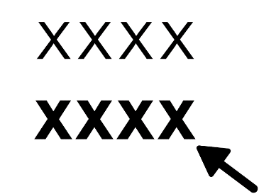 | The hard words are bold.
 | We tell you what hard words mean.
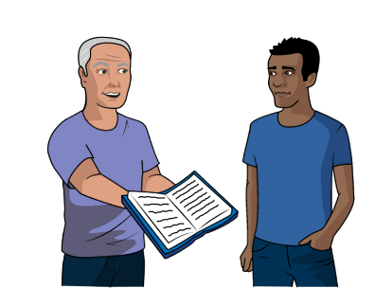 | You can ask someone to help you read  this book.
 | This book is about our annual report.
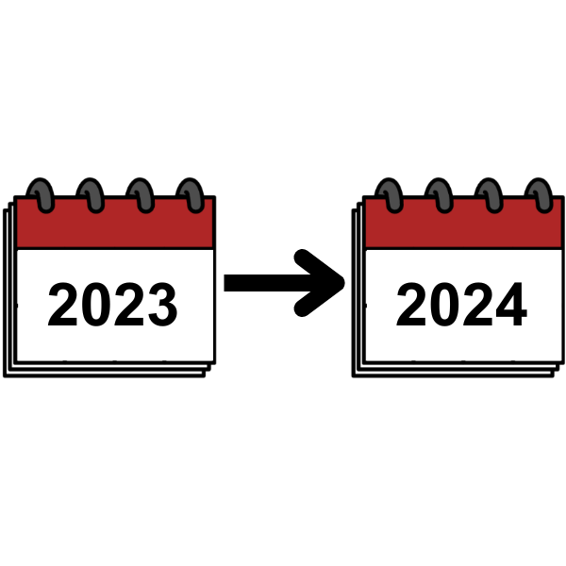 | Our annual report says what we did in 2023 and 2024.
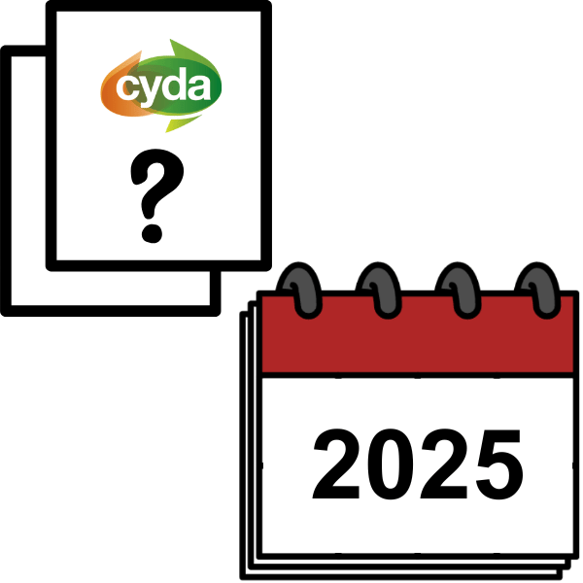 | Our annual report also says our plans for 2025.
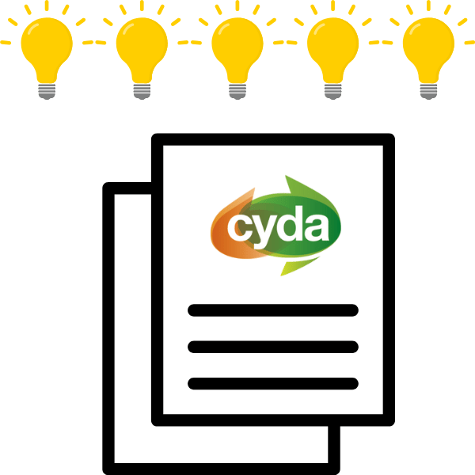 | Our annual report has 5 areas.

We made the report on First Nations land
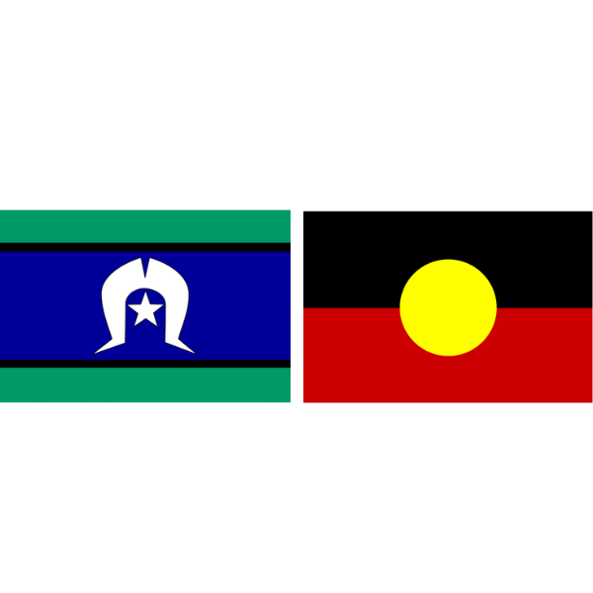 | First Nations people were in Australia first.
 | First Nations people are
 | - Aboriginal
 | - Torres Strait Islander.

How we support the world to be inclusive
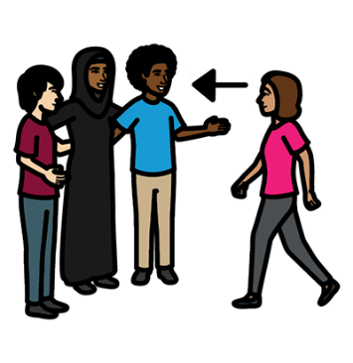 | Inclusive means everyone can be part  of something.
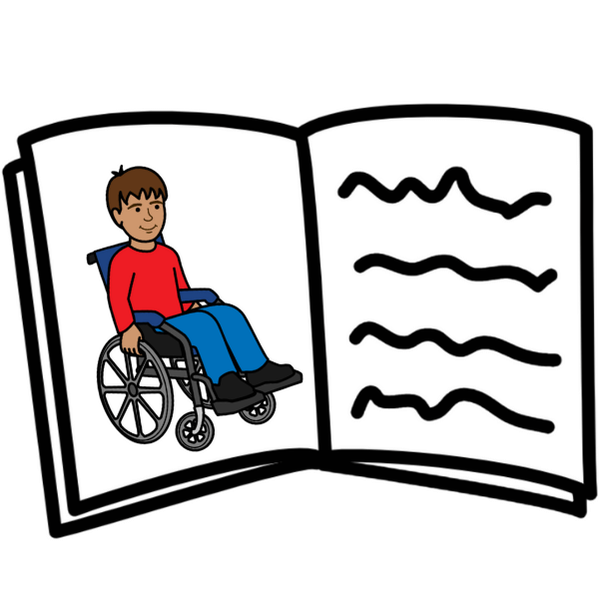 | For example, books should have  disabled characters.
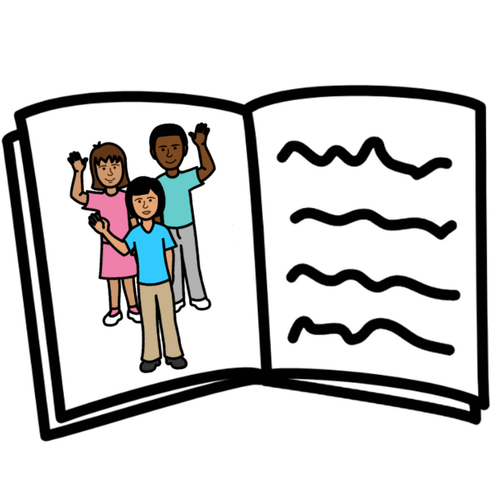 | Characters are people in books.

 | We asked disabled young people to tell us
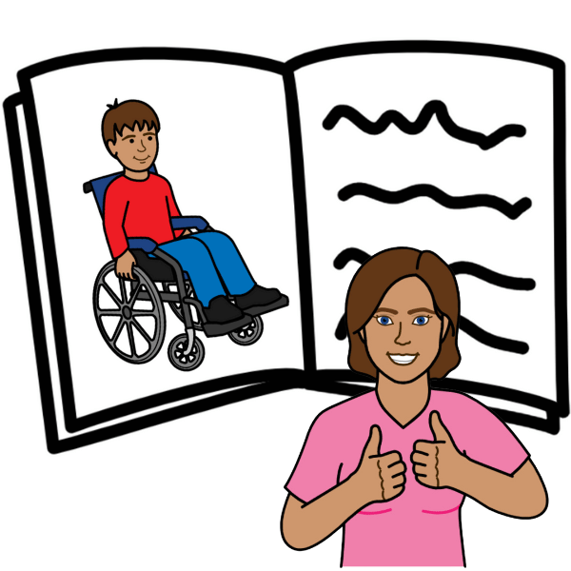 | - what is good about books with  disabled characters
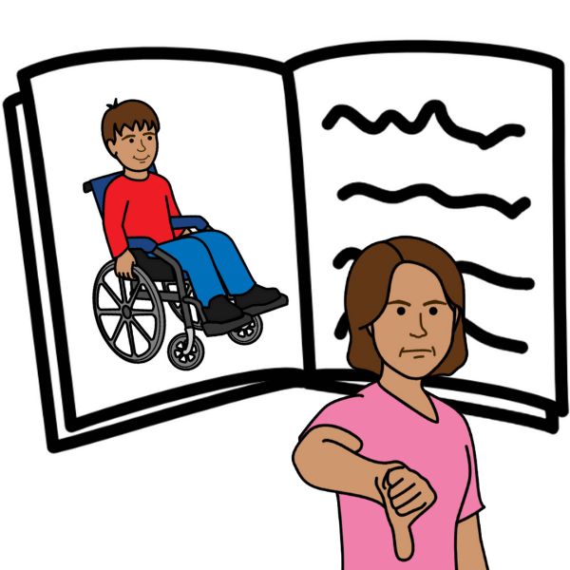 | - what is bad about books with  disabled characters.
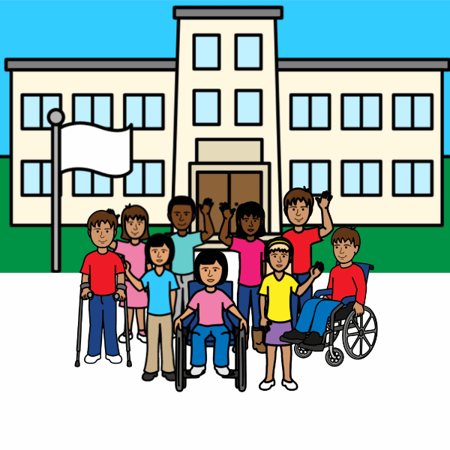 | We told the government we want  inclusive education.
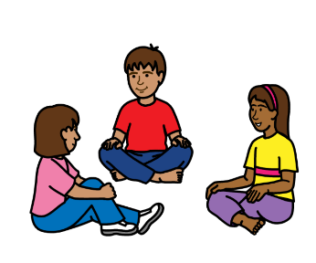 | Inclusive education means that disabled children and non disabled children can learn together.
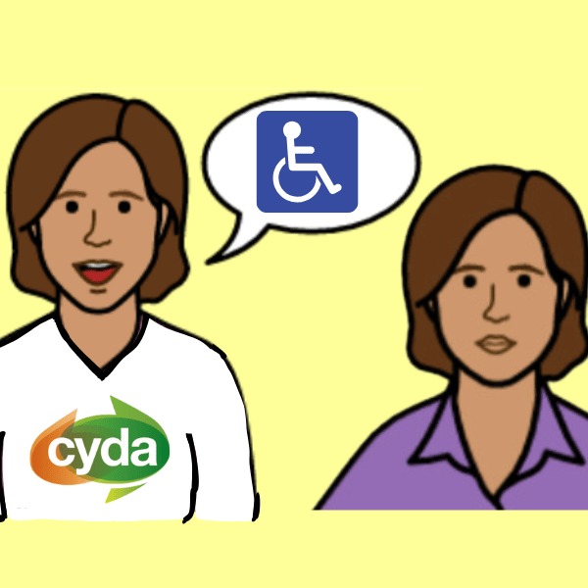 | We talked to employers about how to make  jobs inclusive.
 | We have meetings
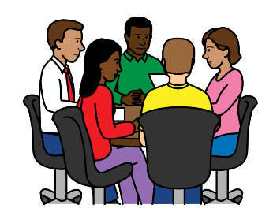 | - in person
 | and
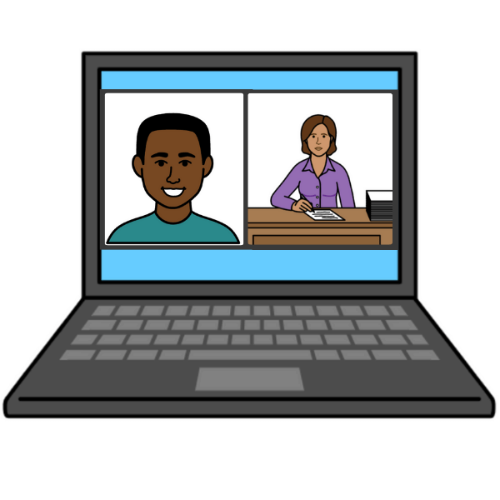 | - online.

How we support equality
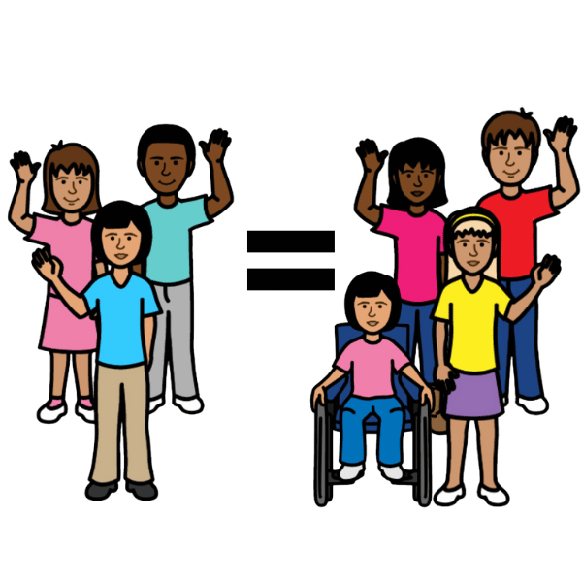 | Equality means everyone is treated the same.
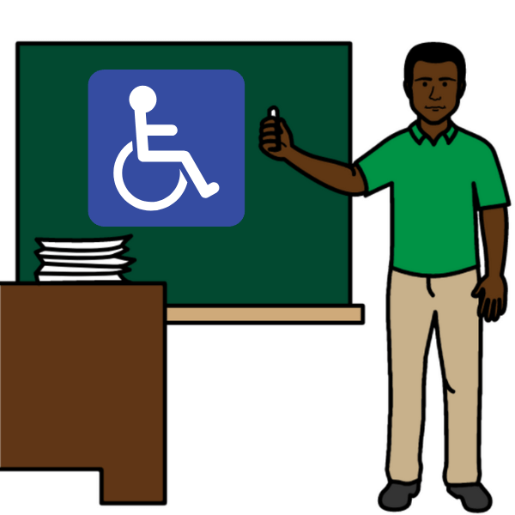 | We told the government that staff need to have training to work with disabled young people.
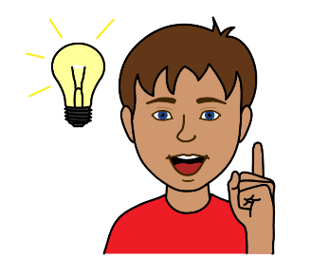 | We asked disabled young people to tell us their ideas about equality.

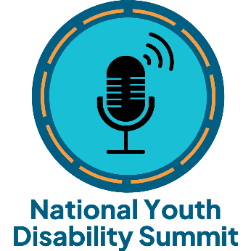 | We worked with disabled young people for  our summit.
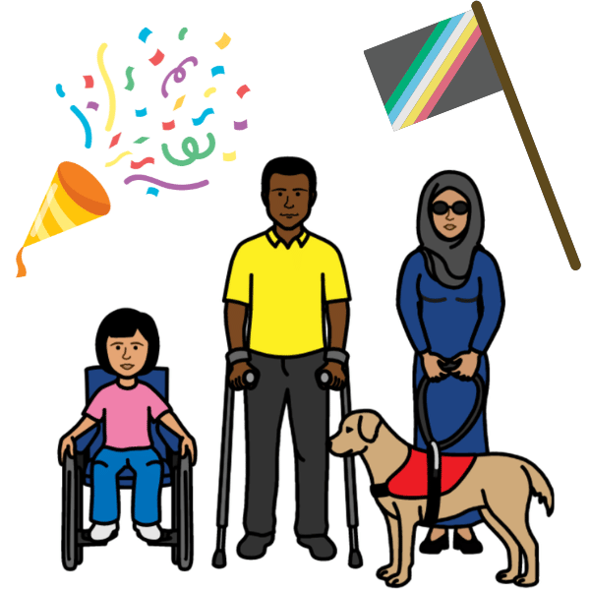 | Our summit was an event for disabled young people.
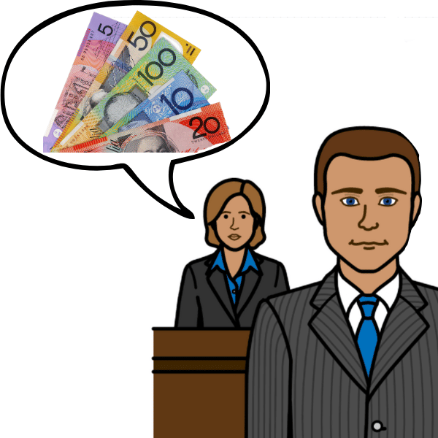 | We told the government to support disabled young people in poverty.
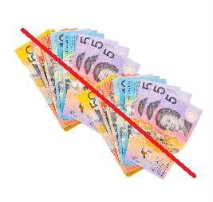 | Poverty means you do not have enough money.

How we change what people think about disability
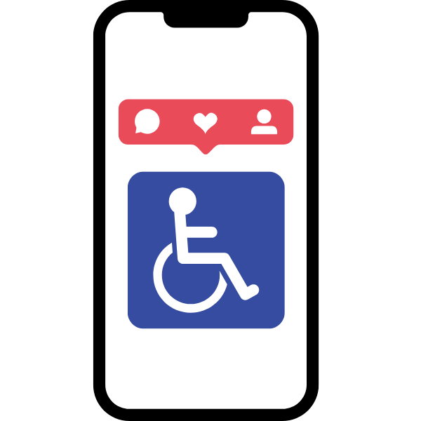 | We talk about disability on social media.
 | Social media includes
 | - Facebook
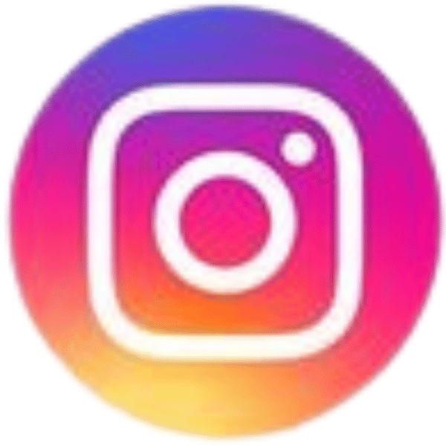 | - Instagram.
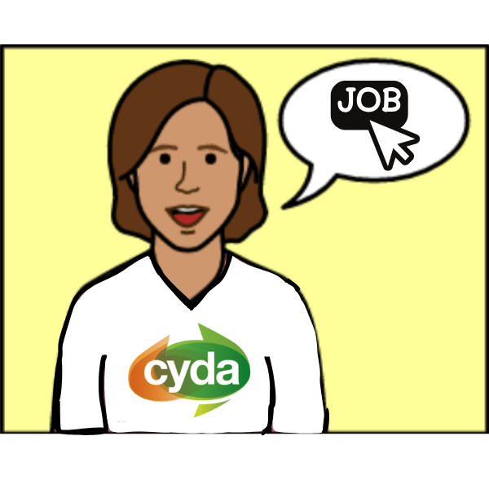 | We shared information about jobs for disabled  young people.
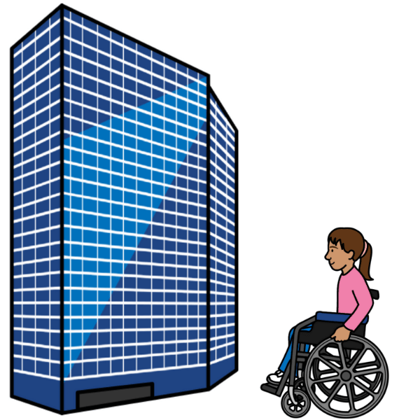 | We worked with other disability organisations.

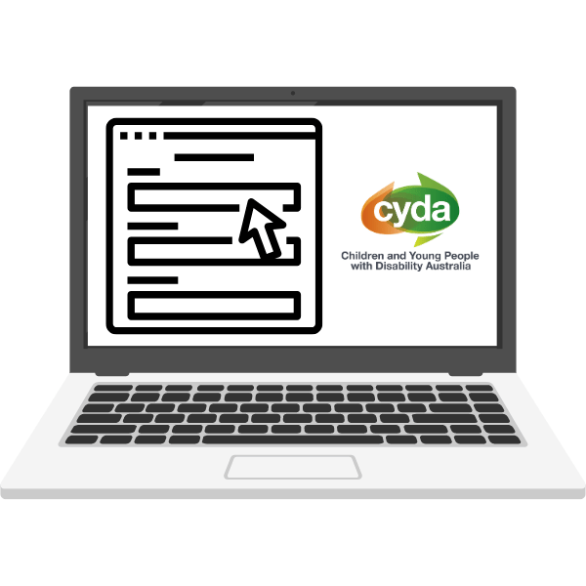 | We made our website more accessible.
 | Accessible means that everyone can
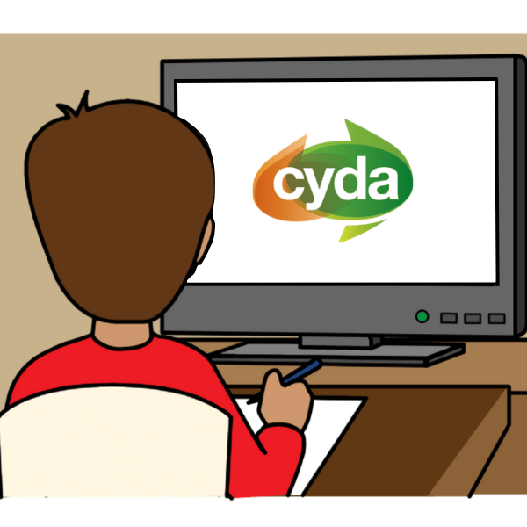 | - use our website
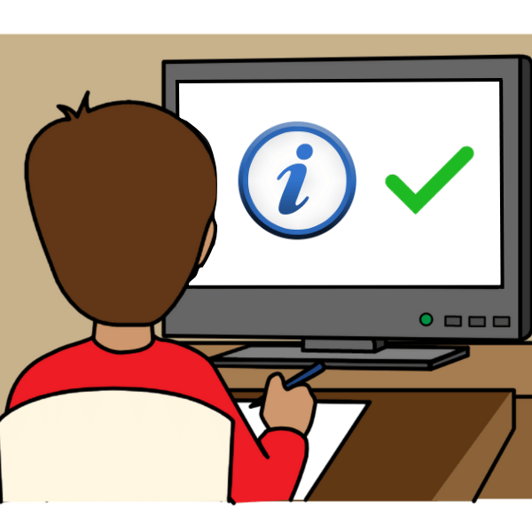 | - understand information on our website.

How we support young people
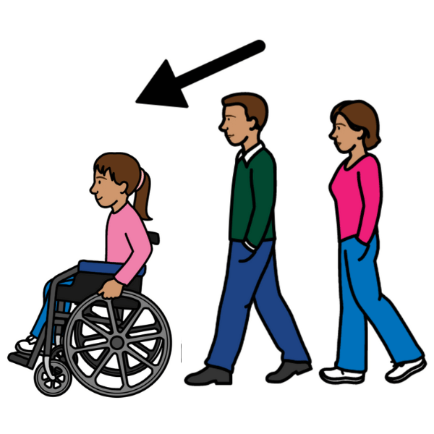 | We support disabled young people to be leaders.
 | We share information about things that are important to disabled young people.
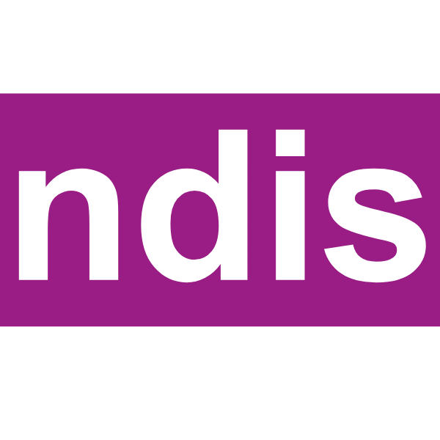 | For example, the NDIS.

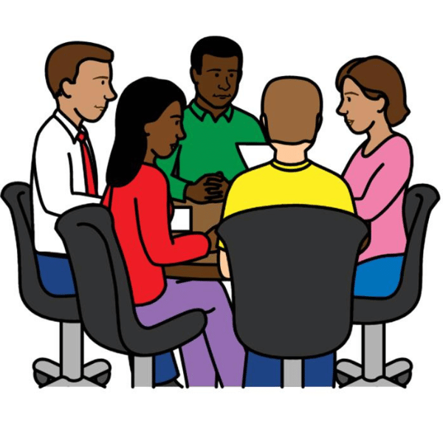 | We work with disabled young people to do research.
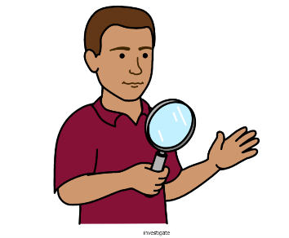 | Research is when you learn more about something.

How we talk about discrimination, abuse
and neglect
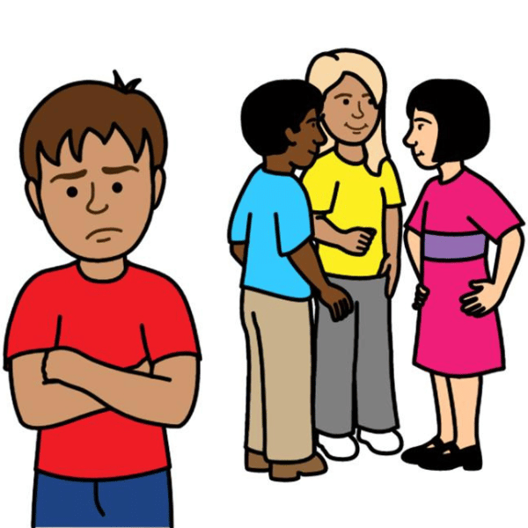 | Discrimination means people are not fair to you because of something about you.
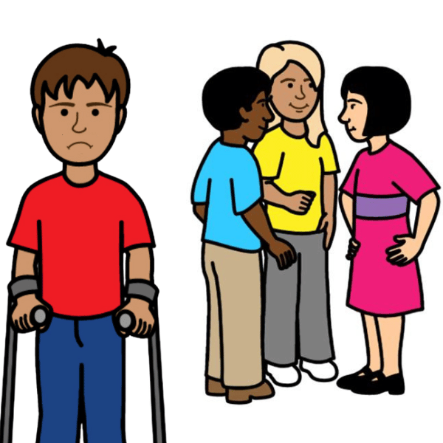 | For example, because you have disability.
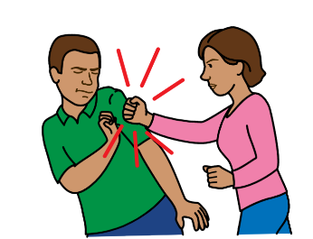 | Abuse means someone hurts you.
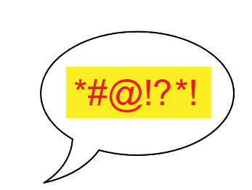 | Abuse can also mean someone says things to make you sad or scared.
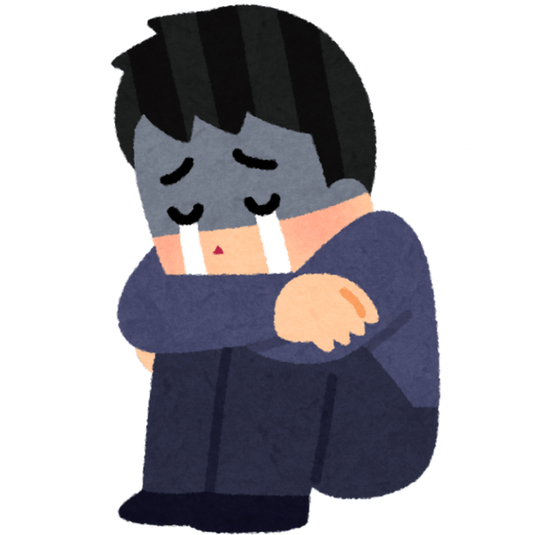 | Neglect means people do not care for you.
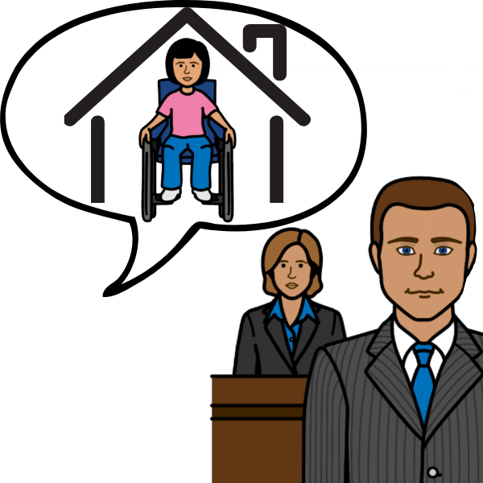 | We tell the government what to do to keep young people with disability safe.

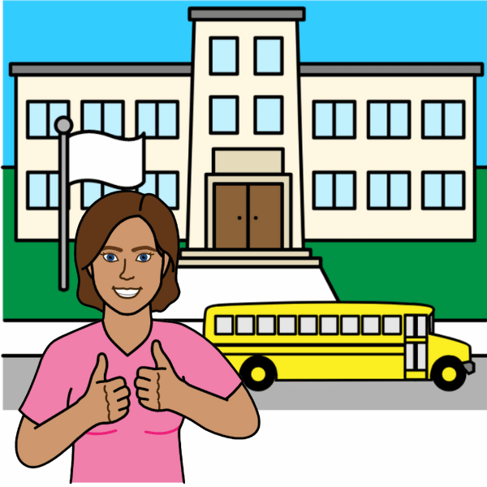 | We share information about rights in education.
 | Rights are things that everyone should
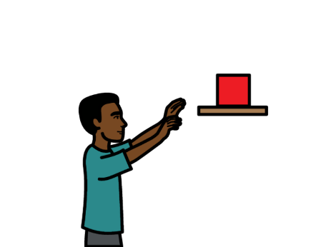 | - get
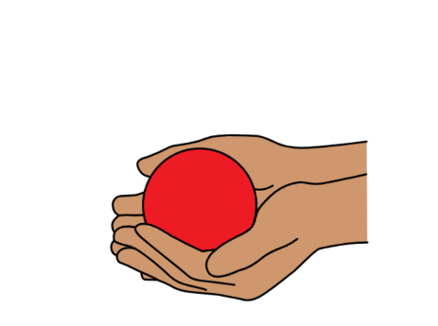 | - have
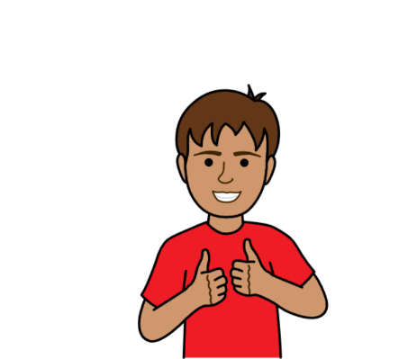 | - do.
 | For example, you have the right to learn in a place that is accessible.

What we will do in 2025
 | We will support disabled young people and family of disabled young people to
 | - get inclusive education
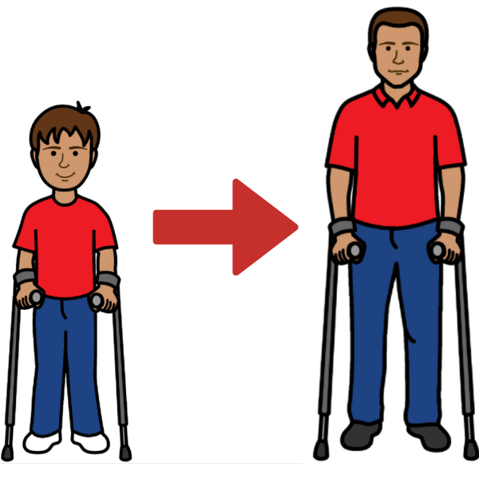 | - know what to do when life changes.
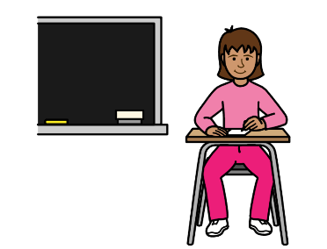 | For example, when a child starts school.
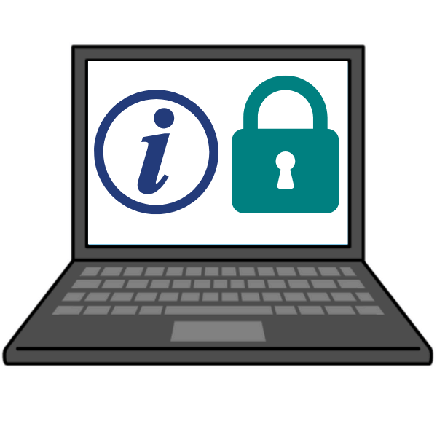 | We will use a new computer program to keep our information safe.
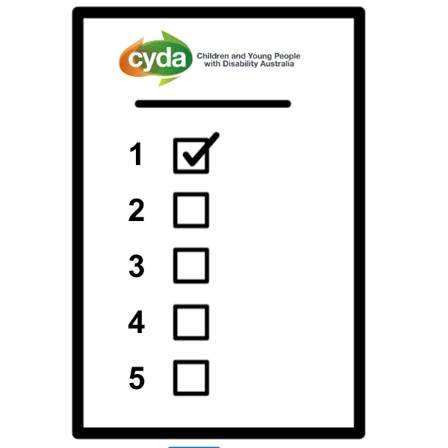 | We will have a new strategic plan.
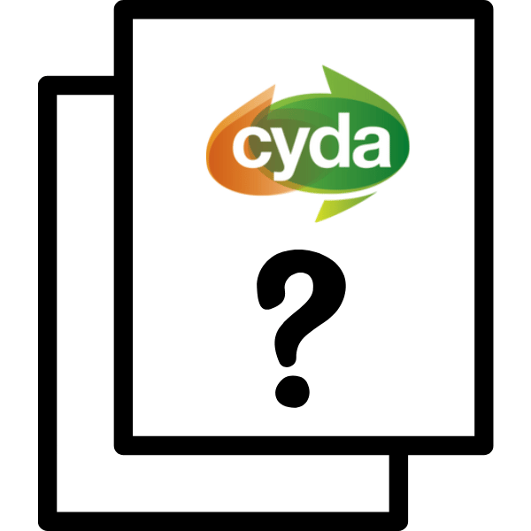 | A strategic plan says how we will do our work.

More information
 | For more information contact CYDA.
 | info@cyda.org.au
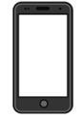 | 03 9417 1025
 | cyda.org.au

PCS is a trademark of Tobii Dynavox LLC. All rights reserved. Used with permission. (November, 2024).

