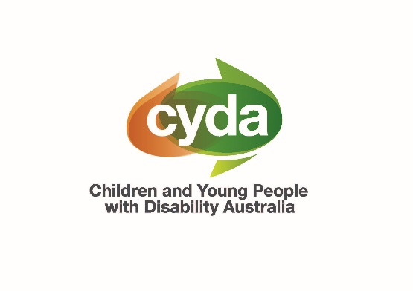

CYDA Board Director Recruitment: Expressions of Interest

**Information for Applicants  
Applications closing Friday 20 June 2025**

**Join our board and help shape the future for children and young people with disability**

Children and Young People with Disability Australia (CYDA) is looking for up to two new directors based in **Queensland, Tasmania, or the Northern Territory** to join our Board.

# About CYDA

CYDA is the national representative organisation for children and young people with disability aged 0-25 years. Our vision is for children and young people with disability in Australia to fully exercise their rights, realise their aspirations and thrive in all communities.

Together with children and young people with disability, their families, and communities, we drive systemic change through advocacy, strengthening representative voices, and building capability and opportunity.

Our work is guided by these core principles:

* **Youth agency and empowerment**: We value the perspectives of young people with disability and centre them in all our work
* **Solutions-focused approaches**: We identify practical solutions through partnerships
* **Collective impact and collaboration**: We build strategic partnerships to drive systemic change
* **Intersectionality**: We recognise that children and young people with disability have diverse experiences and backgrounds
* **Leveraging reform agendas**: We engage in partnerships to maximise positive outcomes

# Who we're looking for

CYDA is a national advocacy body that aims to have representation across all states and territories. To balance representation on the Board, we're specifically inviting applications from people in **Queensland, Tasmania, and the Northern Territory** who are either:

* Young people with disability aged 18-25 years, or
* Parents or caregivers of children or young people (0-25 years) with disability

You **don't necessarily need previous board experience** to apply. We're particularly interested in people with skills in:

* Human resources
* Financial management

We're also interested in potential directors **who may have the capacity to lead a working group or subcommittee, or take on a leadership position in the future**. If this is something which interests you (it’s not required!), please indicate this and describe your relevant experience and/or skills in your covering letter.

**The legal stuff**: To be eligible, you must be at least 18 years of age and consent to taking on the role and responsibilities of a director. You must understand the [responsibilities of board directors](https://www.communitydirectors.com.au/help-sheets/overview-of-your-board-responsibilities), including fiduciary duty, and will need to apply for a [director ID](https://www.abrs.gov.au/director-identification-number/who-needs-apply-and-when) if appointed.

# What being a board director involves

As a CYDA board director, you will:

* Help shape the strategic direction of CYDA through sound governance and financial oversight
* Read board papers carefully, contribute to robust and respectful discussions, and be responsive to out-of-session communications
* Attend approximately 6 online board meetings per year
* Join at least one subcommittee which meets 4-6 times per year
* Attend up to two face-to-face strategy sessions per year (held over 1-2 days, travel costs covered by CYDA)
* Champion the rights of children and young people with disability

Board directors serve an **initial term of up to 3 years**. **This is a volunteer position**, though reasonable costs associated with board duties will be covered.

# How to apply

To express your interest, please send:

1. Your CV/resume (no more than 3 pages)
2. A covering letter (1-2 pages) **OR** a video (no more than 5 minutes long) explaining:
   * Why you are interested in joining the CYDA board
   * Your relevant skills and experiences, including as a member of a board or committee; leadership or strategic oversight roles; and/or experience in human resources or financial management
   * Your perspective on the key advocacy issues that CYDA should pursue as a systemic advocacy organisation
   * Whether you are applying as either a young person with disability or a parent/carer of a child with disability (please include your age/the age of your child or young person)
   * Your connection to Queensland, Tasmania, or the Northern Territory

Please email your application to [info@cyda.org.au](mailto:info@cyda.org.au) with the subject line "Board EOI - [Your Name]" by Friday 20 June 2025.

**Questions?**

If you have any questions about the role or application process, please contact Ebe (Board Chair) at [chair@cyda.org.au](mailto:chair@cyda.org.au).

*CYDA is committed to creating accessible recruitment processes. If you need any adjustments or supports to participate in the application process, please let us know in your application or contact us directly.*