Human Rights-based Needs Assessment Model

Joint Position Statement by Disability Representative Organisations

June 2025

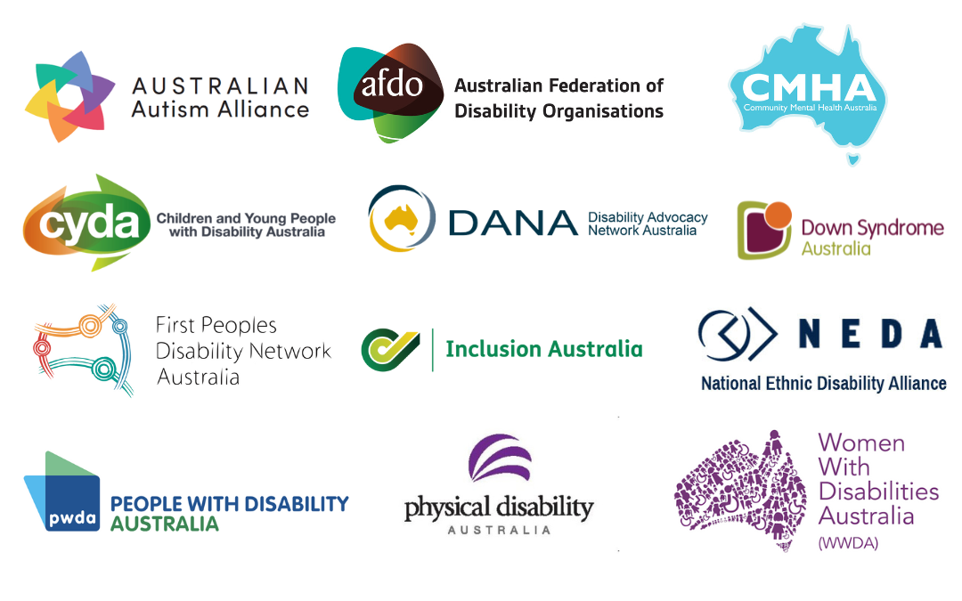

## Executive Summary

This Position Statement, prepared on behalf of Disability Representative Organisations (DROs), offers recommendations to guide the Australian Government’s transition to a new human right-based needs assessment model under the National Disability Insurance Scheme (NDIS). We strongly urge the Department of Social Services (DSS), the National Disability Insurance Agency (NDIA), and implementation partners to embed human rights, co-design, and trusted relationships at the centre of this reform. Our recommendations are grounded in the Convention on the Rights of Persons with Disabilities (CRPD), recent analysis from the Independent Review of the NDIS (2023), and other relevant evidence.

## Background

The NDIS Review recommended shifting the basis for setting a budget from individual support items to a “whole of person” level, supported by new needs assessment processes.[1] The [Explanatory Memorandum of the NDIS Bill 1](https://parlinfo.aph.gov.au/parlInfo/search/display/display.w3p;query=Id%3A%22legislation%2Fems%2Fr7181_ems_f83281ef-0f46-4fbb-a59f-2e19439dcacb%22) intended for the support needs assessment to be “co-designed with the disability community” to ensure “needs are assessed in a holistic and sensitive way”.[2]

On [December 17, 2024](https://ministers.dss.gov.au/media-releases/17186), the Government released a statement regarding progress in implementing NDIS reforms.[3] These updates include a commitment to deliver support needs assessments at no cost to people with disability and their families, the establishment of a dedicated multi-disciplinary workforce to conduct these assessments, and funding for consultation and design towards a new early intervention pathway for children under 9.

On [February 5, 2025](https://www.ndis.gov.au/news/10581-new-tools-better-understand-participants-support-needs),[4] the NDIA announced a ‘Request for Tender’ for adult support need assessment tools (16 years and over) and a ‘Request for Information’ for understanding children's support needs. This marks the beginning of a five-year transition, said to be aimed at improving the fairness and equity of NDIS budgets. The new approach seeks to reduce the administrative and financial burdens on participants, eliminating the need for self-sourced reports and evidence. The Agency claims this will lead to more equitable budgets and greater flexibility in support arrangements.

## Key principles for a human rights-based model of needs assessment

The following principles for a needs assessment model are socio-contextual and human rights-based, in line with the United Nations Convention on the Rights of Persons with Disabilities (UNCRPD). This approach focuses on the interaction between disability and environmental barriers, rather than solely on medical diagnosis or individual functioning.[5] This includes the requirement for the needs assessment process to be equitable, accessible, person-centred, and truly reflective of the varied needs of the disability community:

1. **Recognises diversity and intersectionality.**  
   The assessment process must consider the diversity in how individuals experience disability day-to-day and impacts of fluctuating, episodic, co-occurring and intersecting disabilities. The assessment process must also be responsive to the needs of, and address barriers uniquely experienced by, intersecting and marginalised communities. It must actively acknowledge and counter systemic discrimination. This includes considering the experiences of First Nations peoples, culturally and linguistically diverse (CALD) people, the gender-specific barriers faced by women, girls, non-binary and gender-diverse people with disability, and those living in regional and remote communities.
2. **Embeds accessibility in tools and supporting resources.**  
   Principles of accessibility must underpin the information and support available to ensure that all people with disability understand what a needs assessment is, why it is conducted, what information is required, how information is used for the assessment and the consequences of the assessment. Assessment tools and supporting information need to be communicated in a variety of formats, including but not limited to Auslan, Easy Read, translations for culturally and linguistically diverse (CALD) communities (including emerging communities), and culturally appropriate resources for both First Nations and CALD communities.
3. **Ensures active participation of people with disability and their support networks.**  
   People with disability must be involved in generating evidence for their own assessments. This should include peer-supported self-assessment options and providing draft assessment reports to participants for review and amendment before finalisation.[6] For people with complex support needs, the needs assessment process must include understanding and learning from people with disability and their families and supporters about what works for them. For example, the Autism CRC National guideline for the assessment and diagnosis of autism spectrum disorders in Australia[7] makes clear that effective assessment requires a collaborative, person-centred approach that draws on multiple informants - including caregivers - who can provide critical insight into functional abilities, contextual factors, and what supports are most effective in everyday life.
4. **Incorporates access to independent supported decision making.**   
   The process should provide maximum support for understanding the process and making independent decisions, including capacity building and support for decision making. This includes co-designing tools and resources with people with an intellectual disability and complex communication needs, as well as ‘decision supporters’. In line with the NDIS Supported Decision Making Policy, all NDIA and partner staff are to have the training to think about what support people with disability and their supporters might need to make decisions.
5. **Accounts for impacts of fluctuating and episodic disability.**  
   Assessments must recognise that some experiences of disability are episodic and may vary based on different environments and circumstances.
6. **Considers impacts of co-occurring or intersecting disabilities.**

Assessments must be designed flexibly to enable the consideration of needs arising from co-occurring and intersecting disabilities as an important element that can uniquely impact a person’s needs.

1. **Considers environmental factors and is responsive to life course changes.**  
   Assessments should examine how various environments and life experiences facilitate or limit a person's ability to perform daily activities and participate in society. Consideration should be given to the unique impacts for the person, including changing and intersecting needs, and foreseeable impacts when needs are not met or adequately addressed. Assessments must account for regionality/rurality, experiences of violence and changing circumstances, for example parenting responsibilities, key education and employment transitions as well as changes through the lifespan (including puberty, menopause and ageing).
2. **Equally weights lived experience alongside other forms of evidence.**  
   In establishing needs, self-assessment components must be considered with equal weight alongside other forms of evidence provided by healthcare or other trusted professionals and independent assessors. The process for drawing together and weighting information should incorporate person-centred approaches and allow for flexibility and consistency when considering environmental factors. That is, the definition of evidence-based is comprised of three pillars: 1. Research evidence (science) 2. Clinical expertise (trauma-informed, culturally responsive, LGBTQIA+ inclusive) and 3. Clients’ values and preferences. These pillars should be underpinned by lived experience and none of the pillars are to be valued higher than the other, they must all work together to be considered evidence based.[8]

## Overarching principles for design and implementation

The new needs assessment model needs to be developed in close collaboration and ongoing engagement with the disability community. The process must align with the United Nations Convention on the Rights of Persons with Disabilities (UNCRPD) requirement of “Equalisation of opportunities for Persons with Disability in influencing the promotion, formulation and evaluation of policies, plans, programs and action at national and international levels to further equalise opportunities for persons with disability.”[9] People with disability and their representative organisations must be genuine partners at every stage, through meaningful codesign, transparent piloting and ongoing evaluation that is responsive to change and feedback.

1. **Ongoing commitment to co-design throughout the process:** Co-design should underpin the development of processes for assessment, approved tools, and be maintained throughout the implementation and ongoing evaluation process. Genuine co-design mechanisms should be established with people with disability, including reasonable timeframes and adequate resourcing that enables meaningful engagement with the disability community.
2. **Accessible information and capacity building, including access to supported decision making:** Accessibility should be embedded throughout the process, including written explainers, support resources and templates or forms that guide people through the process. This includes capacity building and support for people with disability, their supporters, and professionals. This should include making information accessible, easy to understand, and clear guidance on where to find support to ask questions.
3. **Piloting,** **evaluation and gradual implementation:** Implement a comprehensive piloting phase with diverse cohorts of people with disability before full rollout, with transparent evaluation and adjustment processes**.** Ensure there is implementation planning and a gradual implementation timeline to allow for thorough testing and refinement of the Needs Assessment model.
4. **Data collection and reporting:**  
    Implement mechanisms for collecting and reporting data on culturally and linguistically diverse (CALD) participants to monitor equity and access, informing ongoing improvements to the assessment process and broader NDIS policies.

## Three-part needs assessments process

There is no single tool that could accurately determine needs for the broad range of disability experiences at milestones across an individual’s lifespan. In considering existing validated tools through the information gathering process, the Government should exercise caution in selecting 'off the shelf' tools that may reproduce medical biases affecting our community. Evidence shows such tools can misrepresent need, especially among people with complex or fluctuating disability (Fisher et al., 2021).[10]

For example, the Autism CRC’s National Guideline recommends that assessment tools be selected based on their validity, reliability, cultural appropriateness, and clinical utility for the individual being assessed. It cautions against the rigid use of any single tool and instead promotes a flexible, multi-method approach grounded in clinical judgement, developmental history, and observation across settings.[11]

The disability community must remain involved in selecting the tools for use by independent Needs Assessors recruited by the NDIA. Likewise, we recommend that use of any approved tools form only one of a three-part Needs Assessments process, consistent with recommendations of the NDIS Review Co-Group.[12]

1. **Self-Assessment**  
   Incorporating self-assessment as a form of evidence in determining needs aligns with the commitment of the NDIS to supporting active participation and control. DROs are concerned that people with disabilities are more likely to under-estimate their needs. People with disability from First Nations communities, culturally and linguistically diverse (CALD) backgrounds, gender-diverse groups, and those living in regional and remote areas may be particularly likely to understate their needs due to the various barriers outlined above and the compounding effects of discrimination. To mitigate this, there must be accessible information and capacity building built into the process to inform and promote understanding about the process, including how needs are experienced, how the assessment will impact them and how they can access support. Recognising people with disability as authorities requires self-assessment to be given equal weighting alongside other forms of evidence.
2. **Engagement with existing trusted professionals and support networks**  
   For many people with disabilities it takes years to develop a trusted relationship with the health and other professionals in their lives. Further, it can take considerable time for health professionals to develop a comprehensive understanding of the person’s condition and needs. The needs assessment must engage with a person’s ecosystem of existing health and allied professionals, and anyone else the person requests to obtain a holistic assessment of the person’s needs.
3. **Independent needs assessment paid for by the NDIA**  
   The independent person conducting the needs assessment must have specific qualifications, skills and training to fulfil the role. This must include the skills to conduct assessments that are gender-specific, culturally sensitive, trauma-informed, disability-specific and rooted in human rights principles of dignity, equality and mutual respect. Assessors should receive training in anti-racism and trauma-informed practices, as outlined in the NDIS Cultural and Linguistic Diversity (CALD) Strategy 2024–2028.

## Recommendations for implementation

We recommend the following elements be incorporated in the transition to the new needs assessment model, underpinned by the overarching principles for design and implementation set out above.

1. **Independent assessor experience and training:**  
   Work in partnership with Disability Representative Organisations (DROs) to agree on comprehensive training requirements and recruitment processes for assessors, prioritising those with lived experience of disability and ensuring diverse representation. Assessors must have demonstrated experience with the specific form of disability they are assessing. DROs acknowledge that many people with disabilities experience barriers to higher education. We strongly recommend that pathways for entry into these roles prioritise people with disabilities themselves, who have had experience working with other people with disabilities, and comprehensive training, over specific tertiary qualifications. This would contribute to addressing the real risk of adequate budgeting and staffing of independent assessors.
2. **Flexibility in assessment process:**  
   Allow for multiple tools that reflect diverse disability experiences and a person-centred approach to inform independent assessments. These should be undertaken on terms negotiated with participants, including funding appropriate time for completion.
3. **Equally weighted self-assessments:**  
   The view of the independent assessor should not be prioritised above evidence from existing practitioners and participants’ own self-assessment of needs. These forms of evidence should be interpreted holistically in maintaining the NDIA’s commitment to a person-centred approach.
4. **Draft assessments reviewed:**  
   People must be able to review the draft of the needs assessment prepared independently, *before* it is finalised and sent to the NDIA. This ensures there is the opportunity to correct any misunderstandings that could result in delayed access to critical supports.
5. **Transparency and accountability in methodologies:**  
   Develop clear guidelines on how assessment results will be used to determine budgets, ensuring consistent approaches for drawing together the information from different assessments and enabling flexibility to account for environmental factors. This includes ongoing monitoring and evaluation of outcomes made public.
6. **Commitment to best practice in accessibility:**   
   Accessibility needs to be integrated across the whole process, particularly for people with intellectual disability or high/complex support needs. This commitment should be demonstrated through codesign, testing and refining accessibility practices throughout the needs assessment and appeals process including clear governance and accountability structures that uphold the CRPD and the NDIS Act.
7. **Appeals process:**  
   Establish a robust, accessible, prompt and independent appeals process for assessment outcomes. There must be a clear process that allows the person to request a re-assessment, during which time, the individual’s funding and support is not reduced.

## About our organisations

This position statement developed by Disability Representative Organisations with coordination support from Disability Advocacy Network Australia (DANA) in their role as the National Coordination Function for the Disability Representative Organisations program. Disability Representative Organisations are funded by the Department of Social Services (DSS) to represent people with disability.

Women with Disability Australia (WWDA) led the development of this position statement, and it is based on the principles outlined in [WWDA’s position statement](https://wwda.org.au/our-resources/publication/wwdas-position-statement-rights-based-needs-assessment-model/).

The following organisations have contributed to and/or expressed their support for this joint position statement:

* Australian Autism Alliance
* Australian Federation of Disability Organisations
* Children and Young People with Disability Australia
* Community Mental Health Australia
* Disability Advocacy Network Australia
* Down Syndrome Australia
* First Peoples Disability Network Australia
* Inclusion Australia
* National Ethnic Disability Alliance
* National Mental Health Consumer Alliance
* People with Disability Australia
* Physical Disability Australia
* Women With Disabilities Australia

1. Recommendation 3, National Disability Insurance Scheme Review. (2023). Working Together to Deliver the NDIS: Final Report. <https://www.ndisreview.gov.au/resources/reports/working-together-deliver-ndis>
2. Parliament of Australia. (2024). *National Disability Insurance Scheme Amendment (Getting the NDIS Back on Track No. 1) Bill 2024*. <https://parlinfo.aph.gov.au/parlInfo/search/display/display.w3p;query=Id%3A%22legislation%2Fems%2Fr7181_ems_f83281ef-0f46-4fbb-a59f-2e19439dcacb%22>
3. Department of Social Services [DSS] (2024). Putting participants back at the centre of the NDIS. <https://ministers.dss.gov.au/media-releases/17186>
4. National Disability Insurance Agency [NDIA], (2025). New tools to better understand participants’ support needs. <https://www.ndis.gov.au/news/10581-new-tools-better-understand-participants-support-needs>
5. Waddington, L., & Priestley, M. (2021). *A human rights approach to disability assessment.* Journal of International and Comparative Social Policy, 37(1), 1-15, doi:10.1017/ics.2020.21; Yates, S., Carey, G., Hargrave, J., Malbon, E., & Green, C. (2021).
6. Ibid.
7. Whitehouse, A. J. O., Evans, K., Eapen, V., & Wray, J. (2018). *A national guideline for the assessment and diagnosis of autism spectrum disorders in Australia*. Cooperative Research Centre for Living with Autism (Autism CRC). <https://www.autismcrc.com.au/access/national-guideline>
8. Department of Social Services. (2025). *National Autism Strategy 2025–2031* (p. 46). Commonwealth of Australia. <https://www.dss.gov.au/national-autism-strategy/resource/national-autism-strategy-2025-2031>
9. United Nations. (2006). *Convention on the Rights of Persons with Disabilities: Preamble (f)*. Office of the High Commissioner for Human Rights. <https://www.ohchr.org/en/instruments-mechanisms/instruments/convention-rights-persons-disabilities>
10. Fisher, K. R., Tait, F., Carey, G., & Hill, T. (2021). *Equity and the use of* *standardised needs assessment tools in disability services.* *International Journal for Equity in Health*, 20(1), 1–11. <https://doi.org/10.1186/s12939-021-01571-7>
11. Whitehouse, A. J. O., Evans, K., Eapen, V., Wray, J., & Prior, M. (2018). *National guideline for the assessment and diagnosis of autism spectrum disorders in Australia*. Cooperative Research Centre for Living with Autism (Autism CRC). <https://www.autismcrc.com.au/knowledge-centre/resource/national-guideline>
12. NDIS National Disability Insurance Scheme Review. (2023). *Working Together to Deliver the NDIS: Supporting Analysis*. <https://www.ndisreview.gov.au/resources/reports/working-together-deliver-ndis-supporting-analysis>