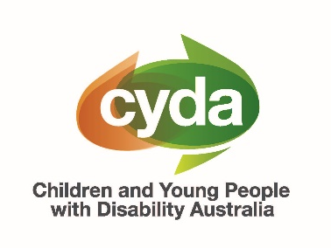
Response to
Parliamentary Inquiry into
Thriving Kids Initiative
2 October 2025

About Children and Young People with Disability Australia (CYDA)

Children and Young People with Disability Australia (CYDA) is the national representative organisation for children and young people with disability aged 0 to 25 years. CYDA has extensive national networks of young people with disability, their families and caregivers, and advocacy and community organisations.

Our vision is that children and young people with disability in Australia will fully exercise their rights, realise their aspirations and thrive in all communities.

CYDA’s Response to the Parliamentary Inquiry

CYDA’s response to the Parliamentary Inquiry into the Thriving Kids Initiative by the House Standing Committee on Health, Aged Care and Disability has two parts:

- A set of recommendations that are based on the lived experiences of our disability community, endorsed by 15 disability and peak organisations.
- An Appendix containing a factsheet presenting key findings of a survey about Thriving Kids that received 1535 response from our disability community, which provides the evidence base for our recommendations.

CYDA’s Recommendations

Ensure no child falls through the cracks by aligning the support ecosystem

Pause NDIS eligibility reassessments and guarantee that children will not be removed from the Scheme until alternative supports under Thriving Kids are fully in place

Provide a clear path of supports for children and young people with disability over nine years old

Our disability community is concerned that the misalignment of current reforms is putting children’s rights to safety, inclusion and continuity of support at risk. Children are being reassessed before alternative supports are available, and there is serious danger that children over nine will fall through the cracks between the NDIS and Thriving Kids. Urgent action is needed for the Australian government to meet its obligations under Australia’s Disability Strategy and the UN Convention on the Rights of People with Disabilities to guarantee access to supports.

Provide adequate time for genuine co-design and evidence-based evaluation

Plan a longer roll-out timetable for Thriving Kids to allow for genuine consultation and co-design

Design a trial period to test and evaluate the Thriving Kids initiative
Our disability community is worried that this Inquiry will be the only opportunity for consultation about Thriving Kids. They are concerned that Thriving Kids will be implemented as the only supports system, and that other supports will be dismantled, before there has been an opportunity for evidence-based evaluation of the Thriving Kids initiative.

Build on and strengthen existing supports rather than starting from scratch

Continue funding and delivering supports that children and young people rely on

Direct resources to programs and services that have already demonstrated impact, using a grassroots connection model to support those most in need

Provide parents and caregivers with tailored information and support to help them better navigate and access services
Our disability community has told us that they use existing NDIS supports frequently. Many will likely need these supports in an ongoing capacity over their whole lifetime, and as part of any new initiative. Supports should be resourced through a proposed grassroots connection funding model already endorsed by Disability Representative Organisations that channels funding to existing programs and supports that are already working (see CYDA's 2024 Foundational Supports Submission, Appendix 1). Additionally, parents require information and supports themselves to reduce the overwhelming responsibility and accountability they bear for coordinating supports.

Listen to existing community expertise to provide our disability community with what is proven to be effective

Ensure supports are tailored to individual needs, neuroaffirming rather than behaviouralist intervention-based, and provide choice, control and guaranteed support

Provide supports such as occupational therapy, speech therapy, psychology and physical therapy

Tailor supports to the specific needs of First Nations, LGBTIQA+, multicultural, and regional/remote-based children with disability, who face intersectional discrimination and overlapping forms of marginalisation
Our disability community has told us that ideal supports through Thriving Kids would be tailored to individual needs, neuroaffirming rather than based on surface-level behaviouralist interventions, and provide choice, control and guaranteed support. They would like Thriving Kids to include occupational therapy, speech therapy, psychology and physical therapy among other supports. We also heard that supports need to be tailored to specific needs, especially for First Nations, LGBTIQA+, multicultural, and regional/remote-based children with disability.

Ensure independent oversight of the delivery of new supports

Establish an independent oversight body to ensure that there is consistency of quality and equity of access to supports across multiple sectors and providers
Our disability community has expressed that receiving supports across multiple sectors and providers, including schools, community and healthcare settings, might lead to variations in quality and equity of access. To ensure consistency, it is important to establish quality assurance and accountability mechanisms.

Organisations endorsing CYDA’s Recommendations
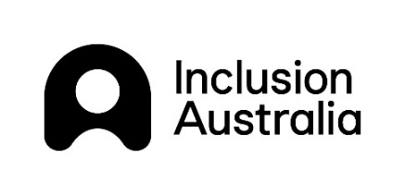


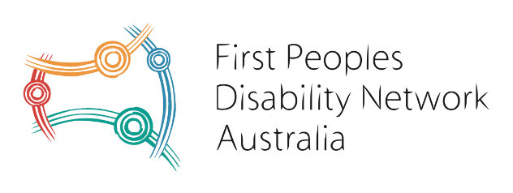
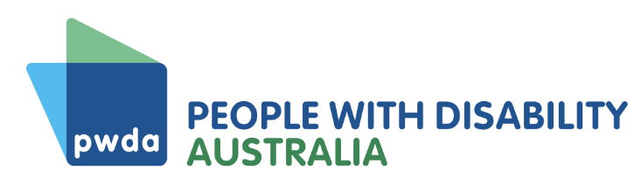
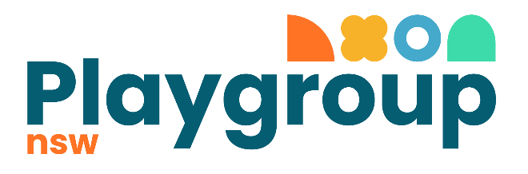
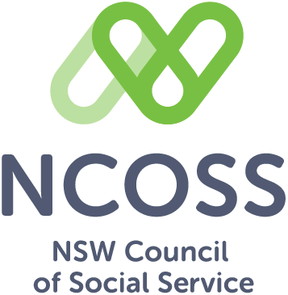
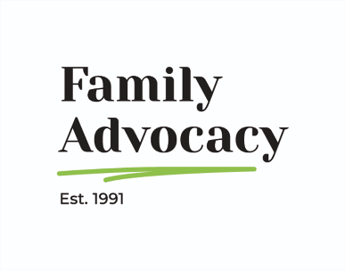

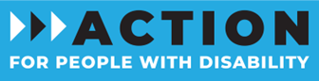

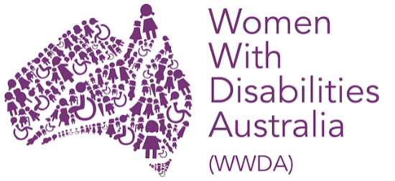


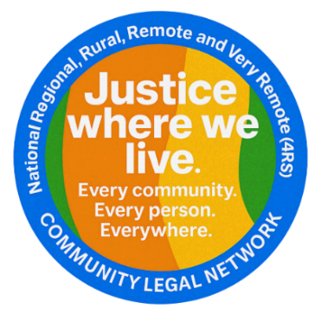
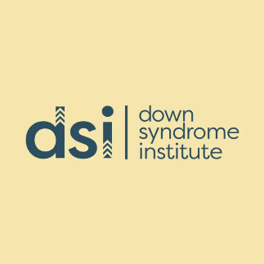

Appendix: Thriving Kids Survey Factsheet
To be released on CYDA’s website 7 October 2025

About the survey
Over 15 days from 27 August to 10 September 2025, Children and Young People with Disability Australia (CYDA) conducted a survey to gather feedback about the Thriving Kids initiative from children and young people with disability and their parents and caregivers.
Content note: This factsheet contains references to trauma, fear, loss of supports, ableism and suicide.

Who we heard from
We received 1535 responses. 79% were parents and caregivers, of which:
- 91% were caring for a child or young person aged 0 to 25 who was an NDIS participant or applicant, and 61% were caring for a child 9 years and under.
- 81% were caring for a child or young person who was Autistic, and 60% for a child with ADHD (these could be co-occurring). For LGBTIQA+-identifying, non-metropolitan, First Nations, and multicultural children, Autism prevalence was higher at 95%, 92%, 91%, and 84% respectively.
- 56% were caring for a child/young person whose gender identity was a boy.
- 22% were from a non-metropolitan area, 7% were caring for a First Nations child or young person, 7% for a child or young person who was from a culturally and linguistically diverse background, and 5% for a child or young person who identified as LGBTIQA+.
5% (77 responses) of respondents were adults with disability, 46% of whom were NDIS participants or applicants.
2% (30 responses) of respondents were children or young people with disability aged 25 or under, 75% of whom were NDIS participants or applicants.
14% (219 responses) of respondents selected other, indicating that they had multiple roles and identities (such as disabled parents of children with disability).
24% were based in New South Wales, 24% in Victoria, 19% in Queensland, 15% in Western Australia, 13% in South Australia, 4% in Tasmania, 2% in the Australian Capital Territory, and 1% in the Northern Territory.
Common disabilities across all groups included Autism, ADHD, developmental delay, learning disability (e.g., dyslexia), psychosocial disability, intellectual disability, physical disability, and others. Disabilities could be co-occurring.

Key issues raised by respondents
The survey asked respondents to share their thoughts about the Thriving Kids initiative, announced on 20 August 2025 by NDIS Minister Mark Butler.

Children falling through the cracks of the support ecosystem
There was a high level of concern about loss of supports, and the inability of a new initiative and mainstream channels to meet needs. Guaranteed support, and maintaining some existing supports, were important to over 70% of respondents.
“If the plan is to bring supports into the school environment, it is pretty much guaranteed the ones who need it most will slip through the cracks.”
“More kids are going to fall through cracks adding even more strain onto families that are already struggling.”

More time for rollout and implementation based on co-design and evidence
79% of respondents felt that 12 months was not enough time to launch Thriving Kids. 16% were unsure, and only 4% thought it was enough time.
Respondents indicated that more time was needed for genuine consultation and co-design with the children and parents/caregivers who would be using the services, a trial period, and amendments based on testing the initiative in practice:
“The program is not evidence based and not co-designed with families. Shouldn't we get a right to say what supports suit our children.”

Worry, fear, confusion and the need for stability
Respondents were worried (76%), scared (51%), and confused (51%) by Thriving Kids. Only 12% were interested, 5% neutral, 4% positive, and 2% excited.
15% selected another emotion, using the open-text box to describe feeling angry (26%), disappointed (5%), frustrated (6%), stressed (4%), powerless, suspicious, abandoned and even suicidal. No positive sentiment was recorded.
“Outraged, sickened, furious and heartbroken.”
When asked why they felt this way, 1143 respondents shared concerns about:
- lack of detailed information and rushed timeline
- problematic descriptions of Autism and disability from government which risk a backwards step to outdated understandings and approaches to disability
- supports allocated via ‘block funding’ that are not individualised
- lack of capacity and equity for delivery in schools
- increased emotional, mental health, and financial burden on families.
“For a single parent who is struggling to care for her autistic children this has put huge anxiety on top of an already stressful situation. I have one child on the verge of needing out of home care which is heartbreaking for us all and shouldn’t happen with the correct supports. Childrens’ future is at stake. Stability is so important.”

Calls to remove ableism and reliance on behavioural therapy
Respondents were concerned with the lack of disability awareness in the Thriving Kids announcement, demonstrating ableism and limited understanding of neurodivergence. They suggested that Thriving Kids would likely emphasise behavioural interventions designed to assimilate autistic children into the mainstream, rather than providing neuroaffirming support. They expressed fear about a focus on correcting behaviours and encouraging masking, leading to trauma and burnout for children. They also felt that behavioural programs would prioritise fast improvements to meet funding requirements rather than children’s needs.
“I am terrified my undiagnosed daughter will be forced into a one-size fits all massively underfunded program that teaches autistic children to mask and be judged on outward expression of neurotypical conformity rather than actual support needs.”

Suggestions for supports
Many survey participants had constructive ideas for ensuring the Thriving Kids initiative could be effective and supportive, highlighting what existing supports they found useful and what supports they would like to see included in Thriving Kids.
When asked how it should work, survey participants were aligned, calling for: resources for schools, reduced gatekeeping, providing sustainable and equitable funding, embedding allied health, supporting families and peers, consulting in accessible ways, and co-designing with those directly affected.

Existing supports are still needed
When asked what existing supports they or the child/ren they cared for used through NDIS, responses included: occupational therapy, speech therapy, psychology, support workers, physiotherapy, behavioural therapy/support, dietician, and food/feeding therapy.
48% of NDIS participants used these supports weekly, 19% fortnightly, and 15% daily. 12% indicated a preference for a more flexible timeframe—one that could be tailored to respond to changing or fluctuating needs.
48% of NDIS participants, their parents and caregivers said that they or their child/ren would need supports for their whole lifetime, and 24% said the timeframe for needing supports was unknown. For example, one respondent explained that Autism is a dynamic disability and support needs may fluctuate over a lifetime.

Supports to be included in Thriving Kids
When asked what supports Thriving Kids should include, top responses were:
Occupational therapy (97%)  Speech therapy (96%)  Psychology (90%)  Physical therapy (86%)  Parenting programs (79%)  Assistive technology (75%)  Skills programs (73%)  School refusal programs (73%)  Peer support networks (71%)  Respite care (68%) | Music therapy (67%)  Art therapy (64%)  Playgroups (63%)  Fidget tools (55%)  Gaming Therapy (46%)  “Other” suggestions were support workers, specialist education services delivered at home, and specialised out of school hours programs.

An ideal Thriving Kids program
When asked about an ideal Thriving Kids program, top responses were:
Tailored to individual needs (86%)  Neuroaffirming (79%)  Provides choice and control (76%)  Guaranteed support into future (76%)  Maintain some existing supports (72%)  Flexible delivery (71%)  Person-centred (71%)  Affordable (69%) | Trauma-informed (65%)  Local (53%)  Low administrative burden (52%)  Rights-based (49%)  Based in everyday settings (46%)  Community-based (39%)  Led by children & young people (33%)  Led by parents (33%).

Parent-specific supports
Parents were wary that they would end up with more responsibility and less support. Their comments suggested they wanted:
- assurances they would not be financially worse off
- neuroaffirming advice/guidance, tailored to unique and complex needs, and
- support workers/respite.

Tailored supports to address diverse and intersectional needs
Survey participants said they wanted support that was tailored to diverse, complex needs. A one-size-fits-all approach was seen as ineffective. Suggestions included:
- For Autistic children and families: tailored supports, neuroaffirming supports, choice and control, guaranteed support and creative therapies that are holistic, relational and joyful.
- For First Nations children and families: tailored supports, ability to maintain existing supports, guaranteed support, and person-centred supports. There was a higher rate of needing support over their whole lifetime. Levels of worry about Thriving Kids were higher than average, with concerns about no information, no consultation, and losing supports.
- For multicultural children and families: neuroaffirming supports, tailored supports, choice and control, guaranteed support, and parenting programs.
- For LGBTIQA+ children and families: neuroaffirming supports, tailored supports, choice and control, trauma-informed supports, peer support networks, and parenting programs.
- For regional/remote children and families: tailored supports, neuroaffirming supports, guaranteed support, and ability to maintain some existing supports. There was high concern about Thriving Kids exacerbating the lack of access to services in regional and remote areas already, especially therapy.

CYDA acknowledges and appreciates the many people who took the time to complete the survey. Their voices and perspectives are at the heart of CYDA’s advocacy. This factsheet shares early survey findings and a comprehensive report will be released soon. For further information, please contact the CYDA Policy and Research Team by emailing Dr Liz Hudson at lizhudson@cyda.org.au.
Parent/caregiver percentage breakdowns are out of 1136 responses to the question.
Percentages are based out of responses to the question.
Out of 69 responses to the question.
Out of 24 responses to the question.
Out of 1242 responses.
Out of 1242 responses.
Out of 1242 responses.
Out of 1242 responses.
Out of 1242 responses.
Out of 1242 responses.
These are based on parent/caregiver responses about the child/ren they care for.

