“Teachers do not get taught about disabilities adequately enough. Education is not keeping up with disability and human rights changes to adapt the environment.” (Parent/Caregiver, CYDA Education survey, 2024).
November 2025
Children and Young People with Disability Australia’s submission to the Australian Government Department of Education.
2025 Review of the Disability Standards for Education.

Authorised by:
Skye Kakoschke-Moore (she/her), Chief Executive Officer
Contact details:
Children and Young People with Disability Australia
E. skye@cyda.org.au
P. 03 9417 1025
W. www.cyda.org.au
Authors:
Dr Liz Hudson (She/her), Policy and Research Manager
Lauren Riessen (She/her), Project Co-ordinator, Inclusive Education
Reviewers: Lived Experience Review by Madeleine Gay (She/her), Policy and Research Officer
A note on terminology:
Throughout this submission, Children and Young People with Disability Australia (CYDA) uses person-first language, e.g., person with disability. However, CYDA recognises many people with disability choose to use identity-first language, e.g., disabled person.

Content warning: This submission references, disability discrimination, racism, harassment and bullying.
Acknowledgements:
Children and Young People with Disability Australia would like to acknowledge the Traditional Custodians of the Lands on which this report has been written, reviewed and produced, whose cultures and customs have nurtured and continue to nurture this Land since the Dreamtime. We pay our respects to their Elders past and present. This is, was, and always will be Aboriginal Land.

Contents
Summary of recommendations 4
Introduction 6
Topic 1: Effective implementation of the Standards 8
Recommendation 1: Strengthen the effective implementation of the Disability Standards 8
Topic 2: Inclusive decision-making 12
Recommendation 2: Strengthen IEPs and re-frame draft Principles 12
Topic 3 Responsibilities for assessment authorities and course developers 16
Recommendation 3: Develop and explicitly outline Nationally Consistent Guidelines, accountability requirements and embed Universal Design for Learning 16
Case studies Young people and parents/caregivers 22
Appendix 29
Appendix 1 References from Education Survey Report 2024 29
Appendix 2 CYDA’s Education-related Policy submissions and Reports 29
Appendix 3 Endorsements by disability and community organisations 30


Summary of recommendations
Recommendation 1: Strengthen the effective implementation of the Disability Standards for Education through;
- Fostering inclusive school cultures: Implement whole-school anti-bullying programs and regular activities that promote disability awareness and inclusion.
- Building staff capability: Require ongoing professional development on inclusive education, wellbeing support, and trauma-informed practice.
- Eliminating restrictive and exclusionary practices: Introduce national guidelines, reporting, and training on positive behaviour support approaches.
- Ensuring transparent and accessible complaints processes: Establish clear, independent, and accountable mechanisms for students and families to raise concerns safely
Recommendation 2
2a) Strengthen Individual Education Plans
Strengthen the Standards to mandate involvement of students into the development, implementation and review of Individual Education Plans
- Ensure IEP development processes are genuinely collaborative, consistently involving students and their families in meaningful decision-making, reflecting students' voices and lived experiences
- Implement regular reviews of IEP effectiveness and adjustments to ensure accommodations remain relevant and are effectively implemented, leveraging technology to facilitate efficient and transparent communication among stakeholders.
2b) CYDA recommendation relating to the Draft Principles:
CYDA recommends reframing the proposed principles for consultation, issues resolution, and complaints handling to use plain, inclusive language that centres the rights, voices, and lived experiences of children and young people with disability. Principles should reflect the intent of the Disability Royal Commission’s recommendations for a national roadmap to inclusive education, the phase-out of segregated settings, and the elimination of restrictive practices except as a last resort
- Replace technical and procedural language with child- and family-friendly terms that clearly express expectations of fairness, respect, and inclusion.
- Recast the principles to focus on human rights, accessibility, accountability, and genuine partnership with students and their families.

Recommendation 3
3a) CYDA recommends the Disability Standards for Education explicitly outlines Nationally Consistent Guidelines for the engagement of external authorities and organisations in education
- Informing schools, assessment authorities and training organisations of responsibilities to ensure the needs of students with disability are met
- Providing clear guidelines for communication of the need for supports/adjustment, required evidence, and responsibility for implementation of supports/adjustments.
3b) Strengthen accountability requirements in the Disability Standards for Education to ensure VET and Higher Education organisations meet obligations to support students to access appropriate adjustments and accommodations for practical placements.
3c) Embed Universal Design for Learning principles as a baseline requirement for curriculum development and accredited course design in the Disability Standards for Education.

Introduction
Children and Young People with Disability Australia (CYDA) is the national representative organisation for children and young people with disability aged 0 to 25 years. CYDA has extensive national networks of young people with disability, families and caregivers of children with disability, and advocacy and community organisations.
Our vision is that children and young people with disability in Australia will fully exercise their rights, realise their aspirations and thrive in all communities. We do this by:
- Raising community attitudes and expectations
- Championing initiatives that promote the best start in the early years for children with disability, and their families and caregivers
- Leading social change to transform education systems to be inclusive at all points across life stages
- Advocating for systems that facilitate successful life transitions to adulthood
- Leading innovative initiatives to ensure the sustainability and impact of the organisation and the broader sector
CYDA welcomes the opportunity to contribute to the 2025 Review of the Disability Standards for Education.
This submission draws on peer-reviewed literature and is shaped by evidence from the data gathered from CYDA’s National Education survey reports (2024, 2022) and from case studies with students and/or parents with lived experience (2025). Refer to Appendix 2 for a list of CYDA submissions relating to Education.
Additionally, our submission was shaped by CYDA staff, the majority of whom have personal and/or family experience of disability and has been reviewed by a young person with disability.
Direct quotes in this submission are drawn from the findings of the Education surveys with young people, families and caregivers. Quotes are indented from main text, italicised and in inverted commas, anonymised (or pseudonyms used) to protect privacy and minimally modified for brevity and/or clarity.

Submission structure
The submission is structured under 3 topic areas, Each part leads with our recommendations and is followed by a more detailed response.
Topic 1: Effective implementation of the Standards addresses Terms of Reference, 1: Whether further action is needed to increase knowledge and support effective implementation of the Standards.
Topic 2: Inclusive decision-making addresses draft Principles – Terms of Reference 2 Appropriate mechanisms to clarify the requirements around consultation, issues resolution and complaints handling in the Standards and Attachment B – from Discussion paper.
Topic 3: Responsibilities for assessment authorities and course developers addresses, the Terms of Reference 3: Ensuring the Standards provide appropriate clarity about the responsibility of authorities and organisations involved in developing and accrediting curricula, training packages or courses to meet the needs of students with disability.
Case Studies: This section includes four case studies to illustrate the education experiences of young with disability and their families. The case studies highlight the real-life experience of a students with disability in Australian education settings, including; early childhood, primary, secondary schools and within the tertiary sector.
Endorsements by other organisations: This submission is endorsed by 14 disability and community organisations. Refer Appendix 3 for the list of endorsements.

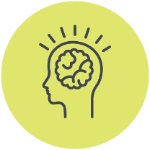
Topic 1: Effective implementation of the Standards

Recommendation 1: Strengthen the effective implementation of the Disability Standards
Recommendation 1: Strengthen the effective implementation of the Disability Standards for Education through national guidance, training, and accountability mechanisms that foster inclusive school cultures, build staff capability, eliminate restrictive practices, and ensure transparent and safe complaints processes, through;
- Fostering inclusive school cultures: Implement whole-school anti-bullying programs and regular activities that promote disability awareness and inclusion.
- Building staff capability: Require ongoing professional development on inclusive education, wellbeing support, and trauma-informed practice.
- Eliminating restrictive and exclusionary practices: Introduce national guidelines, reporting, and training on positive behaviour support approaches.
- Ensuring transparent and accessible complaints processes: Establish clear, independent, and accountable mechanisms for students and families to raise concerns safely
The content in this section addresses the following discussion paper questions:
How the Standards have been put into practice so that students can access and participate in education?
What are the main challenges faced in implementing the Standards?
What further support or guidance would help [students with disability] to access and participate in education?

Standards in practice
After 2+ years since the Disability Royal Commission, CYDA’s national education surveys show students with disability continue to be routinely excluded in their education, with many segregated from ‘mainstream’ schools and classrooms, not attending school full-time, and/or being refused enrolment and excluded from school activities. Suspensions and expulsions are also common practices.
While most students in our surveys receive some support at school because of their disability, many families (34%) report paying out-of-pocket for relevant supports and equipment. Students with disability also face unacceptably high levels of abuse and violence at school, including bullying and restrictive practices such as restraint and/or seclusion.
Overall, families/caregivers of students with disability do not consider:
- students receive adequate support in their education
- they were communicated with regularly about the student’s learning progress
- teachers have high expectations of the student
- teachers have the required training to provide a supportive and enriching education environment.
This illustrates the Standards’ limited impact in enabling students with disability to access and participate in education on the same basis as students without disability.
As illustrated in the below quotes, other factors, including a pervasive culture of low expectations, lack of professional expertise and training for education providers and funding patterns, also contribute to the present educational crisis for students with disability.
“Teachers do not get taught about disabilities and learning disorders adequately enough… Education is not keeping up with disability and human rights changes to adapt the environment.” (Parent/Caregiver, CYDA Education survey, 2024)
Challenges faced in implementing the Standards
As CYDA previously advised in our submission to the Disability Standards for Education 2020 review, education providers and departments’ lack of accountability remain concerning. Since the 2020 review there has been little change. With little oversight for implementation of the Standards, families and students have limited recourse to ensure education providers adhere to their obligations, and there is significant fear of retribution for people who do speak out. Experiences of schools and education authorities disregarding these obligations without consequence or accountability are common, as exemplified in the following quote.
“I was careful with the battles I fought but this meant we were constantly compromising with the school. The complaints system in schools is geared towards favourable outcomes for staff and students, and their families, have little power when it comes to dealing with the monster that is the education system. The complaints I made were those where our son was not safe, to ask that he not be segregated from his peers, and that he be provided with adjustments so he can access his work. We also chose to prioritise addressing any issues which bothered our son.” (Parent/Caregiver, CYDA Education Survey, 2024)
CYDA’s 2024 Education survey report, reflected on experiences of complaints being ignored despite escalation to multiple agencies. There was a view that there lacked a system of accountability for schools, with teachers, school staff, and principals never being held to account for issues worthy of complaint. Other agencies, such as the state/territory departments of education, were considered part of the broader culture that lacked transparency regarding complaints handling and a commitment to improvement. Survey participants, including parents/caregivers of children with disability shared experiences of no recognition of complaints lodged and failures to respond to correspondence or phone calls. As a result, parents were often unsure as to the status and outcome of complaints made.
There were no guarantees as to the timeframes with which complaints resolutions processes would take. As such survey participants described that complaints made in response to significant or time sensitive events would not be met with a degree of urgency. As the following survey participant explains:
“Put a complaint into education department, the ombudsman, and human rights. Told to lawyer up from human rights. Education department denied doing anything wrong. We had kept all documentation from 4 years of hell. No one is accountable.” (Parent/Caregiver, CYDA Education survey, 2024)
Further support or guidance to access and participate in education
We reiterate and strengthen our recommendations to improve education experiences and participation outcomes for students with disability in Australian schools, drawing on findings from CYDA’s Education Surveys (2024, 2022) and supporting evidence from peer-reviewed literature (see reference list in the appendix). Our recommendations are as follows;
Foster inclusive school cultures
- Schools must implement comprehensive, whole-school anti-bullying programs explicitly addressing disability-related bullying, with clear, consistent, and proactive responses
- Encourage and facilitate regular school-wide activities that promote disability awareness and celebrate diversity to foster genuine inclusion and reduce stigma.
Improve teacher and staff training
- Mandate teacher and school staff training in Disability Standards for Education, and invest in mandatory, ongoing professional development for teachers and school staff on inclusive education practices, understanding diverse disabilities, and implementing meaningful accommodations
- Provide targeted training on emotional and psychological support for students experiencing exclusion, bullying, or mental health challenges.
Urgent reform to address the widespread use of restrictive practices and exclusionary discipline
- Establish clear guidelines, standardised data collection, and mandatory reporting around use of restrictive practices and use of exclusions
- Establish comprehensive training in alternative, evidence-based behaviour management strategies, such as trauma-informed care, restorative practices, and proactive PBS approaches that emphasise supportive interventions over punitive discipline.
A transparent, accessible, and safe complaints process that upholds the rights of students, parents, and caregivers.
- Establish clear and accessible complaints procedures, independent oversight and mandatory accountability measures
- Requirement for schools/education providers to provide information about the complaints processes to the school community
- School and educational authorities should provide transparent reporting on complaint outcomes, alongside independent oversight mechanisms, to ensure genuine accountability and responsiveness
- Regular training for school personnel in effective complaint handling, dispute resolution, and responsive communication.

Topic 2: Inclusive decision-making

Recommendation 2: Strengthen IEPs and re-frame draft Principles
Recommendation 2
2a) Inclusive Decision Making - IEPs
Strengthen Individual Education Plans
Strengthen the Standards to mandate involvement of students into the development, implementation and review of Individual Education Plans
- Ensure IEP development processes are genuinely collaborative, consistently involving students and their families in meaningful decision-making, reflecting students' voices and lived experiences
- Implement regular reviews of IEP effectiveness and adjustments to ensure accommodations remain relevant and are effectively implemented, leveraging technology to facilitate efficient and transparent communication among stakeholders.
2b) CYDA recommendation relating to the Draft Principles:
CYDA recommends reframing the proposed principles for consultation, issues resolution, and complaints handling to use plain, inclusive language that centres the rights, voices, and lived experiences of children and young people with disability. Principles should reflect the intent of the Disability Royal Commission’s recommendations for a national roadmap to inclusive education, the phase-out of segregated settings, and the elimination of restrictive practices except as a last resort
- Replace technical and procedural language with child- and family-friendly terms that clearly express expectations of fairness, respect, and inclusion.
- Recast the principles to focus on human rights, accessibility, accountability, and genuine partnership with students and their families.

The content in this section addresses the following discussion paper questions:
Can you tell us about the experiences [students with disability] have had in relying on the Standards to solve a problem with consultation, access or participation in education?
Do you support including the principles at Attachment B in the Standards?
If principles are included in the Standards, how would you like this to be done?
Option 1. To guide best practice, the principles would be included as an example of a measure that an education provider may take to help them to comply with the Standards – no requirements to follow the principles
Option 2. Require education providers to develop and comply with policies that are consistent with the principles and to make those policies publicly available, publish, implement and comply with those policies – requirement for education providers to have consistent policies that are publicly available
Option 3. Require education providers to follow the principles when they consult, handle complaints and resolve issues.

Inclusive Decision Making – CYDA’s feedback on relying on the Standards to solve a problem with consultation, access or participation in education – Individual Education Plans (IEP)
IEPs, if well executed, are a key tool for involving students and families in inclusive decision making. However, CYDA’s education surveys (2024) identify substantial concerns surrounding the development, quality, and implementation of Individual Education Plans (IEPs). Students, parents, caregivers and kin frequently noted that IEPs were either generic, inadequately personalised, or inconsistently executed in classroom settings. Furthermore, meaningful involvement from students with disability and families, in developing and reviewing these plans was reported as limited or tokenistic.
Survey participants described their experiences with IEPs, with the majority sharing concerns regarding their experience of IEP development and implementation. From the outset, respondents were not confident that schools considered IEPs an important foundation in planning supports for students with disability. Therefore, IEPs risk being a box ticking exercise. As one respondent shares:
“I requested an IEP at the beginning of year seven. The first plan created for her was a behaviour plan that was a list of rules and if she didn’t follow them what the consequences would be. I argued for 18 months for an IEP. Even after we had three letters written by her GP, paediatrician and psychologist saying they were causing her psychological harm the school refused to meet with us.” (Parent/Caregiver, CYDA Education survey, 2024)
Others also expressed concern that when schools framed challenges solely as behavioural, it blocked access to IEPs:
“School refused to implement an IEP, even after multiple requests. School insisted it was only a behavioural issue.” (Parent/Caregiver, CYDA Education survey, 2024)
“My mum talked to me about what I wanted to be in the IEP. The school drafted it, however it was impossible to implement and never finalised, so I didn’t have one.” (Student, CYDA Education survey, 2024)
CYDA recommends the Standards are strengthened to mandate involvement of students into the development, implementation and review of Individual Education Plans by;
- Ensuring IEP development processes are genuinely collaborative, consistently involving students and their families in meaningful decision-making, reflecting students' voices and lived experiences
- Implementing regular reviews of IEP effectiveness and adjustments to ensure accommodations remain relevant and are effectively implemented, leveraging technology to facilitate efficient and transparent communication among stakeholders
Comment on the draft principles
The draft principles as currently written are highly procedural and technical. They read more like administrative rules than genuine principles to guide inclusive and respectful engagement. To be meaningful, the principles should reflect the lived experiences of students with disability and communicate, in plain and accessible language, what students and their families can expect when concerns arise.
For example, phrases such as “actively provide the student or an associate of the student with information required to participate in the consultation process” could be rephrased as “make sure the student and their family have all the information and support they need to take part and share their views.” Similarly, “document decisions relating to the matter” could be expressed as “clearly explain and record what decisions were made, why they were made, and how to ask for a review.”
True principles should go beyond process to reflect values such as respect, participation, equity and accountability. Reframing the principles around these values would align them more closely with the Disability Royal Commission’s vision of an inclusive education system where children with disability are safe, supported, and able to thrive.
CYDA recommends a stronger rights-based framing, for example:
- Respect: Every student with disability must be treated with dignity, fairness and cultural safety.
- Participation: Students and their families must be supported to meaningfully take part in decisions that affect them.
- Accountability: Education providers must take responsibility for resolving concerns in a transparent, timely and accessible way.
- Inclusion: Complaints and consultation processes must promote inclusive education and never reinforce segregation or restrictive practices.
Embedding these values into the final principles would ensure they serve as a genuine tool for change — empowering students and families, strengthening trust in education systems and advancing the Disability Royal Commission’s call for a national shift toward inclusive, safe and equitable education for all children and young people with disability.
Implementation within the Standards:
To be effective, these principles must have practical force rather than serve as optional guidance. CYDA supports Option 3 — requiring education providers to follow the principles when consulting, handling complaints and resolving issues. This approach would embed accountability, ensure consistency across education settings, and signal a genuine national commitment to inclusive education.
However, elements of Option 2 could also be incorporated to reinforce transparency and continuous improvement. Education providers should be required to publish and comply with policies consistent with the principles, ensuring students, families, and communities can easily understand how their rights are upheld.
Together, these steps would help move the Standards beyond compliance to active leadership in inclusive practice — aligning with the Disability Royal Commission’s vision for an education system grounded in respect, participation and equity for all students with disability.

Topic 3 Responsibilities for assessment authorities and course developers

Recommendation 3: Develop and explicitly outline Nationally Consistent Guidelines, accountability requirements and embed Universal Design for Learning
Recommendation 3
3a) CYDA recommends the Disability Standards for Education explicitly outlines Nationally Consistent Guidelines for the engagement of external authorities and organisations in education
- Informing schools, assessment authorities and training organisations of responsibilities to ensure the needs of students with disability are met
- Providing clear guidelines for communication of the need for supports/adjustment, required evidence, and responsibility for implementation of supports/adjustments.
3b) Strengthen accountability requirements in the Disability Standards for Education to ensure VET and Higher Education organisations meet obligations to support students to access appropriate adjustments and accommodations for practical placements.
3c) Embed Universal Design for Learning principles as a baseline requirement for curriculum development and accredited course design in the Disability Standards for Education.

The content in this section addresses the following discussion paper questions:
What more should be done to make sure curriculum development, accreditation and certification organisations from all education sectors are meeting their responsibilities under the Standards?
What further support or guidance would help students with disability get the reasonable adjustments they need to participate in work experience within school settings and to take courses with professional accreditation requirements, work integrated learning and practical placements?
What further support may be needed to clarify the responsibilities of the organisations involved and work better together so that students with disability have more consistent support?
How are students with disability considered by your organisation in development of courses and in implementation of assessments?
What further support and guidance is needed to help vocational education and training and higher education providers make sure that students with disability are provided with the reasonable adjustments they need to take courses with work integrated learning, practical placements, and professional requirements?

Drawing on evidence from CYDA’s 2024 Education Survey and sector engagement, this section responds to consultation questions regarding curriculum development, accreditation, and certification responsibilities under the Disability Standards for Education. It highlights the urgent need for greater clarity and consistency across assessment authorities and course developers, including those overseeing professional accreditation, vocational education and training (VET), and higher education programs.
Students with disability continue to experience inequitable access to curriculum, assessment, and work-integrated learning opportunities due to inconsistent expectations and practices across jurisdictions and education sectors. To address this, CYDA calls on the Department for Education to develop Nationally Consistent Guidelines for the engagement of external authorities and organisations in education within the Disability Standards for Education. These Guidelines should ensure that students with disability across Australia have equitable access to reasonable adjustments for assessments, work placements, work-integrated learning, and practical placements.
Across Australia, there are inconsistencies in both the evidence required to access reasonable adjustments and the adjustments available through external assessment agencies. These inconsistencies not only disadvantage students with disability but also create unnecessary administrative burden for schools and external agencies — reinforcing the need for a single, nationally consistent approach.
Nationally Consistent Guidelines should:
- Clarify responsibilities for schools and education providers to communicate with external assessment agencies regarding adjustment needs.
- Include a national template or protocol for reasonable adjustment requests and communication between education providers and external agencies.
- Affirm educators’ responsibilities for applying for reasonable adjustments on behalf of all enrolled students undertaking external assessments.
“I missed out on applying for any kind of accommodations for my ATAR exams because I simply did not know they were an option, or that there was a deadline on them.”
(Student, CYDA Education Survey, 2024)
- Outline processes to support communication, requests, and implementation of adjustments in work experience and work-integrated learning settings.
“All excursions/activities. School could not manage Schedule 8 meds at all, especially away from campus. Kid also had mobility issues (wheelchair/crutches), so school’s provider said no as they could not meet the physical needs.”
(Parent/Carer, CYDA Education Survey, 2024)
- Explicitly include work placement providers under Disability Standards for Education obligations to strengthen accountability and ensure consistent access to required accommodations.
Consistency in the vocational education and training (VET) sector
Students with disability enrolled in VET courses continue to face significant barriers to accessing and implementing reasonable adjustments. Where a student undertakes vocational education outside of their school enrolment (e.g., through TAFE), responsibility for implementing reasonable adjustments must sit clearly with the relevant educational institution.
Further work is required to ensure that VET providers understand and uphold their obligations under the Disability Standards for Education. CYDA’s 2024 Education Survey identified that some students remain reluctant to disclose their disability or request adjustments due to fear of stigma or being perceived as incapable. This is, in part due to the non-inclusive environments experienced at TAFE, as exemplified by the following quote:
“When I was 17, I went to a different “specialist” program at a TAFE college. I don’t know if it counts as bullying, because I wasn’t a specific target, but the social environment in the program was very overtly hostile - from students and teachers.” (Student, CYDA Education Survey, 2024)
In Australia, a Customised Employment approach has been identified as an effective pathway for supporting people with disability — focusing on strengths, interests, and abilities, and shaping a role to fit the individual rather than forcing the individual to fit the role. The VET system must uphold the Disability Standards for Education with a clear understanding that future employers are also bound by the Disability Discrimination Act, and that reasonable adjustments during training should reflect adjustments that would be implemented in the workplace under the Disability Discrimination Act.

Addressing barriers in higher education and professional placements
Challenges addressing barriers are equally present in higher education, particularly where professional placements and registration requirements create additional complexity. Students with disability at a tertiary level continue to face barriers when requesting adjustments for practical placements, often without clear guidance about university responsibilities for facilitating communication and support.
“Placement have absolutely no idea what’s going on behind the scenes, and they’re really slack at bridging that information gap, and so ultimately you end up with placement offers that aren’t appropriate.” (Student, LivedX Series:What Young People Said, 2022)
University disability practitioners consistently report exclusionary practices and requirements imposed by external professional registration bodies. While these bodies are obligated to comply with the Disability Discrimination Act, this compliance is not consistently evident in practice. Explicitly reinforcing the requirement to implement reasonable adjustments within professional placements would promote alignment between professional competency frameworks and obligations under both the Disability Standards for Education and Disability Discrimination Act.
Inherent requirement statements in Australia emerged as part of universities’ responses to disability discrimination legislation. To prevent gatekeeping of knowledge and discrimination against students with disability, the Disability Standards for Education should require that inherent requirements and their communication be transparent and accessible to students — in line with the Tertiary Education Quality and Standards Agency (TEQSA) Act. Inherent requirements must be communicated prior to enrolment, with transparency about any conditions that could affect a graduate’s suitability for future professional roles.
In CYDA’s submission to the Disability Discrimination Act Review 2025, CYDA recommended ammending the Act to include the use of inherent requirement descriptions and considerations in tertiary education course descriptions and to require employers and education institutions to thoroughly and critically consider the genuine inherent requirements of the job or course. Changes to the Disability Discrimination Act will have necessary flow on to both the Disability Standards for Education and Tertiary Education Quality and Standards Agency (TEQSA) Act supporting transparency in the communication from tertiary education instutions and higher education providers regarding inherent requirements.

Embedding Universal Design for Learning (UDL)
Embedding Universal Design for Learning (UDL) principles within course delivery will improve accessibility and efficiency, enabling students to engage with content in ways that best suit their learning needs. This approach reduces reliance on individualised adjustments and promotes proactive removal of barriers to participation. Investment in accessible course design benefits all students and represents a cost-effective strategy for long-term inclusion.
“The teacher needs to know that my son has a disability, and when he's placed in that classroom, there are barriers outside of him that are causing learning issues. They need to change the environment, or the instruction, or the way learning is represented. My son doesn’t need to change — the teacher needs to change something so he can demonstrate success.”
(Parent/Carer, Focus Group - SA Roadmap to Inclusive Education Project, 2025)
Embedding Universal Design for Learning within curriculum development, accreditation, and certification processes across all education sectors should be a central expectation under the Disability Standards for Education. This includes applying Positive Duty Threshold Standards in line with updates to the Disability Discrimination Act and Tertiary Education Quality and Standards Agency (TEQSA) Act Review, ensuring systemic change and equitable access to every aspect of student life.

Strengthening accountability and cross-sector collaboration
There is a need for ongoing cross-sector collaboration and oversight between the federal Department for Education, TEQSA, ASQA, and state education authorities to support and monitor implementation of the Disability Standards for Education. Stronger accountability mechanisms are essential to uphold the Standards and move beyond a system of nominal awareness toward one of active, measurable implementation.
Embedding compliance with the Disability Standards for Education within accreditation reviews and reporting cycles would promote a joined-up education system — one where the Standards are not just a policy reference but a practical framework driving equitable, high-quality education for students with disability.
Together, these recommendations highlight the need for nationally consistent approaches that define, communicate, and uphold responsibilities under the Disability Standards for Education across all sectors. Embedding Universal Design for Learning principles, ensuring transparent and accountable adjustment processes, and establishing clear national guidelines for engagement with external authorities will ensure that every student with disability experiences equitable access, participation, and outcomes throughout their education journey.
CYDA urges the Department for Education, in collaboration with state and territory counterparts, to prioritise the development and implementation of Nationally Consistent Guidelines for engaging external authorities and organisations in education within the Disability Standards for Education. These Guidelines must be co-designed with students with disability, families, educators, and disability advocates to ensure they are practical, rights-affirming, and responsive to the realities of school, vocational, and higher education contexts.
Establishing clear accountability mechanisms, transparent adjustment processes, and consistent expectations across jurisdictions would represent a meaningful national commitment to inclusion. Such reforms would move the Standards beyond policy intent to active practice — ensuring that every student with disability is supported to access, participate in, and thrive within all aspects of education on an equal basis with their peers.


Case studies Young people and parents/caregivers
This section includes four case studies to illustrate the education experiences of young people with disability and their families. The case studies highlight the real-life experience of a students with disability in Australian education settings, including; early childhood, primary, secondary schools and within the tertiary sector. They demonstrate how the strengthening of the Disability Standards for Education would promote inclusion and improved experiences for students with disability. Pseudonyms are used to protect their identities.
Early Childhood Education and Care case study
Zach and Harvey* began day care at a local for-profit centre at three years old. Their parents, Hailey and Nev* noticed things were tricky for the twins socially and emotionally but thought that the Covid lockdowns were a major factor in this and that things would settle down for them eventually.
After a year in daycare, the boys began attending a local council run sessional kindergarten two days a week in addition to one day at long day care. Within the first term the kindergarten teacher told Hailey and Nev that Zach and Harvey would probably benefit from an additional year at four-year-old kindergarten and soon after this, she approached them to share observations of the children in social, sensory and learning interactions. Their teacher presented a clear and sensitive argument as to why Zach and Harvey might benefit from undergoing an assessment for autism and shared the neuro-affirming supports that they were already using with success.
The family began the process which led to a diagnosis for both children and then shared these details with educators at the daycare centre. The educators responded by saying they didn’t think Zach and Harvey were Autistic, but they were just shy and mostly sat quietly in the corner. Hailey acknowledged that daycare staff were trying but were ultimately underpaid, overstretched and lacking in expertise. She said,
“It made me feel worried that they didn’t understand what my kids were feeling and didn’t know how to support them – that they see a kid in distress and think the kid is naturally shy and not put anything in place is really upsetting”.
The boys were experiencing more distress in daycare compared to kindergarten where their needs were being more successfully supported.
Hailey shared, “Daycare was noisier, and they weren’t getting as much time outside for a break. One day Harvey asked me ‘what colour are the walls at daycare so I can wear the same colour a be camouflaged to blend in’”.
In contrast, the kindergarten staff had clear strategies and were proactive with communication. They were managing sensory overload through waterplay, deep pressure activities, and outside breaks.
Hailey noted, “the Kinder teachers themselves were more regulated so this was more soothing for my kids”.
Educators scaffolded social interactions for the children through modelling and explicit teaching. They also proactively set up meetings with the family to share their observations and assist the family to apply for NDIS Early Intervention funding. They even helped Hailey and Nev fill out the paperwork.
Hailey noted that had the kindergarten staff not supported her family through this experience, they may not have had such a successful transition to primary school. Thanks to kindergarten, they had supports in place, knew what adjustments their children needed and were confident to advocate for them.
A strengthened Disability Standards for Education would improve the situation for Zach and Harvey. This experience shows how unequal staff capability and inconsistent implementation of the Standards can fundamentally change a child’s educational trajectory. With stronger requirements for staff training, clearer expectations for reasonable adjustments and nationally consistent guidelines for communication and external supports, children like Zach and Harvey would receive the right help no matter which service they attend. Embedding these reforms in the Disability Standards for Education would ensure all children are understood, supported and included from their very first years of learning.
*Not their real names

Primary school case study
Albie* is a 7-year-old child living in a city with his parents and sister. After his foundation year with two experienced teachers putting learning and disability support adjustments in place, Albie was excited to start year 1. Albie’s parents initiated a discussion with the new teacher prior to starting and agreed to have him spend time in the new classroom the week before. During this visit, the teacher listened to the adjustments suggested by Albie’s family and seemed positive about having him in the class.
In the first week, Albie reported having his name written on the board for being ‘naughty during circle time’, something his parents had told the teacher he found extremely difficult due to his disability. Then he reported that he and some other children had been kept in at lunch time for being ‘naughty’ and later the same group were made to pick up rubbish during lunch as a consequence for poor behaviour. These events were confusing and distressing for Albie. His parents also became aware that he was increasingly outside the classroom with an aide and the learning adjustments were not being implemented as suggested.
Concerned, Albie’s parents requested a meeting that included his class teacher, the principal and Albie’s care team. The need for a comprehensive behaviour support plan was agreed on and learning adjustments were again discussed and agreed on. No minutes were taken so the family were required to follow up with an email to confirm these.
Seven weeks into year 1, the principal phoned to say that Albie would need to be picked up because he was being disruptive for the school photos and ‘very rude’ to the photographer. The photographer, the classroom aide and the principal had all asked Albie to move positions for the photo and he refused. Albie’s parent reminded the principal that one of the adjustments that was agreed on was better preparation for transitions and changes to usual routines. The parent also highlighted that had the requested behaviour support plan been put in place, staff would be aware of Albie’s signs of escalation and effective methods of de-escalation. This adjustment would mean that a stranger, the photographer, was not an appropriate or trusted person for Albie to be interacting with during a time of stressful change such as school photo day.
“We were so deflated to hear the principal say these things about Albie after such in depth discussions about his disability and needs. It felt like the inclusion being talked about is not for your child but for those who are more convenient for adults”.
Albie’s parents felt increasingly unwelcome at the school and didn’t feel comfortable explaining that the adjustments they had requested were in fact a legal obligation for the school to provide, and Albie’s right to have in place.
Feeling like the disregard of Albie’s needs and rights was stemming from leadership, the family decided Albie should be moved from the school for his wellbeing and safety. They attempted to make a complaint, but school staff did not respond to their emails.
A strengthened Disability Standards for Education with clearer adjustments and exclusionary discipline amendments, would have placed a higher level of accountability on the school to complete the training and put Albie’s adjustments in place. These actions could have prevented his distress behaviour and ensured that any other distress behaviour was understood as part of his disability. The additional accountability on school staff would have meant Albie was more likely to be supported with his distress behaviour and less likely to have been suspended. With clearer responsibilities and processes for documenting consultations, adjustments and reviews, it is likely school staff would have initiated consultation and recorded adjustments along with a timeframe for implementing and review. This would have removed the onus from the family to initiate meetings and follow up when actions were not taken, a position that ultimately led to them being perceived as ‘difficult’. There would also have been a clearer pathway for conciliation meaning there was a better chance of Albie’s adjustments being recognised as a right and being implemented and the school being upskilled in their responsibilities.
*Albie is not their real name.
Secondary school case study
Beth* attended a mainstream high school from Years 7 to 10 and describes these years as some of her most challenging. Although she could toilet independently, staff insisted on monitoring her every time she used the bathroom due to perceived “fall risks,” leaving her without privacy and sometimes accompanied by two adults. Requests for dignity and independence were repeatedly dismissed, with staff referring her to occupational health and safety policies rather than seeking reasonable adjustments.
Throughout high school, Beth experienced severe bullying. She recalls a classmate drawing offensive caricatures of her on the board while teachers watched silently, unsure or unwilling to intervene. Although other students occasionally stepped in to defend her, the bullying was poorly managed, leaving Beth anxious, isolated and experiencing panic attacks. Despite performing well academically, the lack of social support and meaningful intervention made school emotionally unsafe.
Beth also discovered — only by chance, through her siblings — that she had a learning plan that had existed since kindergarten. She had never been told about it, never consulted, and was shocked to learn that the plan was outdated and contained misinformation. “I would have liked to know what my learning plan was and have a say in what went into it,” she said.
Midway through Year 9, Beth moved into a specialised program — a smaller, student-led learning community within the school. Each student received one-on-one weekly guidance with a teacher they chose, with additional support available as needed. This autonomy allowed Beth to manage her learning in ways that reduced anxiety, including studying from home when required. The personalised structure, high expectations and genuine partnership with students helped Beth regain confidence and prepared her more successfully for Years 11 and 12, which she describes as far more positive.
Future opportunity
Beth believes meaningful change will only occur when schools genuinely value the voices of students with disability. While she knew policies existed, she rarely saw them followed in practice. She wants teachers and school leaders to treat learning plans as living documents, updated regularly and developed with students, not for them. She notes that young people today are more empowered, open about disability and willing to challenge poor practice — a shift that schools must meet with transparency, accountability and real participation. Beth now helps her younger sister develop her learning plan, attending or recording meetings to ensure her sister’s access needs are respected. She says schools should ask every student, “What do you need to learn well?” and expect high achievement rather than imposing low bars.
Call to action
Beth believes that any changes to policy or practice must be student-led. “Nothing about us without us,” she says, emphasising that consultation, collaboration and high expectations are essential for young people with disability to thrive.
A strengthened Disability Standards for Education with clearer requirements for inclusive decision-making, transparent complaints pathways and genuine involvement of students in their learning plans would have ensured Beth’s needs, voice and rights were central to every adjustment and intervention. Beth’s story shows how weak implementation of the Standards leaves students without dignity, safety or meaningful access to education, even when policies exist on paper. Embedding stronger accountability, universal design and consistent guidance across curriculum and assessment authorities would help guarantee that no student again faces outdated plans, unmanaged bullying or systemic low expectations simply because the Standards were not followed.
*Not their real name

Case study Disability Discrimination in Tertiary Education
23 yr old Grace* was feeling really excited to start her university degree three years ago. As a young person with psychosocial, physical and neurological disability she was eligible for support through her university’s Student Services Department.
‘I completed lengthy documentation to provide evidence of my disability when I first signed up to the University’s student services.’
The next step was meeting with her assigned Disability Focal Point to facilitate and support her adjustment needs to study.
Grace requested flexible course arrangements, flexible attendance and hybrid studies through the university’s Disability Services for Students.
‘My request for accommodations and adjustments to my attendance and flexible course arrangements were repeatedly refused.’
‘Attending lectures and classes in person is not always possible for me. My disability means that some days I physically can’t get out of bed. When my adjustment needs were not met, I was faced with the difficult decision to either miss out on part of my education, or to push myself to attend classes in person and risk fatigue and periods of burn out.’
Without these reasonable adjustments in place, Grace was unable to have a note taker in class or to attend remotely.
‘While fellow students were able to attend all of the lectures and tutorials in person, I was struggling to keep up as I was not only unable to attend every class, but I was spending a lot of time, money and energy fighting to have my reasonable adjustment needs met’.
Despite providing evidence of her adjustment needs when registering with the university’s Disability Services each time Grace was unable attend a class or fell behind on assessments, she was required to complete lengthy forms and provide dated medical documentation to ‘prove’ that she was unable to attend.
‘Although my doctor had already provided the relevant evidence for my ongoing, chronic medical conditions and disability, the university requested new evidence each time I made a request for reasonable adjustment. It became unmanageable, stressful and expensive.’
Grace made internal complaints to the university but says that nothing was done. Seeking advice, Grace reached out to independent advocate who told her it was a clear case of discrimination.
‘Navigating a complaint was so tiring and added another layer of burden and administrative work. I was trying to continue my studies while the university continued to put roadblocks in my way. In the end the stress and fatigue were unmanageable, and I decided to defer my studies.’
Grace says her degree became unmanageable and she decided to defer her studies. While she hopes to complete her degree someday,
‘The ableist culture at Australian Universities is tied to the beliefs and value systems of the university administration and board. This will continue to be the case until students with disability are genuinely consulted, valued and can participate in their education on an equal level as their peers.’
A strengthened Disability Standards for Education would create tertiary environments where disabled students are valued, heard and able to learn on an equal basis with their peers. Grace’s experience shows how inconsistent implementation of the Standards, rigid administrative processes, and a lack of accountability in higher education can directly push students with disability out of their studies. Stronger requirements for transparent, rights-based complaints processes, consistent adjustments, and accountability for universities and accreditation bodies would prevent students from being forced to “prove” their disability again and again just to participate.
*Grace is not their real name

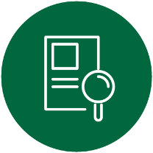
Appendix

Appendix 1 References from Education Survey Report 2024
CYDA 2024-25 Education Survey Report (Students with Disability). Smith, C., Hart, J., Dickinson, H. (2025) “I’ve really had to fight for my right to education”: Australia’s education system from the perspective of students with disability. CYDA Youth Education Survey 2025. Report prepared for Children and Young People with Disability Australia (CYDA), Melbourne
CYDA 2024-25 Education Survey Report (Parents and caregivers of Children with Disability), Smith, C., Hart, J., Dickinson, H. (2025) “They lowered the bar rather than raise the child”: CYDA Parent and Caregiver Education Survey 2024. CYDA Youth Education Survey 2025. Report prepared for Children and Young People with Disability Australia (CYDA), Melbourne

Appendix 2 CYDA’s Education-related Policy submissions and Reports

CYDA’s work is rights-based and informed by the direct experiences and diverse voices and visions of children and young people with disability across Australia. CYDA grounds its work in evidence and a human rights approach. This submission is supported by CYDA’s previous work in this area as listed below:
CYDA 2025. CYDA’s submission to the Anti-Bullying Rapid Review
CYDA, 2025. CYDA’s submission on Changes to the Disability Standards of Education
CYDA, 2025. Disillusion and Delay: CYDA’s survey of the learning experiences of children and young people with disability in 2024
CYDA 2024. CYDA’s submission to the Senate Inquiry into Better and Fairer Schools (Funding and Reform) Bill 2024
CYDA 2023. CYDA’s surveys of the learning experiences of children and young people with disability in 2022 and 2023
CYDA, 2022. Joint Submission to the Disability Royal Commission; Charter of Human Rights
CYDA, 2020. Disability Royal Commission – Response to Restrictive Practices issues paper

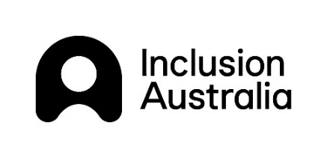
Appendix 3 Endorsements by disability and community organisations
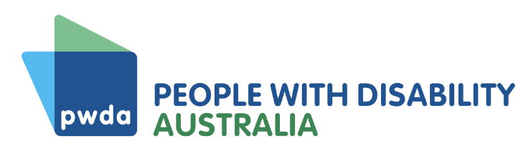

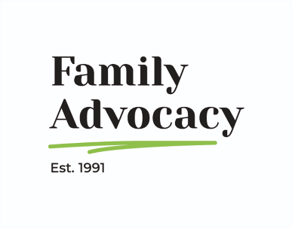

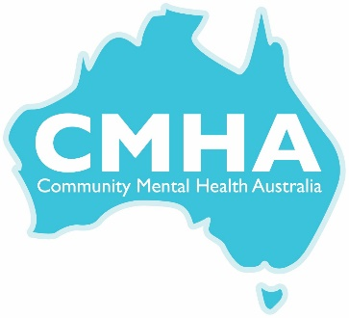
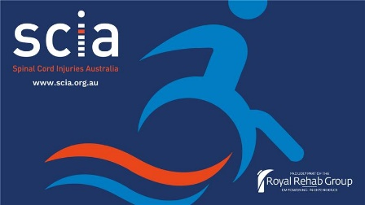
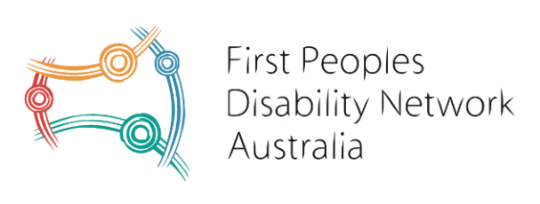
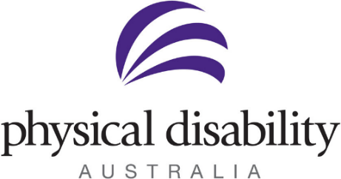
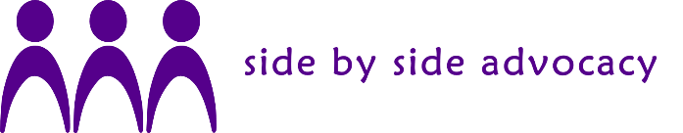

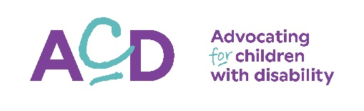
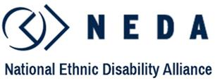
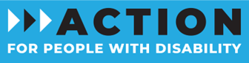
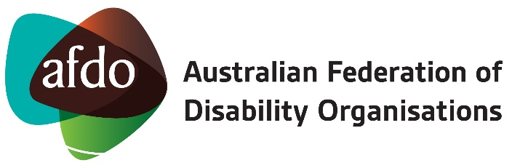


Children and Young People with Disability Australia
Suite 8, 134 Cambridge Street Collingwood VIC 3066
PO Box 172, Clifton Hill VIC 3068
Phone 03 9417 1025 or
1800 222 660 (regional or interstate)
Email info@cyda.org.au
ABN 42 140 529 273
Facebook: www.facebook.com/CydaAu
Instagram: cydaaus
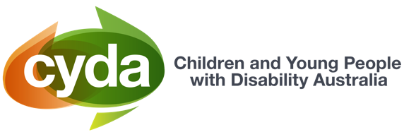
www.cyda.org.au

“Nothing has changed” (2025) CYDA
2020 Review of the Disability Standards for Education (2020) CYDA
Disillusion and Delay: CYDA’s survey of the learning experiences of children and young people with disability in 2024 (2025) CYDA
Disillusion and Delay: CYDA’s survey of the learning experiences of children and young people with disability in 2024 (2025) CYDA
Disillusion and Delay: CYDA’s survey of the learning experiences of children and young people with disability in 2024 (2025) CYDA
Disillusion and Delay: CYDA’s survey of the learning experiences of children and young people with disability in 2024 (2025) CYDA
LivedXSeries: What Young People Said, Tertiary Education and Learning (2022) CYDA
Strengthening the Disability Discrimination Act for children and young people with disability (2025) CYDA

