February 2026
A Roadmap to an Inclusive Education System in South Australia
Transforming education so every child learns, belongs, and thrives


About this document
Authorised by:
Skye Kakoschke-Moore (she/her), Chief Executive Officer
Contact details:
Children and Young People with Disability Australia
E. skye@cyda.org.au
P. 03 9417 1025
W. www.cyda.org.au

Acknowledgements:
We would like to acknowledge the Traditional Custodians of the Lands on which this report has been developed, whose cultures and customs have nurtured and continue to nurture this Land since the Dreamtime. We pay our respects to their Elders past and present. This is, was and always will be Aboriginal Land.
Thanks:
CYDA acknowledges the experiences of children and young people with disability, their parents and caregivers and appreciates their time to contribute to the development of the SA Roadmap to Inclusive Education. Their voices and perspectives are at the heart of designing CYDA’s advocacy and informing our messages to government
This roadmap has been contextualised and adapted for South Australia from the Australian Coalition for Inclusive Education (ACIE) National Roadmap. CYDA acknowledges the ongoing advocacy efforts of ACIE and thanks ACIE for their support during this project.
JFM Fund has provided financial support to this project.
The views expressed herein are not necessarily the views of JFM Fund and
JFM Fund does not accept responsibility for any information or advice
contained herein.


Content warning: This report references systemic discrimination, and ableism.

Contents
Contents 3
Introduction 4
Our Vision: Building the Foundations for an Inclusive Education System 5
From strong foundations to transformative change 5
What inclusive education looks like 6
Our Context and Imperative for Change 8
South Australia’s opportunity to lead 8
Building the courage to transform 9
Foundations for Systemic Transformation 11
Grounding Inclusion in Human Rights 11
Building one education system for every learner 12
The Roadmap for Change: Critical Actions for Inclusive Education Reform 13
Laying the groundwork for belonging and inclusion 13
Embedding inclusive practice into education policies and models 16
Sustaining and supporting a thriving inclusive community 18
Sustaining Momentum – working together for lasting change 22
Cross-Sector Collaboration and Leadership 22
Accountability, Monitoring and Evaluation 23
Continuing the Conversation 24

Introduction
Children and Young People with Disability Australia (CYDA) is the national representative organisation for children and young people with disability aged 0 to 25 years. CYDA has extensive national networks of young people with disability, families and caregivers of children with disability, and advocacy and community organisations.
Our vision is that children and young people with disability in Australia will fully exercise their rights, realise their aspirations and thrive in all communities. CYDA values the lived experience of the community as a basis for driving systemic change and advocating for system reform that meets the needs of children and young people with disability.
The South Australia Roadmap to Inclusive Education (the SA Roadmap) is shaped by evidence gathered from the following South Australian sources:
CYDA’s SA Roadmap Surveys (2025) of students with disability, parents/caregivers and teachers (662 participants responded to the survey)
CYDA’s seven focus groups (2025) with students with disability, parents/caregivers and teachers
CYDA’s co-design team (2025): children and young people with disability (x2), parents/caregivers (x2) and educators (x1)

Direct quotes in this submission are drawn from the survey, focus groups and codesign data. Quotes are indented from main text, italicised and in inverted commas, anonymised (or pseudonyms used) to protect privacy and minimally modified for brevity and/or clarity.

Note: This document is intended to be updated and adapted over time, guided by ongoing consultation.

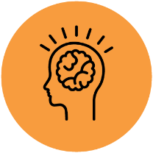

Our Vision: Building the Foundations for an Inclusive Education System

From strong foundations to transformative change
South Australia stands at a pivotal moment. From strong foundations, we can transform our education system to become truly inclusive – one that delivers equitable, high-quality education for every learner.
“We keep retrofitting the existing systems instead of reimagining them. Inclusion should be considered in all policies.” Teacher (Survey Participant)
Children, Young People with disability and their families, educators, and communities across South Australia have told us clearly what inclusive education means to them. It means that every child is welcomed, respected, and supported to learn, belong, and thrive alongside their same-aged peers in classrooms within their local schools.
Inclusive education is not a “one size fits all” approach. It is flexible, responsive, and culturally safe. It adapts supports, strategies, and environments to enable each child to succeed academically, socially, and emotionally. It values diversity, celebrates strengths, and fosters empathy, connection, and understanding across the whole school community.
“I feel like a lot of the time children can be funnelled into certain areas … So it's about having those open and equal options in all areas of education, and then that flow onto all areas of life.” Parent/Caregiver (Codesign Group)
This document is intended to guide not only cultural change, but sustained system reform, supported by clear governance, measurable outcomes and transparent reporting to ensure the South Australian education system is working across the sector to remove barriers to inclusion and embed inclusive approaches that support students with disability.

What inclusive education looks like
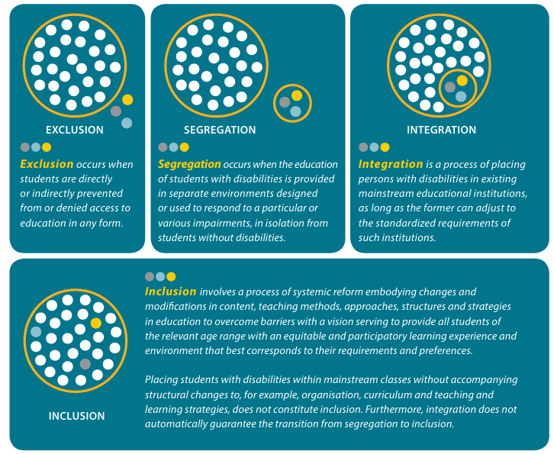
Image – sourced online- ‘A summary of the evidence on inclusive education’
Inclusive education means that every student is welcomed, valued, and supported in their local school community. Students are engaged alongside their same-aged peers in curriculum, activities and school life with adjustments that support their success. It means all children are seen as capable individuals:
- Who bring unique contributions and qualities.
- Who are given equitable opportunities to participate in all aspects of school life.
- Who are supported to reach their full potential in ways that affirm their dignity, independence, and sense of belonging.
‘[inclusive education means…] A safe, supportive environment for my child to grow and prosper into a valuable member of our community.’ Parent/Carer (Survey Participant)

To support South Australians to access and engage in quality education, students must start together and stay together throughout their educational journey. South Australia must incorporate and utilise the National Best Practice Framework for Early Intervention in our preschools and schools to ensure children have the best start to their education, setting students up for success and flowing through to all aspects of lifelong learning, including post-school education.


Our Context and Imperative for Change
South Australia’s opportunity to lead

“When our children and young people thrive, so does South Australia.”
— Purpose Statement for SA Public Education
South Australians are innovators, we don’t just talk about change, we make change happen.
We are nation-leading, embedding Autism Inclusion Teachers in every department-run primary school, and world-leading, with the appointment of the first Minister for Autism. Our public education strategy is bold and forward-thinking, underpinned by a powerful purpose statement for South Australian public education:
“Preschools and schools are the heart of local communities... When our children and young people thrive, so does South Australia.”
South Australia has the opportunity to be the first state or territory to reach a basic level of compliance with the UN Convention on the Rights of People with Disabilities, by formally endorsing General Comment 4 and transforming our education system to being truly inclusive, enabling students with disability to thrive alongside their same-aged peers.
“Mainstream students should mix with disability students and have a chance to mentor or become friends and understand how important it is in society to be inclusive.” Student (Survey Participant)
We can deliver our Education Purpose equitably for students with disability — and lead the nation once again by transforming education to be truly inclusive for all students.
“Children with disabilities need to be included into mainstream not placed in special schools because in society we don’t have a suburb that people with disabilities are allowed to live. They are part of society and that’s how it should be in schools. Make it inclusive and normal.” Parent/Carer (Survey Participant)

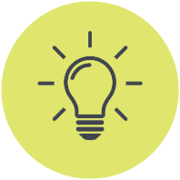
Building the courage to transform
A truly inclusive education system demands transformative change and a steadfast commitment to building one universally accessible system that supports every student.
Although progress has begun, our education system still reflects segregation and exclusionary practices that limit the potential of students with disability and diminish our collective vision for an inclusive society. A respondent to the parents/caregivers survey stated:
“The existence of special options gives mainstream sites an excuse to avoid inclusion.” Parent/Carer (Survey Participant)
Too often, students are present but not included — experiencing integration rather than inclusion as one student highlighted in a focus group:
“I feel more included when I can sit with my friends, and I'm treated the same as everyone else... And teachers could make it easier to ask for help by offering it to everyone in the class, so it doesn't feel like I'm the only one who needs it.” Student (Focus Group)
South Australia continues to maintain a system of segregation where students with disability are ‘recommended’ for placement in a setting that is isolated from students without disabilities.
This, along with other reported restrictive practices show that our current mainstream system is ill-equipped to support students with disability, to the point that families and staff within segregated environments cannot even imagine a future in which we have true inclusion in our general education system. It’s an indictment on our society and our school communities that families and staff fear an intolerant and ableist culture.
“…if places like ours [Special Education Centre, stand alone, completely segregated from mainstream setting] sort of didn't exist… what it would do to families. I feel like the families would be ostracised... If their children remain mainstream, I just don't know what they would do to families' mental health.” Teacher (Focus Group Participant )
Patterns of exclusion perpetuate inequity and reinforce ableist assumptions about who belongs in our classrooms.
As the Commissioner for Children and Young People has reported, exclusionary practices such as suspension and informal exclusionary practices remain alarmingly common. In South Australia, the education system includes alternative enrolment options for students – these are exclusionary options that too often have been developed to segregate students with disability. ‘Better Behaviour Centres’ are a clear example of students with disability being over-represented in exclusionary practices, rather than provided with support they require within their schooling environment.
“Many suspensions related to melt downs often escalated by staff mishandling situations and not allowing for processing time or student misunderstanding instruction or being punished for such things as using an inappropriate word assuming that he understood the meaning of the word and was not simply imitating others behaviour.” Parent/Carer (Survey Participant)
The South Australian government has the opportunity to address Recommendation 7.2 from the Disability Royal Commission ‘Prevent inappropriate use of exclusionary discipline against students with disability’ and embed consistency in it’s approaches to behaviour and discipline action through the development of an Inclusive Education Strategy.
“I usually get in trouble when I'm doing something that annoys the teacher. Sometimes I whistle, or tap the table, sometimes I don't even know I'm doing it… I get sent home because it's too loud/overwhelming and then I miss out.” Student (Survey Participant)
The SA Roadmap Project heard extensively from students about the need for stronger, proactive steps to be taken to prevent bullying and harm at school. It was identified that bullying behaviours came from both peers and teacher staff.
“I have a lot of trauma because of teachers and students mistreating and bullying me.” Student (Focus Group)
There is evident need for change, to protect students with disability from harm with one student responding to our survey urging schools to ‘Take bullying seriously’. These findings highlight the urgent need for strengthened whole-school approaches to wellbeing and safeguarding, ensuring that both staff and students are equipped and accountable for creating safe, respectful, and inclusive learning environments.
South Australia has the opportunity to strengthen whole-school approaches to behaviour, wellbeing and safety by embedding trauma-informed, strengths-based practice across all settings, supported by workforce training, clear guidance and system-level monitoring of restrictive and exclusionary practices.

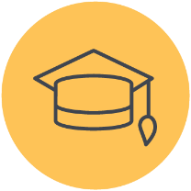
Foundations for Systemic Transformation

Grounding Inclusion in Human Rights
Inclusive education requires a rights-based commitment to remove barriers and respond to the whole learner. It is grounded in the Human Rights Model of Disability, which ensures every student’s right to belong, participate, and learn.
Through the Human Rights Model of Disability, inclusive education must acknowledge the experiences of First Nations peoples, recognising the disproportionate impacts of disability arising from institutional and systemic racism, intergenerational trauma, and the additional barriers these create. Inclusive education must also respect that cultural understandings of inclusion and disability are deeply rooted in collective wellbeing, community responsibility, and connection to kin—fundamental strengths that enrich how we design and deliver support.
“Listen and be more understanding.” First Nations Student (Survey Participant)
Inclusive education is informed by the Social Model of Disability, recognising that exclusion arises from barriers in the environment—not from the child.
Inclusive education is also enriched by the Biopsychosocial Model of Disability, which reminds educators to understand each student in their full individual, personal, social, and contextual reality—through an intersectional lens, as we move towards a cultural model of inclusion that encompasses and acknowledges the experiences of all.
Together, these models provide the foundation for a truly inclusive system — one that values diversity, upholds dignity, and strengthens belonging for all.
“When did human rights automatically erode because someone is non-speaking? Do we not matter? ...If you want to support me to thrive, ask me what I need. Don't assume anything. And definitely don't group non-speakers as one with a one-size-fits-all type of approach. We are all different.” Student (Focus Group)

Building one education system for every learner
This roadmap sets out the three stages of reform that South Australia must take to fully realise inclusive education. All stages must be driven by legislative and policy foundations that are underpinned by, and committed to:
- Building strong foundations for inclusive education
- Guaranteeing equitable access and participation
- Transforming systems to end segregation
- Protecting students from harm
- Ensuring accountability and transparency at every level.
This roadmap has been informed through extensive co-design and consultation with students and young people, families and carers, teachers, and education professionals in South Australia.
- Teachers overwhelmingly believe students with disability should be included in their local schools alongside same-aged peers
- Families and caregivers want wellbeing, friendship, and meaningful participation at the heart of their child’s education
- Students want supports that are flexible, respectful, responsive, and non-stigmatising—and real action on bullying.
This document has been developed to support the sector, and schools to mobilise the potential of our workforce and communities to improve the delivery of education and outcomes for students with disability.
“Teachers, early childhood education and care centre and school communities and the parents/carers/advocates of children and students who experience disability have the responsibility for taking action for inclusive behaviour in their education and care setting.”
We can work together to grow and transform our system, so our teachers are empowered and confident to support all students, our school communities are safe and welcoming to all families, and our students ultimately reap the benefits of being educated together in a truly inclusive education system.

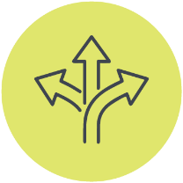
The Roadmap for Change: Critical Actions for Inclusive Education Reform
The following roadmap outlines the steps South Australia must take—together—to make inclusive education a lived reality for every student.
The following information is represented in a visual format on pages 20 and 21.
Stage 1

Laying the groundwork for belonging and inclusion
Short Term (2026-2029): Foundations
Culture:
1.1 The education sector must develop and implement a shared, system-wide understanding of inclusive education, aligned with human rights obligations, to ensure consistent interpretation and practice across State, Catholic and Independent schools, and to clearly articulate the benefits of inclusion for all students.
1.2 South Australian State Government to establish a Cross-Sector Inclusive Education Advisory Group to ensure State, Catholic and Independent schools are accountable for change, supporting implementation and monitoring of short, medium and long term outcomes.
1.3 Introduce state-level recognition and incentive mechanisms, including awards for innovation in inclusive education, to promote, support and scale effective inclusive practice across schools and systems.
Community and Connection:
1.4 Enshrine student perspective as a formal and ongoing driver of reform by establishing a Statewide Student Inclusion Reference Group, with clear pathways for advice to inform policy design, implementation and evaluation (‘nothing about us without us’), led by the state Department for Education as a cross-sector initiative.
Communication and Collaboration:
1.5 Leading cross-sector collaboration, the state Department for Education must establish clear, minimum requirements for schools to provide families and carers with accessible information about student rights, supports, and transparent, timely complaints processes, with escalation pathways where concerns are not resolved.
Capacity and Confidence:
1.6 Require all South Australian schools to participate in a Positive Inclusion Indicator framework, as a part of the South Australian Inclusive Education Strategy by establishing a consistent baseline for inclusion practice, monitoring progress over time, and informing system-level accountability and support.
1.7 All South Australian schools will participate in ongoing, evidence-informed professional learning in inclusive education. Mandating the use of Multi-Tiered Systems of Support (MTSS) and Universal Design for Learning (UDL) into Quality Differentiated Teaching Practices (including assessments), ensuring available technology and tools are utilised appropriately to support accessibility. Teachers within segregated education settings (specialist education centres, special classes) will benefit from engagement in these programs to continue to build skills, belief and knowledge they require to deliver inclusive education in non-segregated settings.
1.8 Tertiary teaching degrees accredited in South Australia include mandatory, assessed inclusive education content aligned with UDL and MTSS. Initial teacher education programs accredited in South Australia will include mandatory, assessed inclusive education content, developed in partnership with people with disability and aligned with national best practice. The Teachers Registration Board of South Australia, the Australian Education Union and the State Government will jointly progress and oversee implementation of these reforms.
Consistency and Commitment:
1.9 Department for Education, in consultation with Cross-Sector Inclusive Education Advisory Group to develop and implement a South Australian Inclusive Education Strategy, aligned with General Comment 4 of the CRPD, formally adopting the National Best Practice Framework, and integrated with the State Disability Inclusion Plan 2025–2029, to underpin coordinated, system-wide reform.
This strategy will guide implementation of inclusive education in our general education settings and set out key steps to desegregate through a workforce strategy, enrolment policies, a hub and outreach model, and provide monitoring and accountability through a positive inclusion indicator framework, and system-level key performance indicators. The key performance indicators in the areas of enrolment, participation, progress and education outcomes will ensure inclusion is embedded at a systems level.

1.10 Ensure all schools consistently meet their obligations under the Disability Standards for Education by providing timely, appropriate supports and adjustments that enable students with disability to access the Australian Curriculum on the same basis as their peers.
1.11 The South Australian Government to immediately ban the use of the most dangerous forms of restrictive practices, appoint a Senior Practitioner and adopt the recommendations of the Anti-Bullying Rapid Review.
1.12 The South Australian Government to legislate the right of students with disability to enrol in general education.
1.13 No new segregated schools to be built, with funding instead directed towards activities that support the implementation of the South Australian Inclusive Education Strategy.

Stage 2

Embedding inclusive practice into education policies and models
Medium Term (2030-2034): Systems Transformation
Culture:
2.1 Embed disability content across the curriculum to ensure all students develop an understanding that disability, diversity and difference are a normal part of the human experience, alongside expanded access to Auslan education across South Australian schools.
Community and Connection:
2.2 Embed inclusion roles within all Student Representative Councils and work closely with local communities to engage mentors with disability to support students in these roles to increase their awareness, understanding and community connections.
2.3 Promote student interaction with the community through increased school engagement with local community centre and library activities, supporting ‘lifelong learning’ and connection with local community.
Communication and Collaboration:
2.4 Increase transparency for families and carers through regular public reporting on statewide educational outcomes by the Department for Education to the Education Minister, for students with disability and school inclusion indicators.
2.5 System-level Key Performance Indicators (KPIs) in the South Australian Inclusive Education Strategy and deliverables will sit at, and above site level - with accountability sitting with Principals and Principal Consultant/Local Education Teams.
Capacity and Confidence:
2.6 Schools to have inclusive education transformation plans in place. Implement a statewide hub-and-outreach model, transitioning resources and expertise into local schools to support students previously educated in segregated settings, and building sustainable, strengths-based inclusive capacity through mentoring, co-teaching and ‘team around the teacher’ approaches.
Consistency and Commitment:
2.7 Review the role of student support officers/education support officers, acknowledging these roles must strengthen teachers’ inclusive practice, be used in line with best practice guidelines, and must not replace teachers’ responsibilities to deliver high quality education. The review will ensure we have qualified and confident supports in our schools where a review of the student support officer (School Services Officer/Education Support Officer/Early Childhood Worker) role is essential, with the view to support upskilling, valuing and appropriately remunerating these positions.
2.8 Legislate a full ban on restrictive practices and limit exclusionary discipline as a last resort with strict safeguards.

Stage 3

Sustaining and supporting a thriving inclusive community
Long Term (2035-2040): Inclusive Excellence
Culture:
3.1 Progressively phase out segregated education settings, ensuring all students are welcomed and supported to learn alongside same-aged peers in inclusive general education, with coordinated transition planning and system-level safeguards.
Community and Connection:
3.2 Require active community and local government engagement with state community inclusion indicators, with the intent to have schools actively engaging local government representatives and local business in governing council roles. Building local communities where all students are valued members and are supported in their education journey to becoming engaged citizens.
3.3 Increase collaboration between local government and the education sector—recognising that libraries and community centres support students long after their ‘formal education’ is completed.
Communication and Collaboration:
3.4 All schools to actively support students, who are given agency in planning their educational supports and journey, with families and carers seen as collaborators throughout the process.
Capacity and Confidence:
3.5 Redistribute resourcing from segregated education settings into general education, ensuring specialist expertise is retained and provided through outreach models that strengthen inclusive practice in local schools. Maintaining an outreach model to support a wrap-around ‘team around the teacher’ and where required ‘team around the school’ to ensure Quality Differentiated Learning Practice (QDTP), adjustments and supports are provided.
3.6 Require the South Australian curriculum to include the same in-built flexibility as the Australian curriculum so teachers can adapt and present content from the student’s year level in a way that is personalised to the student’s learning needs.
3.7 Maintain support to deliver the Expanded Core Curriculum (ECC). The ECC is essential for students with sensory disability (Blind or low vision, and Deaf or hard of hearing). As students with sensory disability have unique educational needs that, if not addressed, can lead to poor long-term outcomes, it is vital to maintain support for delivery of the ECC through outreach services with specialist teachers of the Deaf and hard of hearing, and teachers of the vision impaired supporting the teachers teaching these students at their local schools. It is also vital to maintain access to intensive literacy support for Braille users, and bilingual-schooling for Deaf students throughout their education.
Consistency and Commitment:
3.8 Following cross-sector engagement supporting inclusive education – the sector must commit to increasing the recruitment, retention and progression of teachers and education staff with disability, recognising the importance of visibility, representation and lived experience in sustaining inclusive education. The Department for Education along with catholic and independent schools associations must work with the Teachers Registration Board to support tertiary institutions to enable students with disability to complete teaching degrees and move into the workforce.
3.9 Restrictive Practices are fully prohibited, and all responses to behaviours are inclusive and trauma informed.
3.10 The state Department for Education to evaluate the long-term impact of the reforms undertaken through the Roadmap on the enrolment, participation and outcomes of students with disability, using data to drive continuous improvement.

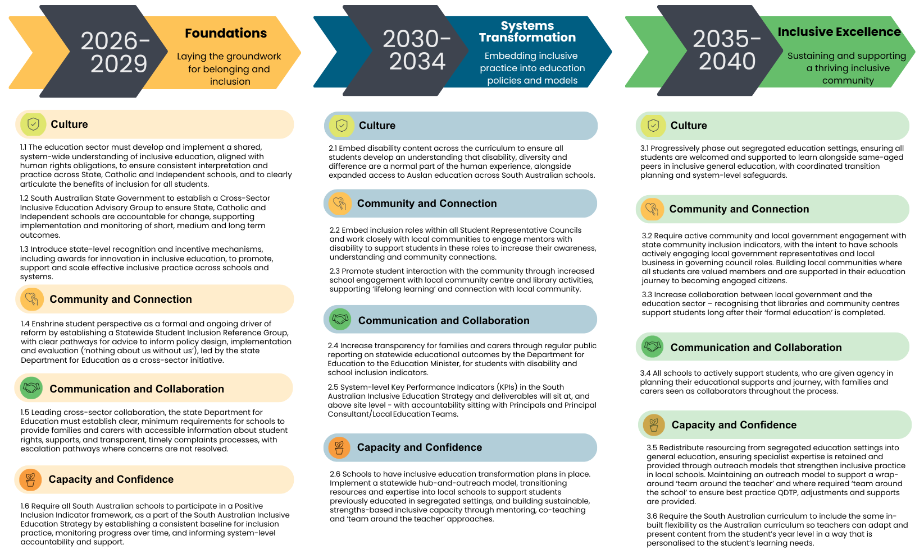

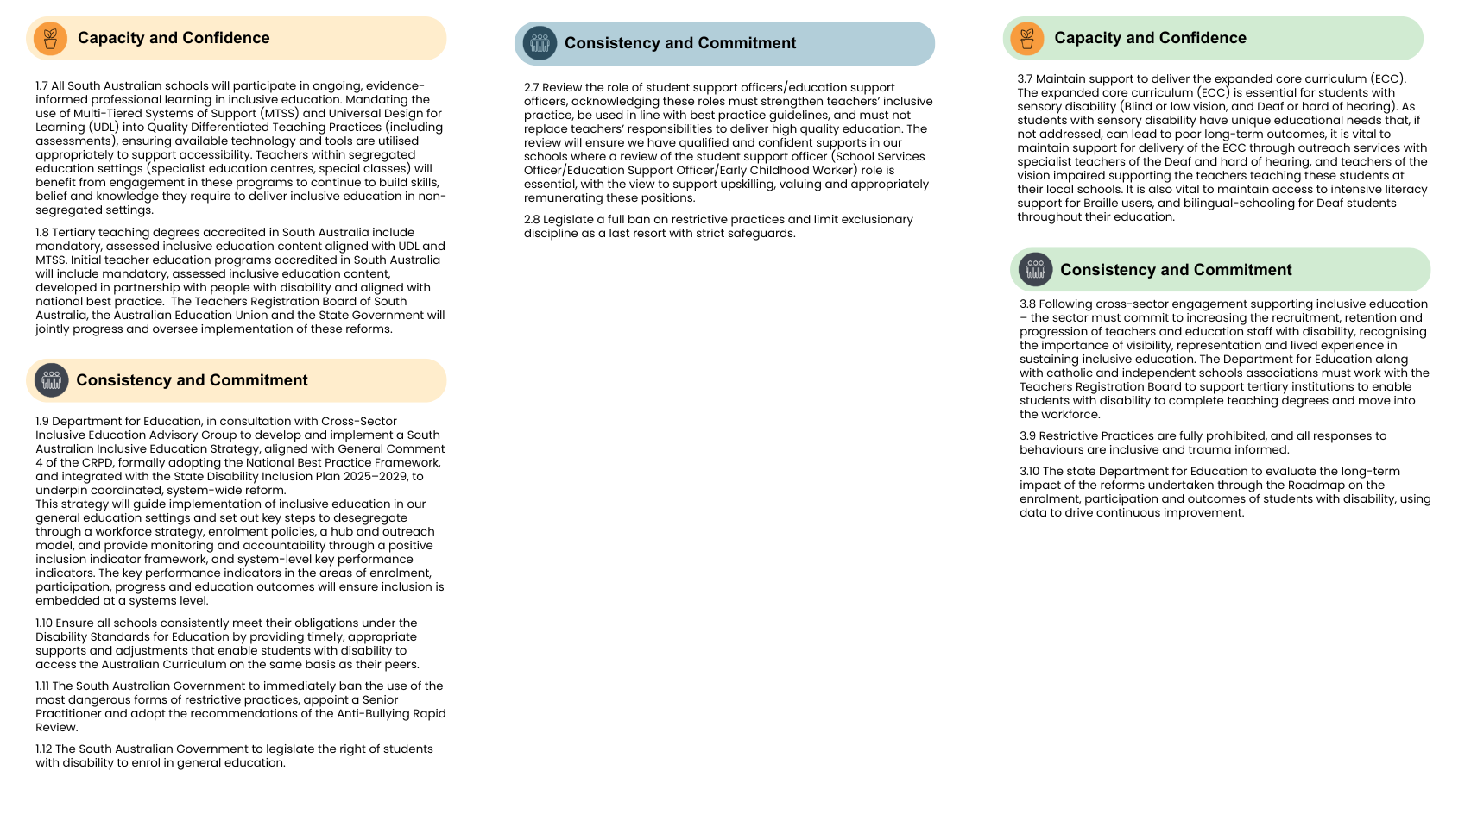

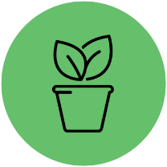
Sustaining Momentum – working together for lasting change

Cross-Sector Collaboration and Leadership
Transforming education to be truly inclusive is not the task of schools, or individual teachers alone — it requires sustained, coordinated leadership across government, education sectors, and communities.
South Australia has already demonstrated that collective action is possible. A cross-sector response was undertaken to address recommendations from the Royal Commission into Violence, Abuse, Neglect and Exploitation of People with Disability, and this collaboration must continue and deepen.
Inclusive education reform depends on shared accountability between the Department for Education SA, Catholic Education SA, Independent Schools SA, alongside the disability community, universities, and workforce representatives. Families, carers, and young people must remain central partners in all decision-making processes.
Our shared leadership priorities include:
- Establishing a Cross-Sector Inclusive Education Advisory Group to guide implementation, monitor progress and publicly report on system wide outcomes. Including children and young people with disability, families, educators and policy makers, along with independent expertise in this group will ensure lived experience informs decision making at every stage.
- Embedding lived-experience expertise at every level of policy design and governance through regular statewide surveys of students with disability, families and educators, with findings published and used to inform policy refinement, resource allocation and system priorities.
- Aligning state initiatives with the ACIE National Roadmap and UN General Comment 4 to ensure consistency and rights-based practice nationwide.
- Promoting subsidised, ongoing, evidence-informed professional learning so educators have the knowledge and confidence to teach inclusively.
“I am excited to see the next steps in SA’s journey towards inclusion in education on the back of the recommendations from the Disability Royal Commission.” Teacher (Survey Participant)

Accountability, Monitoring and Evaluation
Transformation must be transparent. Progress towards inclusion should be measured, reported, and improved through continual reflection and learning.
All reform stages must be underpinned by clear legislative and policy frameworks that guarantee equitable access, protect students from harm, and embed accountability at every level.
“…principles and leadership are important, but it's a top down, bottom-up approach that is needed to hold everybody to account and to hold each other to account.” Parent/Caregiver (Co-Design Group)
To support this, monitoring should be embedded through clearly defined system-level and school level indicators, with annual public reporting on enrolment, participation, wellbeing and exclusionary practices for students with disability. Key Performance Indicators (KPIs) at both school and leadership level must include feedback loops to supporting accountability and provide recourse mechanisms. Public awareness and transparency of progress should be measured and demonstrated through quality data collection, and reporting through live data dashboards at school, regional and system levels and regular public reporting.
Monitoring should focus on:
- Rates of enrolment, participation, and achievement of students with disability
- Reduction in segregation, isolation, exclusionary and restrictive practices
- Student wellbeing, belonging, and school climate indicators
- Teacher capability, confidence and access to inclusive practice supports. Annual public reporting, independent oversight and routine review of dashboard data should be used to track progress and trigger action where outcomes stall. This will help maintain trust and transparency, ensuring the community can see tangible progress.
“If they’ve [Education Directors] got some sort of KPIs that they’re employed under…there needs to be feedback that’s actually acted on as to how well they’re doing… at the moment nothing's ever done. So, there needs to be a better option.” Teacher (Focus Group)



Continuing the Conversation
Inclusive education is not a single policy or timeframe — it is an ongoing cultural shift that grows through partnership, dialogue, and shared reflection—
“…with a culture of inclusion comes a message that connects the people that make up the First Peoples disability community and also reaches out to others. The message of inclusion is: You are not alone. You are our community, and we are yours. If we can come together and stick together, then nothing can divide us.”
This roadmap was co-designed through deep consultation with students and young people, families and carers, teachers, and education professionals. Their voices define what inclusion must look like in practice.
“Training needs to include lived experience, and it needs to include voices of people with disabilities, students with disabilities, if they're not them delivering the course. Equity needs to be threaded through everything…there's a really low understanding of equity, and what that actually looks like.” Parent/Caregiver (Co-design Group)

“… I have seen people who are sort of outside of this world, one of the things that gets them to actually really connect with this stuff…I think you have to get them to kind of put themselves in the shoes of the student…What does it feel to be a disabled student that's in class trying to do this… I would say, as a teacher, I would feel that's quite impactful to just hear that voice along with very clear examples [of what you can do to improve practice]…” Student (Codesign Group)
We must commit to maintaining these conversations — listening, learning, and adapting as we move forward. Professional learning, peer networks, and ongoing engagement with the disability community will keep inclusion visible, valued, and evolving.
“[we need a roadmap that refers to]… a journey without an endpoint. I think [an endpoint] that disregards that the fact that we as society continues to evolve. And I think it's important to acknowledge this, and there's the indication of progress there. But I think this is something that needs to continue to evolve, because that is what happens with us as humans.” Teacher (Co-design Group)

Children and Young People with Disability Australia
Suite 8, 134 Cambridge Street Collingwood VIC 3066
PO Box 172, Clifton Hill VIC 3068
Phone 03 9417 1025 or
1800 222 660 (regional or interstate)
Email info@cyda.org.au
ABN 42 140 529 273
Facebook: www.facebook.com/CydaAu
Twitter: @CydaAu
Instagram: cydaaus
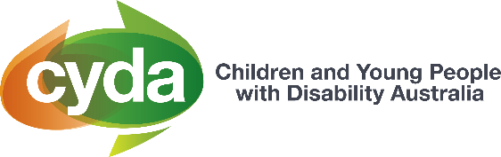
cyda.org.au

Summary of the evidence on Inclusive Education
Dept of Health, Disability and Ageing (2025) National Best Practice Framework for Early Childhood Intervention | Australian Government Department of Health, Disability and Ageing
Department for Education South Australia Our Strategy for public education South Australia. Purpose statement. (p. 6)
Department for Education South Australia Our Strategy for public education South Australia (p. 6)
United Nations (2016) Convention on the Rights of Persons with Disabilities, General Comment 4
⁴ Connolly, H. Commissioner for Children and Young People SA. (2020) The Blame Game – The perspectives from South Australian children and young people on the causes and impacts of education exclusion and why we need to stop blaming children for system failure.
Avery, S. (2018). Culture is Inclusion: A narrative of Aboriginal and Torres Strait Islander people with disability. First Peoples Disability Network (Australia).
Department for Education South Australia (2022) Principles of inclusion for children and students with disability in education and care
United Nations (2016) Convention on the Rights of Persons with Disabilities, General Comment 4
Dept of Health, Disability and Ageing (2025) National Best Practice Framework for Early Childhood Intervention | Australian Government Department of Health, Disability and Ageing
South Australian Government State Disability Inclusion Plan 2025–2029
Australian Government Department of Education Disability Standards for Education 2005
United Nations (2016) Convention on the Rights of Persons with Disabilities, General Comment 4
Avery, S. (2018). Culture is Inclusion: A narrative of Aboriginal and Torres Strait Islander people with disability. First Peoples Disability Network (Australia). Sydney, Australia, p207.

