May 2026
Explainer
What does the Federal Budget mean for children and young people with disability?

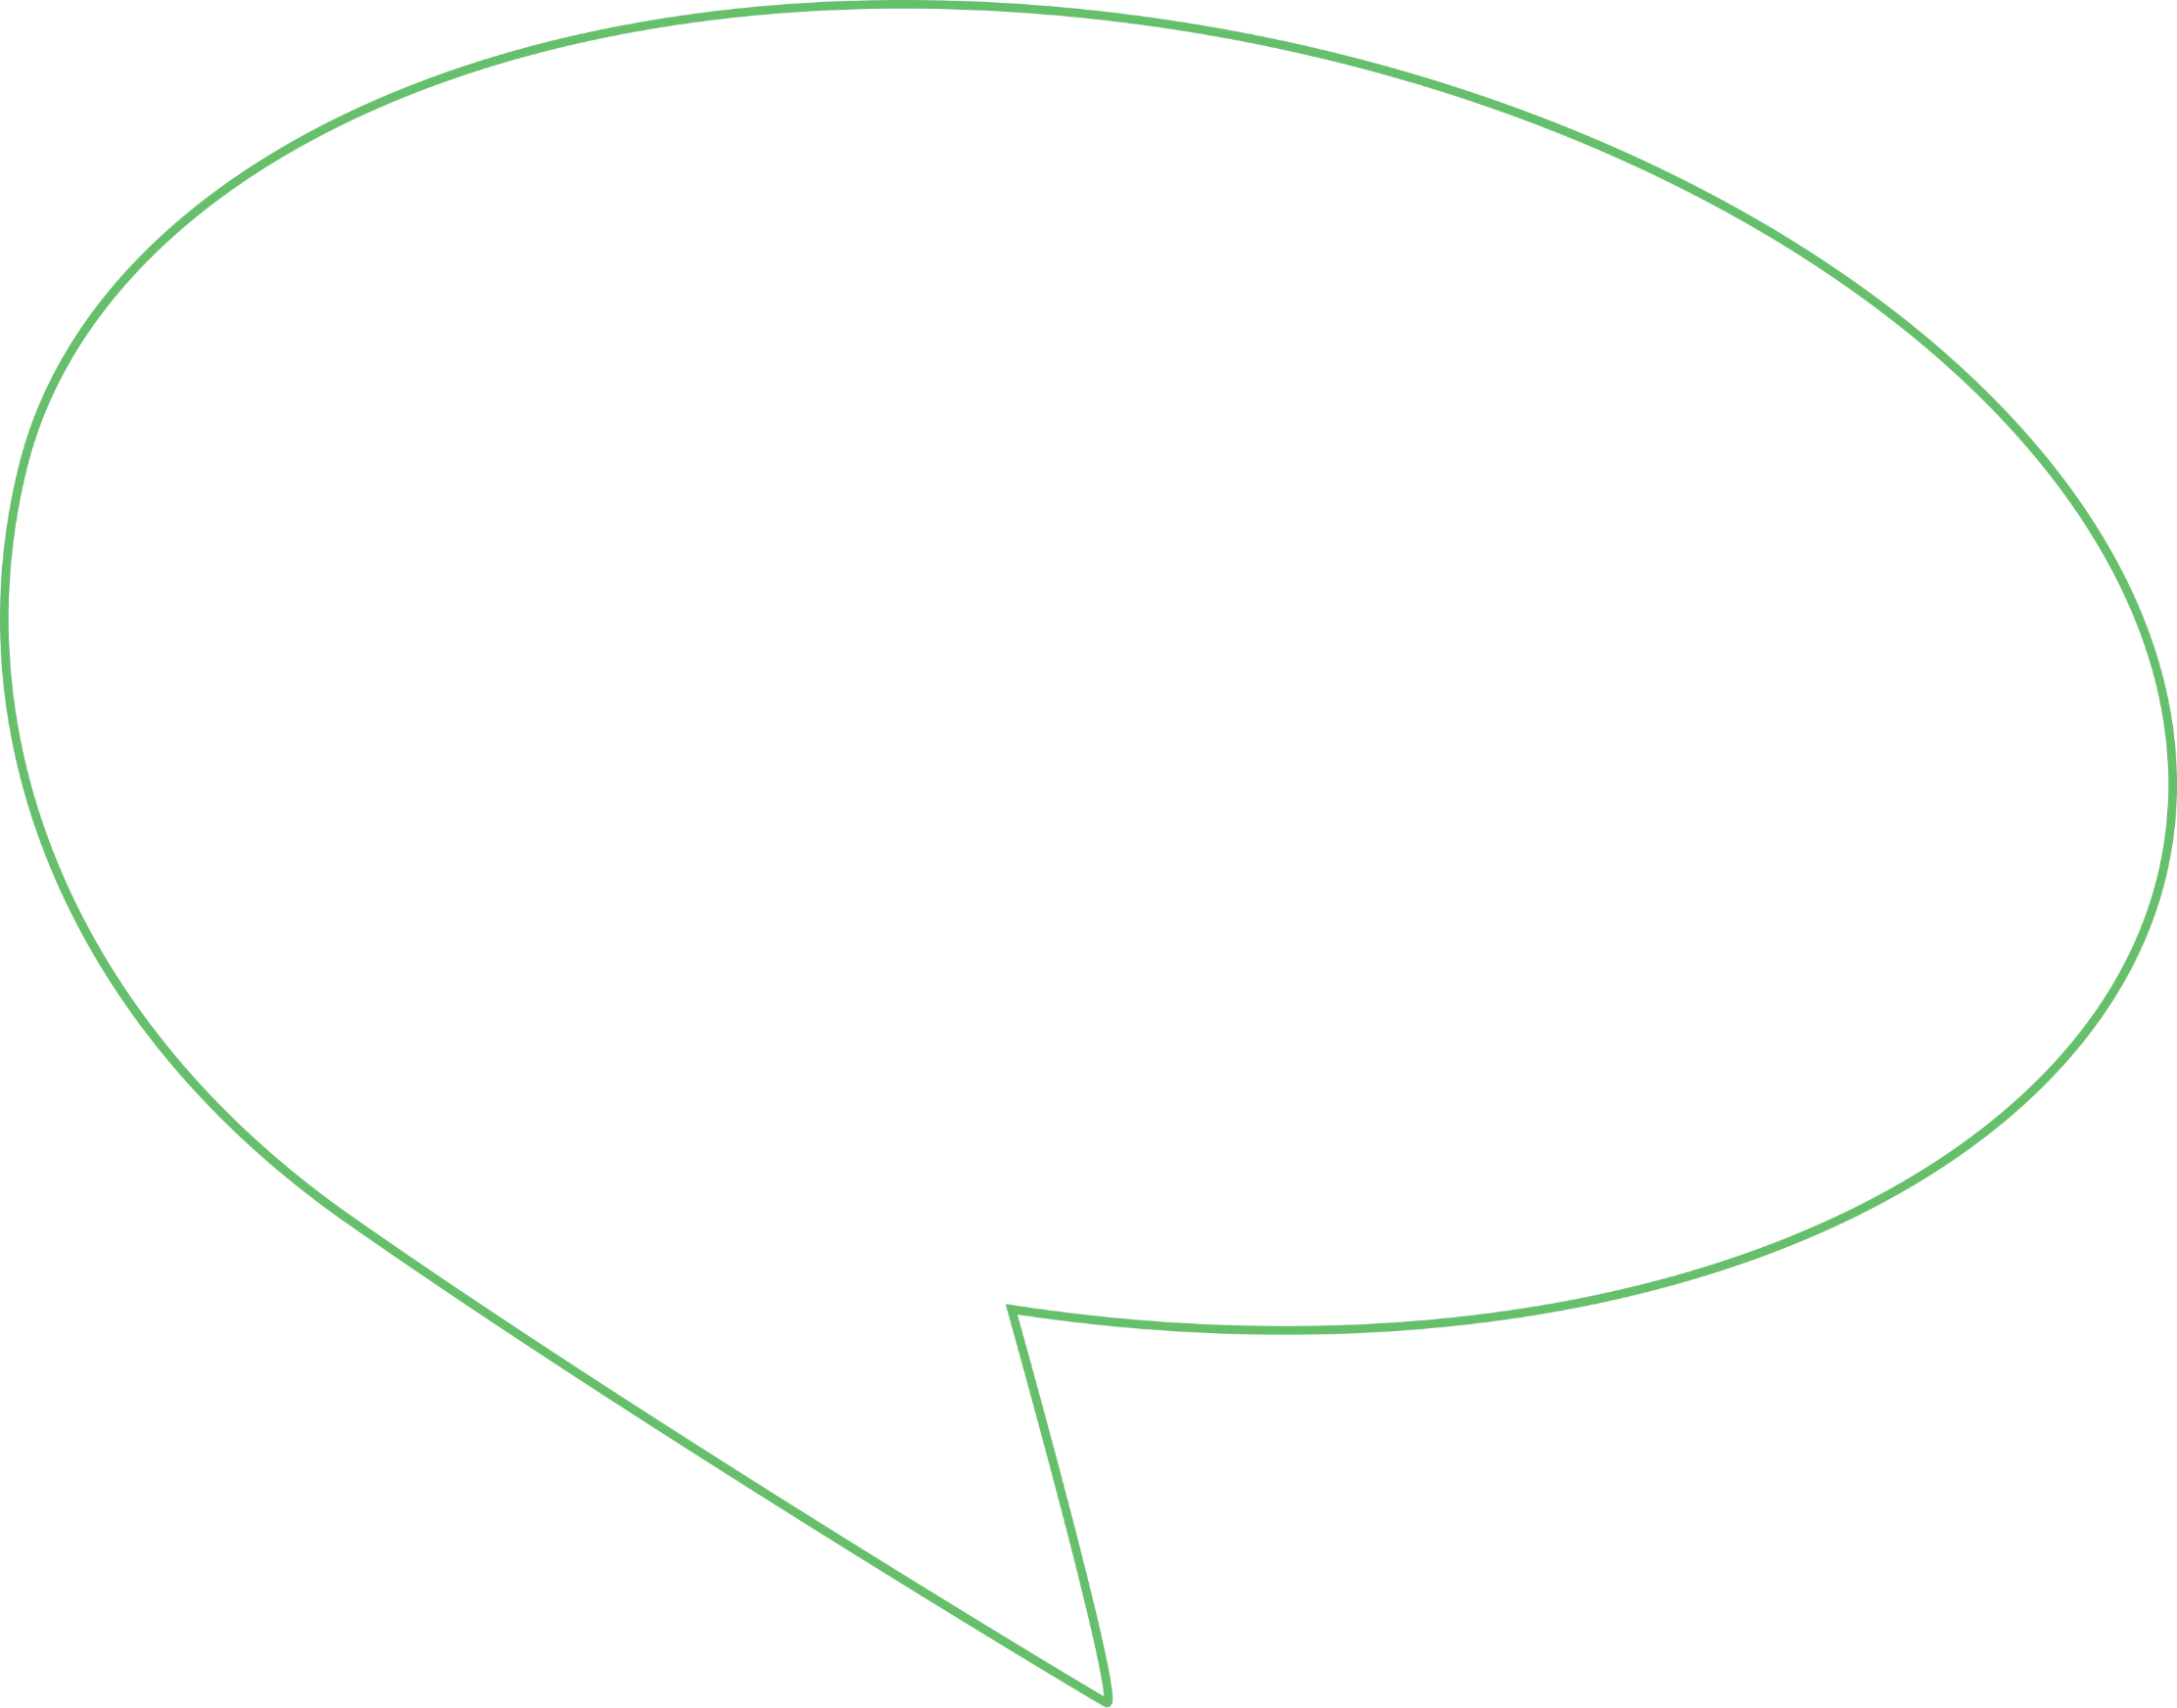
Contents

National Disability Insurance Scheme 3
Thriving Kids 4
Education 5
Employment 6
Health 7
Safety 8
Other Funding 9
So, what does this all mean? 10
The latest data on children and young people with disability 11

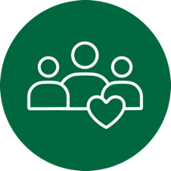
On Tuesday, 12 May, the Australian Government handed down its Federal Budget for 2026-2027. This explainer outlines some of its measures and what they may mean for children and young people with disability and their families or caregivers.
It is broken up into key topic areas: NDIS, Thriving Kids, Education, Employment, Health, Safety, and Other Funding.

National Disability Insurance Scheme
A headline focus of this Budget is slowing the growth of the NDIS by making major cuts to spending. Over the next four years, the government plans to save $37.8 billion by reforming the Scheme and bringing the overall number of participants down by roughly 160,000 people.
With more than one in two (52%) participants aged under 18, this may significantly impact how and where children and young people access supports.
Key measures include:
- Reducing funding for the NDIS by $37.8 billion over four years
This will happen by limiting who is eligible for the Scheme and unscheduled plan reviews, reducing social and community participation funding, and targeting fraud.
- $1.7 billion for spending on NDIS reforms over five years
This will help the NDIA deliver a new payment system, a Fraud Fusion Taskforce, New Framework Planning, and mandatory registration of high-risk NDIS providers. It includes $48.4 million over three years to support NDIS reform consultation and implementation, and $14.7 million for the NDIS Appeals program. The government will spend $110.9 million per year ongoing after this period.
- $200 million for spending on a new Inclusive Communities Fund
This will be spent over three years to support community organisations to deliver group-based social and community participation activities and individual capacity building support for NDIS participants. However, overall, funding for social and community participation is decreasing in this Budget.

Thriving Kids
The Australian government’s Thriving Kids program, announced in August 2025, is meant to be an alternative to the NDIS for some children with developmental delay and autism under nine. States and territories will begin to roll out these supports from October 2026.
This year’s Budget includes $2 billion in funding for the program, to be divided between the Federal and state and territory governments over the next five years.
Key measures include:
- $1.4 billion for spending on state and territory implementation
This will be provided to state and territory governments to support the delivery of Thriving Kids services in their state or territory.
- $600 million for spending on Federal measures
This includes $126.1 million for a Medicare-funded three-year-old health assessment, $120.9 million to provide information and support helplines for families, $60.8 million for workforce development, and $21.6 million for a national communications campaign.

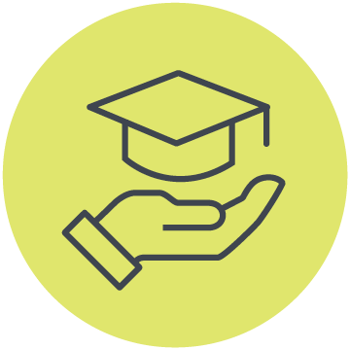
Education
A lack of a truly inclusive education system remains one of the biggest issues facing children and young people with disability today. Many experience discrimination, exclusion, and barriers to participation at schools, universities, in childcare, and elsewhere.
This year’s Budget includes a mix of measures affecting education and early childhood supports for children and young people with disability.
Key measures include:
- Reducing disability-related school funding by $463 million
These projected savings over the next four years will come from tighter compliance oversight for Students with Disability Loading, the additional funding provided to schools to support students with disability. While the government still expects to spend $5.1 billion next financial year on this Loading, stricter rules may make it harder for students with disability to get the support they need.
- $247 million for spending on the Inclusion Support Program
This existing initiative helps Early Childhood Education and Care (ECEC) service providers to include children with disability.

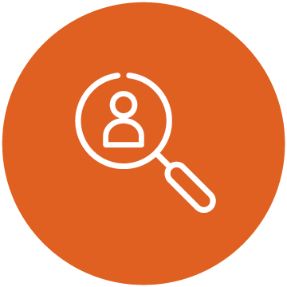
Employment
Access to meaningful and inclusive employment is key to promoting independence, financial security, connection and well-being. But unemployment and underemployment rates remain high for young people with disability in Australia.
This year’s Budget includes some funding to support employment rights for young people with disability and caregivers.
Key measures include:
- $3.2 million for spending on extending the Carer Inclusive Workplace Initiative
This initiative helps employers develop and adopt practices that support employees with caring responsibilities. The funding will be provided over four years, followed by $800,000 per year ongoing.
- $800,000 for spending on extending disability complaints hotlines and services
This funding will be used to extend the Complaints Resolution and Referral Service and the National Disability Abuse and Neglect Hotline. These support people with disability to report and resolve workplace, employment and abuse complaints.

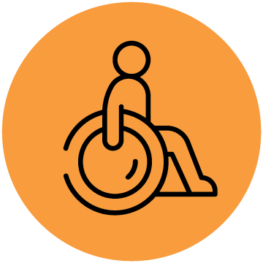
Health
Health systems play an important role in early identification, diagnosis, mental health support, and ongoing wellbeing. However, children and young people with disability often face extra barriers when it comes to accessing affordable, inclusive, and timely healthcare.
This year’s Budget includes a range of health measures relating to disability and health data, mental health, healthcare access, and support services for young people in general.
Key measures include:
- $14.2 million for spending on health data collection
This will be provided over three years to deliver the National Health Survey and refine the National Survey of Disability, Ageing and Carers.
- $3.1 million for spending on mental health support for some students
This will be provided over four years to continue the existing mental health support offered to Years 7 to 9 students at public secondary schools across Australia.
- Funding for spending on First Nations youth mental health
Two new remote services delivered by the National Aboriginal Community Controlled Health Organisation (NACCHO) will replace existing headspace services.
- A slight increase to the Medicare levy threshold for low-income households
This will mean some singles and families will be able to earn a little more before having to pay the Medicare levy. For families, the threshold will increase by 2.9% or $122 to $4338 for each dependent child or student.
- Ongoing access to public dental services for some children
The government will continue allowing children eligible for the Child Dental Benefits Schedule to access dental care through state and territory public dental services.
- Changes to Medicare rebates for children’s sleep disorder services
The government is achieving $3.1 million in savings over four years, and $400,000 ongoing afterwards, by applying a lower rebate to Medicare Benefits Schedule listings for sleep disorders in children and adolescents.


Safety
Children and young people with disability are at increased risk of violence, abuse, neglect, homelessness, and social exclusion. Accessible, trauma-informed and culturally safe support services are essential for supporting them to stay safe and connected in their communities.
This year’s Budget includes funding for homelessness, family violence, child safety, and wellbeing initiatives, including some targeted supports.
Key measures include:
- $4.1 million for spending for children experiencing violence or homelessness
This will be provided over two years to Primary Health Networks to continue delivering a pilot trauma-informed outreach support program for women and children affected by domestic violence or homelessness. Extra funding will also support First Nations women and children.
- $59.4 for spending for young people experiencing, or at risk of, homelessness
This will be provided to states and territories over four years to support more than 4000 young people aged 16 to 24 in receipt of ABSTUDY who are experiencing, or at risk of, homelessness.
- $171.7 million for spending on a national Children and Family Support program
This will be provided over five years, and then $19.6 million per year ongoing, to bring together existing prevention and early intervention family programs and launch a national model from 1 July 2027.
- $182.6 million for spending to make the child support system safer
This will be provided over four years to close loopholes in the child support scheme linked to financial abuse, non-compliance, and weaponisation.
- Mental health, safety, and anti-extremism spending following the Bondi attack
This includes $42.9 million for mental health supports, $80 million to prevent violent extremism and youth radicalisation, and $500,000 for stronger security at Jewish youth camps.
- $42.8 million for spending on supporting the safety of First Nations youth
This will be spent over five years, followed by $9.3 million per year ongoing, to create permanent arrangements for the National Commission for Aboriginal and Torres Strait Islander Children and Young People.
- $12.5 million for spending on initiatives to combat child sexual abuse
This funding will be provided to multiple agencies and child safety bodies, including $400,000 to the National Office for Child Safety (NOCS), to strengthen responses to child sexual abuse.


Other Funding
The Budget also includes measures to support Disability Representative Organisations (DRO) and sector sustainability, disability aviation standards, and expanded health, disability and ageing services.
Key measures include:
- $15.9 million for spending on DROs to support community engagement
This will be provided over four years, followed by $6 million per year ongoing, to help the disability sector engage the disability community on reforms.
- $38.1 million for spending on disability standards for aviation
This will be provided over four years, and $7.3 million per year ongoing, to establish the Aviation Consumer Protection Authority and an independent ombudsman scheme.
- $2.7 billion for reinvestment into health, disability and ageing services


So, what does this all mean?
The 2026-27 Federal Budget includes some positive measures for children and young people in general, especially around health, safety and wellbeing. But it does not provide much targeted investment for children and young people with disability in particular.
Cutting $37.8 billion from the NDIS and $463 million in disability-related education funding over four years will have real impacts for the nearly one million disabled children and young people under 25 who live in Australia. While funding important programs like the $2 billion Thriving Kids initiative and the $200 million Inclusive Communities Fund is intended to fill the gaps created by these enormous reductions, they do not come close to making up for what has been lost.
The government’s message is clear: it expects mainstream services like schools to support children and young people with disability more, but without providing enough funding.
What’s missing?
The Budget also failed to address key recommendations CYDA has made to the government in recent years. Building an Australia in which every child and young person with disability is supported to live, learn, develop, and thrive alongside their peers means genuinely investing in systemic change.
- In disability supports, that means prioritising clear and flexible support pathways parallel as part of and on top of the NDIS.
- In education, it looks like investing in a National Roadmap to Inclusive Education, inclusive early childhood education and care, a national independent oversight body, teacher training, and other measures.
- In employment, it means funding a National Youth Disability Employment Strategy, increasing income support to young people with disability, and transitioning to wage equity measures.
- While for sector sustainability, it requires investment in whole-of-government coordination, genuine co-design, targeted funding for intersectional disability communities, and more.
CYDA will continue to advocate for inclusive systems for children and young people with disability across all areas of life.
Learn more about our recommendations in our 2026-27 Pre-Budget Submission here.

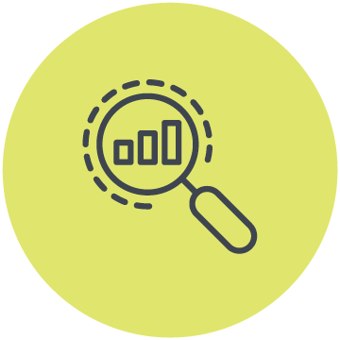
The latest data on children and young people with disability
This explainer includes multiple statistics relating to children and young people with disability in Australia.
These are drawn from CYDA’s Snapshot of Children and Young People with Disability in Australia – A Key Statistics Report, which brings together the latest available data about our community.
It covers 10 key topics: demographics, early childhood, education, employment, health and wellbeing, housing and transport, income and finance, NDIS supports, safety and justice, and social and community housing.
Access the full report here.

Children and Young People with Disability Australia
Suite 9, 134 Cambridge Street Collingwood VIC 3066
PO Box 172, Clifton Hill VIC 3068
Phone 03 9417 1025 or
1800 222 660 (regional or interstate)
Email info@cyda.org.au
ABN 42 140 529 273
Facebook: www.facebook.com/CydaAu
Twitter: @CydaAu
Instagram: cydaaus
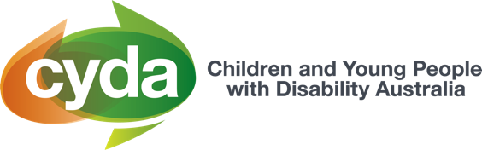
cyda.org.au

