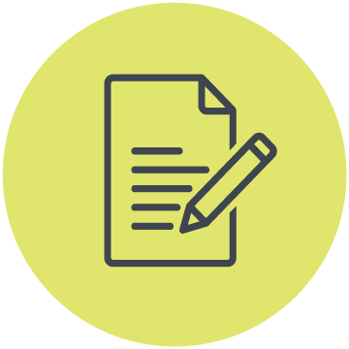
Fact sheet
How Australia’s social media ban impacts children and young people with disability

Survey findings

What is covered in this fact sheet
- Key results at a glance
- What we learned
- What children and young people want instead

About the survey
In May 2026, CYDA surveyed children and young people with disability, parents, and caregivers about their thoughts on the Social Media Minimum Age (SMMA).

This is the world-first law, passed in Australia in December 2025, that restricts anyone under 16 from holding an account on popular social media platforms like Facebook, Instagram, TikTok, and others.

We wanted to find out how the ban impacts the rights, well-being and safety of children and young people with disability.

The survey heard from 118 respondents. These included:
- 23 children and young people with disability under 16
- 42 children and young people with disability aged 16 to 25
- 53 parents or caregivers of children with disability under 16

Key results at a glance
For people with disability under 16:
- 95% still access social media in some way
- None feel safer online because of the restrictions, while 33% think it is less safe
- 48% feel more isolated, lonely or disconnected from community
For people with disability aged 16 to 25:
- 24% have been blocked from platforms due to inaccessible verification technology
For all groups:
- Nearly 80% think the restrictions are not fair and do not meet the needs of children and young people with disability

What we learned

Most children and young people under 16 are still on social media
Most respondents told us the social media restrictions are easy to get around, with 95% of under-16s still accessing social media in some way.

To do that, many told us they either use existing accounts, new alternative accounts, stick to unaffected platforms, or just repeat the verification process until they get through.

“It didn’t work, and every single person I know still has access”

The restrictions aren’t making online spaces safer
Many respondents said they thought the government should focus on making platforms themselves safer, rather than on restricting access for children and young people.

No one under 16 said they felt safer under the new law, and one-third felt online safety had actually become worse. Only 4% of parents reported their child felt safer.

“Platforms like YouTube have now been made significantly less safe (and inconvenient) because the under 16’s don’t have accounts and therefore are either using it ‘logged out’ without the ability for the [algorithms] to ‘learn’ what is appropriate for them and no parental controls”

Social isolation and disconnection has worsened
The social media ban may be making children and young people with disability feel more isolated.

We heard that 48% of under 16s were struggling to stay connected with friends or support networks, 38% felt isolated or lonely, and 38% felt like they missed out on community connection and access to information.

“I have felt so much more lonely since it went into effect.”

Age verification is creating accessibility and privacy barriers
Multiple people in our survey raised concerns about accessibility, privacy, identity verification and data security.

People with disability aged 16 to 25 were particularly impacted by inaccessible verification tools, with 76% saying they faced issues when trying to prove their age, and 24% not being able to access social media as a result.

Face recognition was the most common barrier.

“As a 21-year-old, these restrictions have only blocked by my accessing sites which I would otherwise be able to freely access.”

What do children and young people with disability want instead?
Roughly 80% of children and young people with disability, and parents or caregivers, thought the ban was unfair and just did not work.

They were clear about what they wanted instead.

Instead of focusing on restrictions, some suggested that the government should:
- Hold social media companies accountable for online safety
- Improve platform design, moderation and safety measures
- Invest in online and offline opportunities for connection and community
- Consult children and young people with disability on future policy changes
Learn more at https://cyda.org.au/resources/social-media-minimum-age/

